**Les notions de STAGE D’ETE :**

* **API :**

- Signifie APPLICATION PROGRAMMING INTERFACE

- C’est un moyen de communication entre deux logiciels (entre deux logiciels diffrentes , ou composantes d’une application , client a un serveur , logiciel a des developpeurs (exemple de google : connexion avec google) )  
- API c’est un intermediare , le client va demander a l’API une information , ce dernier va aller chercher cette inforamtion dans la base de donnes pui renvoyer au client dans un second de temps.

- Si on n’a pas une API on aura : diffficulte a integrer des services tieres (externs) : c’est-à-dire integration de services tiers dans l’application serait complexe donc vous devez les coder d’où perte de temp . exemple : service de paiment : integrer une api de paiemnet tiers telle que Paypal , service de messagerie , reseau social , sevice de geolocalisation (map ) , service de stockage   
autre exemple : toujours vous trouvez dans les sites se connecter avec google ou facebook , voila c’est un api de google et meta .   
 - les API alors creent des methodes standarisees et reutlisables permettent aux developpeurs d’acceder a des donnes specifiques lors de la construction d’applications

-deux types :

**\*\*\* API privees** : les personnes en dehors de votre entreprise ou l’application n’ont pas acces aux donnes disponibles de votre base de donnes .

**\*\*\* API publiques** : utiliables par d’autres persones , qu’elles soient sur l’application ou non donc permet recolter des donnees d’une autre application pour ameliorer leurs propres projets sans les coder …. Comme API de meteo , API De spotify ,… alors a la place de collecter vos propres donnes meteorologique vous pouvez utiliser une API de meteo et y trouver vos donnees !

*ALORS API est une couche intermediare entre DB et la personne qui va acceder ou manipuler les donnes .

D’où une requete directe et non controllee peut engendrer le chaos , API permet la securite , integrite des donnes (insertions , des mises a jour , suppressions incorrectes.) d’où les incoherences dans la BD et donc compromettre (Mettre dans une situation critique) l’integrite des donness.

-En utilisant des API et des frameworks appropriés, Vous pouvez contrôler les requêtes et les interactions avec la base de données. Cela permet d'assurer la sécurité, la cohérence des données, les performances optimales et une maintenance plus aisée de l'application.

**API REST :**

- signifie Represntational State Transfer

-contient des lignes **directrices architecturales** qui strcturent la facon de communiqur les donnes entre votre application et le reste du monde ou bien entre differentes composants de l’application .

-touts les API REST sont RESTful , mais toutes les API no sont pas RESTful

-base sur protocol **http** pour transferer des informations . (c’est comme le protocole de communication web) 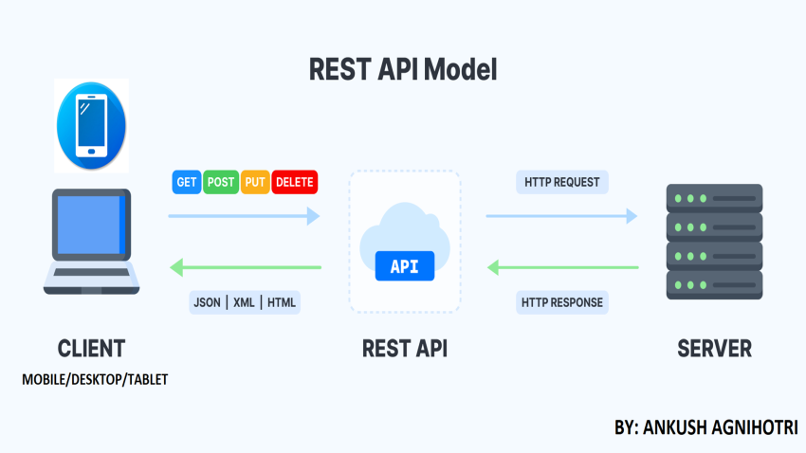

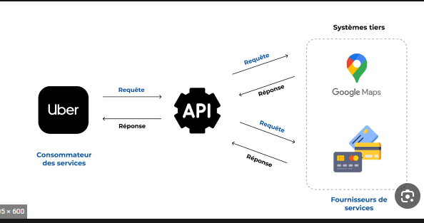

- les poitns positifs de api rest  :

**Separation de client et du serveur** : c’est-à-dire : le client se concentre sur la recuperation et l’affichage de l’information et le serveur le stockage et la manipualtion des donnes donc chacun a son role . d’où peu importe comment le serveur est construit ou comemnt le clients est code , au moments ou tous les deux ont leur communication selon **lignes directrices architectureales REST** en utilisant **http** , la communication se fait !

D’où on peut travailler sur les deux : une equipe travaille front end et autre le back end grace a L’API REST .

**STATELESS** :

**Sans etat** , serveur ne souvegarde aucune requetes ou reponses precedentes , mais coment il fonctionne si on ne garde pas une **trace** des requetes alors ?

Alors chaque message est isole et independant du reste , d’où il faut assurer d’envoyer avec la requete toutes les donnes necessaires pour etre sur d’avoir la reponse la plus pricise possible , c’ad : Est-ce que je pourrais avoir du ketchup sur les frites que j’ai commandées à ma table ? » et pas

vous demandiez des frites à votre serveuse.  Et ensuite :  Excusez-moi, je pourrais avoir du ketchup avec ?

il vous dit Avec quoi ?  , une serveuse stateles n’aurait aucun idee de ce dont vous parlez …

Alors c’est propriete rend la chaque requete et chaque reponse est tres determinee et comprehensible .

**Cacheable** :

Reponnse contient la capacite de mettre les donnees en cache ou de les souvegadrder

Si les donnes sont etre mises en cache alors on aura une reponse avec un **nuemro de version**

Si utilisateur fait la requette deux fois (revoir le contenu pour la deuxieme fois) : charger les memes donnes a partir le cache la seconde fois

**Unifrome interface :**

Lors de la creation d’une API REST , les develppeurs acceptent d’utiliser les mems normes d’où uniforme interface donc une api REST d’une application parut communiquer de la meme facon avec une autre application entierement differentes

**Layered system (couches) :**

C’est-à-dire le role de client est de communiquer avec un commpsant de l’API et apres ce composant va interagit ensuite avec d’autre et ainsi de suite , le client ne savez pas cette etape de quel va etre interagit et comment ! ,,,, exmeple : faites une requete a l’API FACEBOOK pour recuperer les dernieres postes , vous n’avez aucune idee sur les composantes avec l’aquels l’API Faecebook communique ensuite ….

**LES ALTERNATIVES AUX API REST :**

Il existe aussi **API SOAP**: Simple OBJET ACCES PROTOCOL CONTRAIREMENT A REST

* C’EST UN PROTOCOLE ET PAS UN STYLE D’ARCHITECTURE

PLUS UTILISE DANS LES grandes entreprises. (Couches de securite , de confidentialite des donnees , integrites supplementaires que REST)

- l’un des types d’API les plus populaires, qui constitue un élément indispensable de la boîte à outils de tout développeur de nos jours : une **API REST** ! . 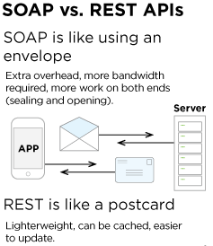  
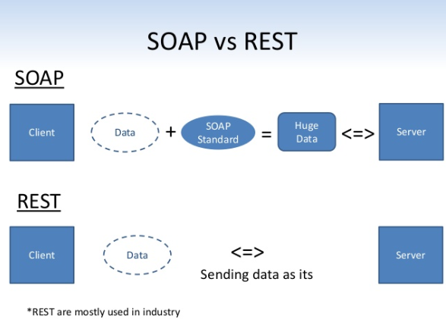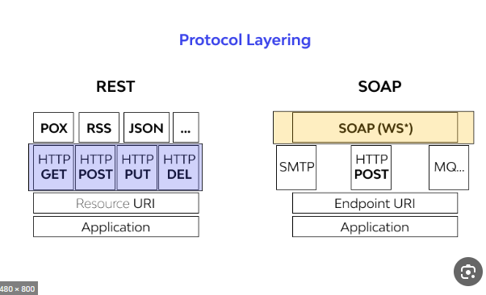

Creating a Model for an Existing Database in Entity Framework Core :

in Visual Studio, select menu Tools -> NuGet Package Manger -> Package Manger Console and run the following command:

PM>   
**Scaffold-DbContext "Server=.\SQLExpress;Database=SchoolDB;Trusted_Connection=True;**

**PROBLEMES :**

IN TOOLS NUGETTS PACKAGE MANAGER == > PACKAAGE MANAGER CONSOLE TAPE :

Scaffold-DbContext "Name=DB_ANCFCC" Microsoft.EntityFrameworkCore.SqlServer -OutputDir Models

Or add **-force** to force it car on peut trouver d’autre models au meme nom ..



MAIS IL FAUT DANS LE FICHIER : **APPSETTINGS.JSON** AJOUTEE LA LINE SUIVANTES :

**"ConnectionStrings": {**

**"DB_ANCFCC": "server=ABDESSAMAD\\SQLEXPRESS; database=DB_ANCFCC;Trusted_Connection=true;TrustServerCertificate=True"**

**}**

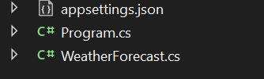

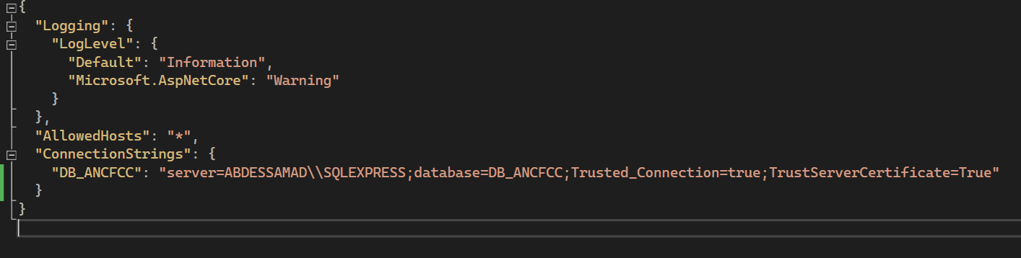

**La migration :**

Dans le contexte du developpement de base de donnes fait reference a la gestion des changements de sheema dans une base de donnees.

C’est le faite de representer les modifications apportees a la structure de la base de donnees (creation des tables , l’jout , suppression ….. )

**Pourquoi ?** : permet de gerer les changements de shema de manière controlee au lieu de modifier directement la base de donnees .

***Créer Une migration represente ces modifications d’où vesionner et suivre l’historique de modifications apportees a la base de donnees au fil du temps. Bach katb9a tabe3 ach dertii f la base de donens hit kaytcreeya un dossier fih des fichies b7aal blaan dyal giit f logiiique masi different f l’idee …. kola migration jdida imlique un fichier jdid fdossier…***

**Fait par EF CORE MODEL d’où EF Core migrations :**

**So ?** Migration is a way to keep the database schema in **sync** with the **EF Core model** by preserving data.

Migration le but dyalha howa : katkhelli la base de donne en synchronisation m3a EF Core Model ,,,

**\* L’ORM** permet de faciliter la manipulation des donnees en fournissant des fonctionnalites de **mapping** , de **synronisation** et de **gestion des operations de base de donnees**. ( **Mapping objet relationnne**l ) .

* **EF Core est une API** puissante pour l’acces aux donnes dans les applications .NET .
* **EF Core (Entity Framework Core)** : est une **bibliothèque** d'accès aux données pour les applications .NET. Il s'agit d'un **ORM** (Object-Relational Mapping) qui permet de faciliter la communication entre une application et une base de données relationnelle.

La phrase **Mapper les objets aux tables** : etablir une correspondance entre **les objets de l’applicaton et les tables de la BD** , pour assurer **Data mapping**

(ربط البيانات)

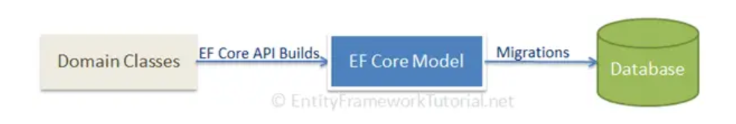

**EF CORE API , responsable sur de la cosntrucion du model EF CORE a partir des classes de domaine .**

**EF CORE MODEL respresente la structure et les relations des entites dans l’applicaton …   
les migrations EF CORE permet de créer ou mettre a jour le shema de LA BD en fonctions du modele EF CORE**

**Les migrations EF CORE sont des commandes executes dans la console NuGet Package Manager ou dans l’interface de ligne de commande dotnet CLI , ces commnades genere des sctipts , ces derniers peuvent etre executes pour mettre a jour le shema de la BD . d’où on garantit que La BD est synchronisee avec la structure des classes de domaines de votre application.**

**How to do it ?**

**1… Adding a migration :**

**Manager Console** from the menu Tools **->** NuGet Package Manager -**>** Package Manager Console in Visual Studio and execute the following command to add a migration.

**CODE :** **DANS CLI :**  
  
**dotnet ef migrations add Migration1 --context OurFullstackDbContext**

**MIGRATION 1 : C’EST LE NOM DE VOTRE CHOIX ….   
OURFULSTACKDBCONTEXT : C’EST LE NOM DE DBCONTEXT de votre application**

Ensuite UN DOSSIER MIGRATIONS DANS LE PROJET S’AFFICHE ….

**2…UPDATE THE DATABASE :**POUR CREER DATA BASE BASED ON THE CONTEXT AD DOMAINE CLASSES AND THE MIGRATION SNAPSHOT …

**dotnet ef database update --context OurFullstackDbContext**

D’OU UN DOSSIER **__EFMigrationsHistory** S’AFFICHE DANS LA BASE DE DONNES DANS LES TABLES .   
  
**3..how to remove a migration :**

**dotnet ef migrations remove**

**ELLASSE9 LI JEBTO F LEKHHER : KIFACH T UPDATER EF CORE F # M3A DATABASE YLA ZEDTI FIHA CHI HAJA : ….**

**NEFTARDO ZEDTI HADA F LA BASE DE DONNE :**

**ALTER TABLE Candidatures**

**ADD Verrouille BIT NOT NULL DEFAULT 0;**

**ZID HADA F LA CLASS  FEL MODELS … : PAR EXEMPLE**public bool Verrouille { get; set; }

**ZID HADA F PACKAGE MANAGER CONSOLE :**

Add-Migration AddVerrouilleColumn

**BDEL SMIYA DYAL ‘AddverrouilleColumn’  bchi haja siginificatif te39eel 3liha …**

**Apres makolchi succeded ; dir tam nit : Update-Database**

**AND DONEEE………**

# C# Design Pattern: Singleton :

# THE SINGLTON design pattern is a creational design pattern , le but est de assurer que la class a un seule instance est donner le global point of access to it au cours de la vie de l’application dans le but d’eviter les resultas inexepted .

# Singleton class structure faut contient : 1 a private or protected constructor . 2 have a static property ( ) to return an instance of a class

# 3 At least have non static public methode for a singleton operation

# 

**DANS CANDIDATCONTROLLER :**

HttpGet("Search/{idConcours}")] // Had la partie kate3ni bli rah idConcours est obligatoire //// LA PARTIE {IDConcours} /// les deux accolates

**KNOW THE FOREIGN KEY AND DROP IT :**SELECT f.name AS foreign_key_name, OBJECT_NAME(f.parent_object_id) AS table_name, COL_NAME(fc.parent_object_id, fc.parent_column_id) AS column_name, OBJECT_NAME(f.referenced_object_id) AS referenced_table_name, COL_NAME(fc.referenced_object_id, fc.referenced_column_id) AS referenced_column_name

FROM sys.foreign_keys AS f

INNER JOIN sys.foreign_key_columns AS fc

ON f.object_id = fc.constraint_object_id

WHERE OBJECT_NAME(f.parent_object_id) = 'Candidatures';

;

ALTER TABLE Candidatures

DROP CONSTRAINT FK_Candidature_AgentId;

Problème :   
  
issue with the JSON data that you're trying to parse. Specifically, the JSON object contains a trailing comma at the end of an array or object, which is not allowed in some JSON parsers.

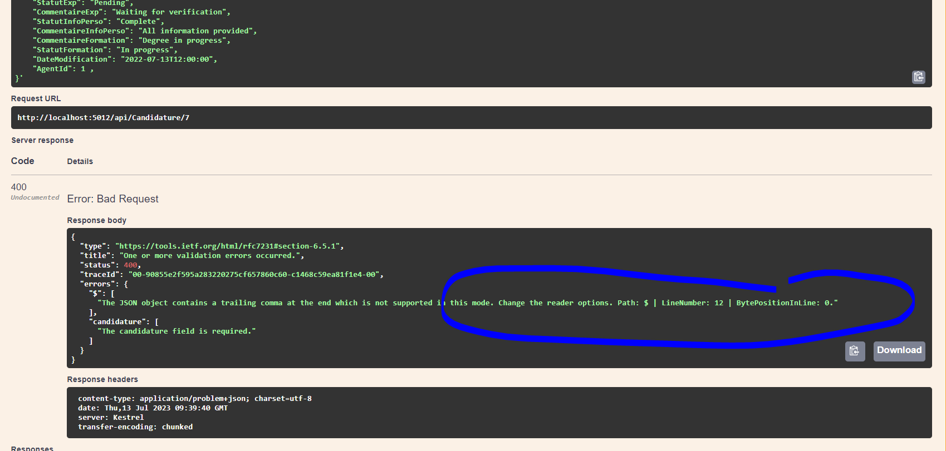

**7yeed l comma flkheer fach te3ti request hadi par defaut s’applle trailingcomma**

**LA PARTIE DE AUTHENTIFICATION ATDAR AVEC MICROSERVICES ….. DONC MACHI BDARORA DIRHA b les thechnique l3adiyin monolithique application**

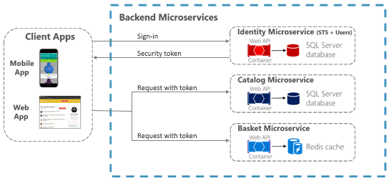

**Comment ca marche ???**

-Les microservices d’authetification sont utilises **pour securiser les Api et les services web** .   
-les utilisateurs peuvent acceder a des services a partir de differentes applications et appareils

- gestion de sessions des utilisateures , l’autorisation des utilisateurs en fonction de leurs roles et permissions (dans notre cas agent et administrateur )

- POUR L’IMPLIMENTER ON UTILISE DIFFRENTES TECHNOLOGIES COMME **OATUTH** , **OPENID CONNECT** , **SAML** , **JSON WEB TOKES (JWT)**

_ EXEMPLE : LA CONNECTION A UN SERVICE GOOGLE , FOURNIR L’ID ET MOT DE PASSE ENSUITE GOOGLE UTILISE DES MICROSERVICES D’AUTHETIFIVATION POUR VALIDER LES L’ID ET MOT DE PASSE , ET PUIS **GENERER UN JETON D’ACCES** EXEMPLE DE **OAuth** ou **openid Connect** , contient les informations sur l’utilisateur et ses permissions qu’il a ,,,,

Donc ce jeton est utlise pour autoriser l’acces aux differentes **services googles** par exemple **gmail** , alors le services gmail utilise alors les microservices d’authentifcation de google pour **valide le jeton** et verifier si l’user a le droit d’acceder a sa boite email ou non ,,,,

**EXPLICATION DE CODE BACKEND ETAPE PAR ETAPE :**

**CREATE PROJET ;**

**ETAPE 1 : CREATE BASE DE DONNE WITH SQL SERVER …**

**ETAPE 2 : OPEN A NEW PROJECT**

**ETAPE 3 : open Appesettings.json and tape :**

"ConnectionStrings": {

"DB_ANCFCC": "server=ABDESSAMAD\\SQLEXPRESS;database=DB_ANCFCC;Initial catalog=DB_ANCFCC;Trusted_Connection=true;TrustServerCertificate=True"

}

PERMET DE FAIRE STOCKER LES CHAINES DE CONNEXION A LA BASE DE DONNES (STOCKES DANS DB_ANCFCC )

SERVER = LE NOM DE SERVEUR SQL ET L’INSTANCE A LAQUELLE SE CONNECTER …

DATABASE = LE NOM DE DATABASE …

INITIAL CATALOG = DB_ANCFCC LE NOM DE LA BASE DE DONNES A LAQUELLLE SE CONNECTER … . OPTION ALTERNATIVE A DB

TRUSTED CONNECTION = TRUE CAD L’AUTHENTIFICATION WINDOWS POUR SE CONNECTER A LA BD . CAD L’APPP UTILISE LES INFORMATIONS D’IDENTIFICATION DE L’UTILISATEUR ACTUEELLEMENT CONNECTE A WINDOWS POUR SE CONNECTER A LA BD

TRUSTED SERVER CERTIFICATE = TRUE , CAD INDIQUE A L’APP DE FAIRE CONFIANCE AU CETIFICATS DU SERVEUR SQL SERVER MEME IL NYA PAS ETE EMIS PAR UNE AUTORITE DE CErTIFICATION RECONNUUE

**ETAPE 4 :ADD IN : Programs.cs ceciii apres Add services…**

**CONFIGURE LES SERVICES UTILISE PAR L’APPLCATION**

// Add services to the container.

// AJOUTER UN CONTEXTE DE BASE DE DONNES A LA CONFIGURATION DE L’APPLICATION …

builder.Services.AddDbContext<DbAncfccContext>(options =>

options.UseSqlServer(builder.Configuration.GetConnectionString("DB_ANCFCC")));

** C’EST POUR UTILISER SQL SERVER COMMME FOURNISSEUR DE LA BASE DE DONNES

** LA METHODE ADDDBCONTEXT EST UTILISE POUR AJOUTER UN CONTEXTE DE BASE DE DONNESS NOMMEE DbAncfccContext A LA CONFIGURATION DE L’APPLICATION ASP.NET CORE

**ETAPE 5  : IN THE TERMINAL TAPE : Scaffold-DbContext "Server=.\SQLExpress;Database=SchoolDB;Trusted_Connection=True;   
 IN nuget package manager**

**POUR GENERER DES MODELS AUTOMATIQUEMNT SANS LES CREES MANUELLMENT ….. A L’AIDE D’OUTILS TELS QUE ENTITY FRAMWORK. (EF CORE)**

**UN ORM UTLISEee POUR LA MODELISATION DE DONNEES DANS LES APPLICATIONS ASP.NET …..**

**LES MODELS : ____________-**

**\*\* SONT DES CLASSSES**

**\*\* Sont les objets metiers dans l’application OU LES DONNES ,,,**

**\*\* Representer des donnes et des objets metier dans une application**

**\*\* Represente d’autres types de donnes comme les fichiers , les flux de donnees , les parametres de configuration , etc ….**

**\*\* Utilises souvent dans le cadre Architecture MVC (MODEL , VUE , CONTROLEUR) D’ASP.NET ,,… ET PAR SUITE ENCAPSULER LES DONNES ET La LOGIQUE METIERS DE L’APPP**

**LA CLASSE SUPPLIMETAIRES AJOUTES ??? DbAncfccContext**

GENEREE AUTOMATIQUEMENT PAR **ENTITY FRAMEWORK** A PARTIRE DU MOM DE LA BASE DE DONENS A LAQUELLE LE CONTEXTE EST ASSOCIE ,

LA CLASSE **DBANCFCCCONTEXT** HERITE DE LA CLASSE **DB CONTEXT** POUR CHAQUE ENTITE DE LA BASE DE DONNES QUE VOUS SOUHIATEZ MODILISER

**Exemple :**

**public DbSet<Utilisateur> Utilisateurs { get; set; }**

** Hada bach kantbee3 les champs de la table utilisateur….   
  
** CE code permet de suivre les enregistements de la table Utlisateures de votre base de donnes et les gerer via le contexte de base de donnees..

**En résumé**, pour modéliser une base de données relationnelle à l'aide **d'Entity Framework** dans une application ASP.NET, vous devez définir des **classes d'entités** qui représentent les tables de la base de données, puis les ajouter à votre contexte de base de données à l'aide de **propriétés DbSet.**  
  
**LES CONTROLLEURS :**

**En résumé,** les contrôleurs dans une application ASP.NET sont responsables de la **gestion des demandes HTTP entrantes** et de la coordination des flux de données entre **les modèles et les vues.** Ils sont souvent utilisés en conjonction avec des vues et des modèles dans le cadre de **l'architecture MVC** d'ASP.NET.

Les **contrôleurs** récupèrent les données à partir des **modèles**, les préparent pour l'affichage, puis **renvoient les vues appropriées à l'utilisateur**. Les contrôleurs peuvent également effectuer des tâches telles que la validation des données utilisateur, l'authentification et l'autorisation, la gestion des erreurs et la gestion des sessions d'utilisateur.

**Error :**

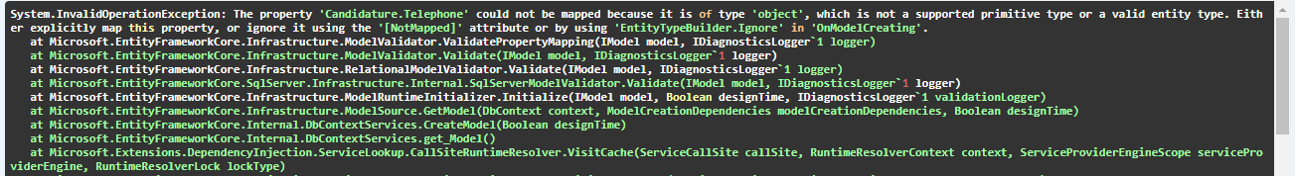

**\*\* [NotMapped]** is an attribute in C# that is used to exclude a property or field from being mapped to a database column.

** It is typically used in **Entity Framework** to exclude properties that do not have a corresponding column in the database, or properties that should not be persisted to the database.

** When you add the **[NotMapped] attribute** to a property or field, **EF Core** will not create a column for it in the database schema, and it will ignore the property when mapping the entity to the database. This means that the property will not be persisted to the database, and **any changes made to it will not be saved.**

** Ye3nii hadik la propriete EF CORE MAPS maghadich ycreer liha column f database ghadi ytjahelha ET aslan makaynach dik la proprite f table f database aslan

**Hada exemple bach tfheem :**csharp

Copy

public class Person

{

public int Id { get; set; }

public string Name { get; set; }

[NotMapped]

public string FullName => $"{FirstName} {LastName}";

public string FirstName { get; set; }

public string LastName { get; set; }

}

In this example, the Person class has a FullName property that is computed from the FirstName and LastName properties. Since FullName is not a physical column in the database, we can use the [NotMapped] attribute to exclude it from being mapped to a database column.

When EF Core maps the Person entity to the database, it will only create columns for the Id, Name, FirstName, and LastName properties, and will ignore the FullName property.

By using the [NotMapped] attribute, we can define properties that are not mapped to the database, **while still being able to use them in our code as if they were part of the entity.**  
  
**SQL :**

Had code f sql katlimiter biih **int** to 0 ,,1 ,,2 o madkheel hta chi haja akhra …   
 **ALTER TABLE Candidatures**

**ADD CONSTRAINT CK_StatutInfoPerso CHECK (StatutInfoPerso IN (0, 1, 2));**

**ALTER TABLE Candidatures**

**ADD CONSTRAINT CK_StatutExp CHECK (StatutExp IN (0, 1, 2));**

**ALTER TABLE Candidatures**

**ADD CONSTRAINT CK_StatusAgent CHECK (StatusAgent IN (0, 1, 2));**

**ALTER TABLE Candidatures**

**ADD CONSTRAINT CK_statusGlobal CHECK (statusGlobal IN (0, 1, 2));**

**ALTER TABLE Candidatures**

ADD CONSTRAINT CK_statusDoc CHECK (StatutDoc IN (0, 1, 2));

**Expliquer le code ;   
  
var profilesWithCount = await _DB_ANCFCC.Concours**

**\*\*\*­*Await** : est une methode qui attendre que la requete a la base de donnees soit terminee avant de continuer l’execution du code.   
  
**\*\*\*\* await _DB_ANCFCC.Concours** : renvoi un objet de type **Dbset< Concours>** represente la collection de tous les enregistrements dans la table ou la vue Concours. Et stockee dans cette variable **var** de **type IEnumerable<Concours>** ou **IQueryable<Concours>** selon le cas ..

**\*\*\*\*\* IEnumerable<T>** : est une **interface** que l’on peut implementer pour representer une **sequence d’objets de type T**   
. Le but c’est : Représenter une **collection** d'enregistrements de la table ou de la vue Concours, qui ont été extraits de la base de données à l'aide d'une **requête LINQ.**

**\*\*\*\*\*IQueryable <T> :** interface generique qui etend de IEumerable <T> permet de :

* d’optimiser la requete
* minimiser la quantite de donnees transferees entre le serveur et le client .

Permet la construction de requetes plus complexes qui sont traduites et executees cote serveur plutôt que cote client ..

La difference c’est que **IEnumerable <T>** peut executer ses operations de requete qu’apres avoir recupere **toutes les donnees** de la source de donnees . 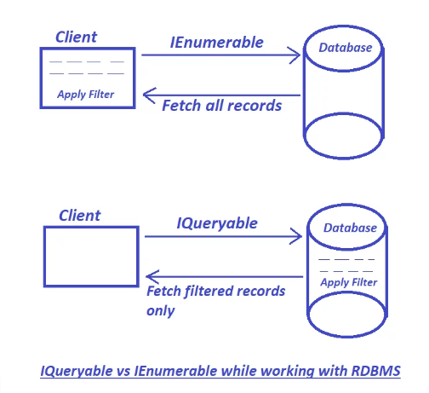

**NB :**

**\*\* RDBMS** : RELATIONNEL DATABASE MANAGEMENT SYSTÈME

IS A COLLECTION OF PROGRAMS AND CAPABILITIES THAT ENABLE IT TEAMS AND OTHERS TO CREATE , UPDATE , ADMINISTRER AND OTHERWISE INTERACT WITH A RELATIONAL DATABASE

** THE MOST POPULAR DATABASE SYSTÈM AMONG ORGANIZATIONS ACROSS THE WORLD

**\*\* RDBMS VS DBMS :**

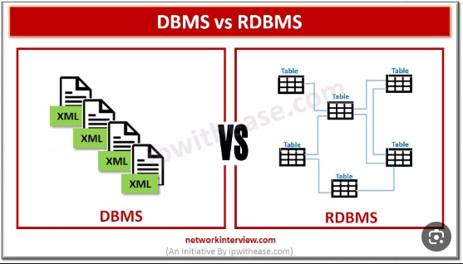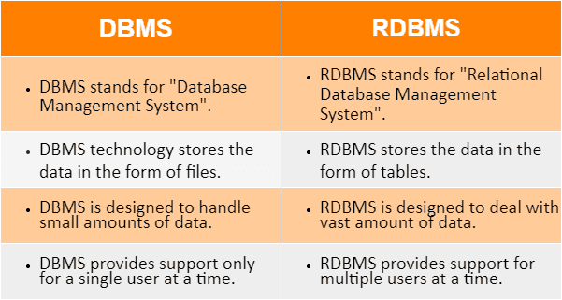

**\*\*\*\*\*\*\*Note tres important :**   
\*\*\*\***IEnumerable<T>, toutes les données sont chargées en mémoire et les opérations de requête sont effectuées sur la collection en mémoire**. Cela peut être inefficace pour les grandes collections de données, car cela nécessite d'abord de **charger toutes les données en mémoire avant de pouvoir les traiter**.  
  
**LLaSSe9 dyal la photo :**   
  
So the difference between **IQueryable** and **IEnumerable** is about where the filter logic is executed.

One executes on the client side and the other executes on the database.

So if you working with only in-memory data collection **IEnumerable** is a good choice

but if you want to query data collection which is connected with database `**IQueryable** is a better choice as it reduces network traffic and uses the power of SQL language.

**\*\*\*\* Resume** : En résumé, **IEnumerable<T>** est généralement utilisé pour **les collections de données** en **mémoire**, tandis que **IQueryable<T>** est utilisé pour **les requêtes de données** à **distance**, telles que **les requêtes de base de données**.

ALSO , two classes that contain extension methodes to write **LINQ Queries…**

**** **Requête LINQ** : **Language Integrated Query :**

** utilisee dans **dot net** , **java Script** , **php** ….

** On peuvent ecrire des requetes pour extraire , filtrer , trier , grouper , combiner des donnees a partir de differtentes sources de donnees telles que des collections d’objets , des bases de donnees , des fichiers XML, etc ,,,,

** Est Compilees en expressions d’arbre d’expression (trees)

*** **Resumee** : dans le contexte D’entity framework (EF Core) , **les requetes LINQ sont utilisees pour interagir avec une base de donnees relationnelle**. On ecrit des **requetes LINQ qui sont ensuite traduites en SQL** par **EF Core** et executees sur la base de donnees pour extraire , filtrer , trier , combiner des donnees en utilisant les fonctionnalites de SQL .

** We write a LINQ query to **IEnumerable** collection OR **IQueryable** data sources …

** Two ways to write it  : **Query Syntax** and **Methode syntax..**

**\*\* \*\*\*\*\*\*** **1 / Query syntax :** similar to SQL defined within the C# Or vb code.

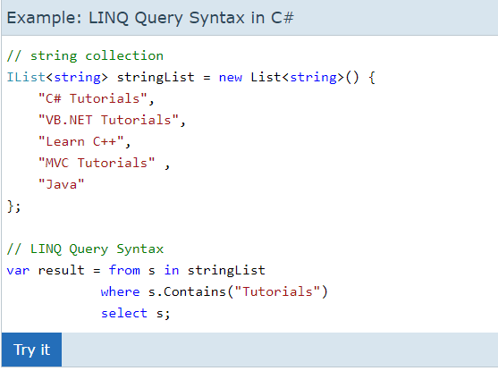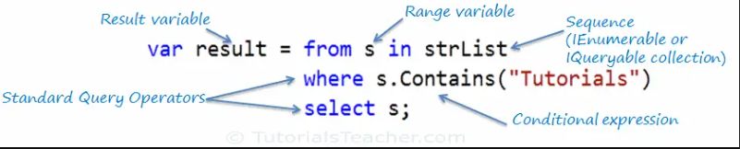

** **always** a LINQ QUERY SYNTAX STARTS WITH ‘**FROM**’ CLAUSE AND ENDS WITH a SELECT OR GROUP CLAUSE  
**we can use various opertors like filtering , joining grouping , sorting ….

** the range variable it’s like a variable that loops in the colllection (LIKE LOOPS FOR i=0 … )

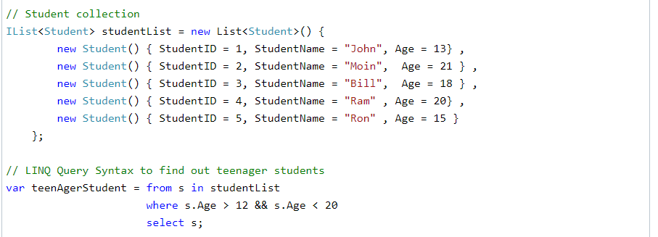

**2***/// Methode Syntax :**

_ known as **fluent syntax** also .   
_ the compiler converts **query syntax into methode syntax** at compiler time !!

_ uses extension methodes included in the **Enumerable** or **Queryable** static class .

_ example : returns a collection of strings which contains a word ‘ Tutorials’ :

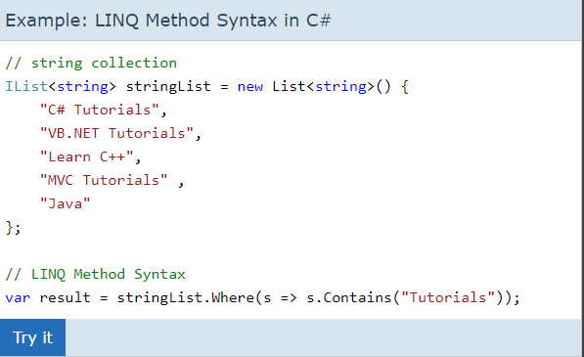

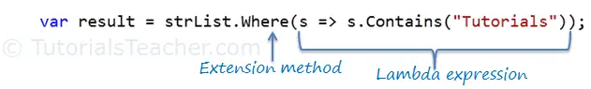

**\*\* Where() methode is defined in the Enumerable class**

* **LAMBDA EXPRESION :**

**A **shorter way** of representing **anonymous methode** ( ???) using some **special** syntax.

**Lamda expresssion works like an **anonymous methode**

**\*\*Anonymous methode** : so as the name suggests ,, methode without a name

**In C# can be defined using the **delegate keyword** and can be assigned to a variable delegate type…

**Example :

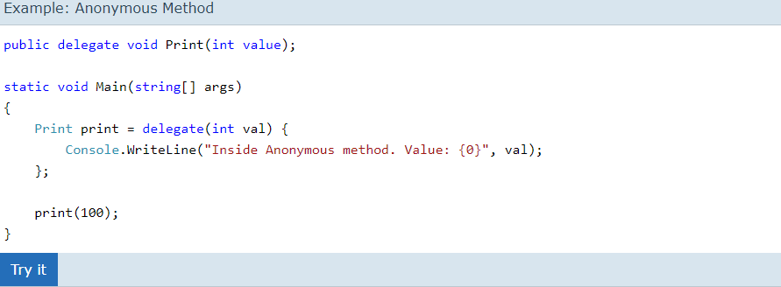

**Explication :**

Ce code C# utilise une méthode anonyme pour initialiser une déléguée. Voici une explication ligne par ligne :

1. La première ligne crée une déléguée appelée `Print` qui peut être utilisée pour appeler une méthode qui prend un argument de type `int` et ne renvoie rien.

2. La méthode `Main` est la méthode d'entrée du programme et est exécutée en premier lorsque le programme est lancé.

3. La ligne `Print print = delegate(int val) { ... }` crée une instance de la déléguée `Print` et l'initialise avec une méthode anonyme. Cette méthode anonyme est créée à la volée, directement lors de l'affectation de la variable `print`. Elle prend un paramètre `val` de type `int`. À l'intérieur de la méthode anonyme, la chaîne de caractères "Inside Anonymous method. Value: {0}" est écrite dans la sortie standard de la console, en utilisant la méthode `Console.WriteLine()`. Le `{0}` est un espace réservé pour le paramètre `val`.

4. La dernière ligne appelle la méthode anonyme en utilisant la déléguée `print` et lui passe la valeur `100` comme argument. Cela entraîne l'exécution de la méthode anonyme, qui affiche "Inside Anonymous method. Value: 100" dans la sortie standard de la console.

En résumé, ce code montre comment définir une méthode anonyme en utilisant **une déléguée en C#**. **Une méthode anonyme est une méthode qui n'a pas de nom** et **est définie directement dans une expression**. Elle est utilisée ici pour encapsuler une fonctionnalité spécifique qui n'a pas besoin d'être définie dans une classe séparée. Ce code est considéré comme une méthode anonyme car la méthode n'a pas de nom propre et est définie directement lors de l'affectation de la variable `print`.

**Dans notre cas :**

**Anonymous method checks if student is teenager or not :**

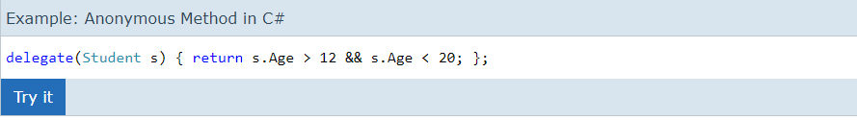

**Anonymous method can be reperesented using a lamda Expression in C# : Transforamtion**

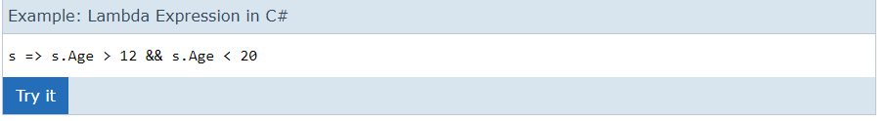

**HOW ???**

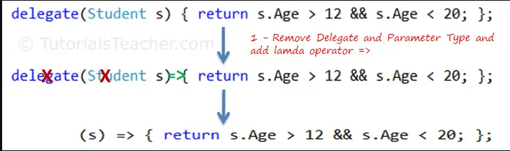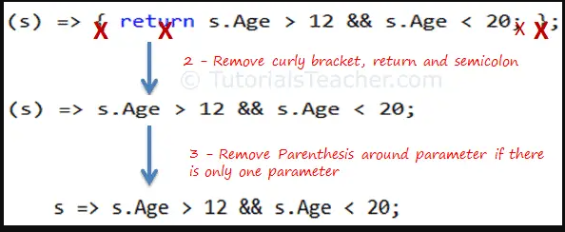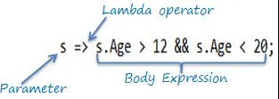

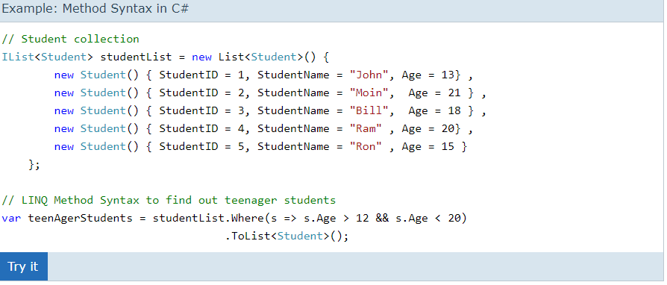

**\*\* Methode Syntax so it’s like calling extansion methode ( where … )**

**\*\* the var can be used to hold the result ot the LINQ query …**

**BUT WHY LINQ ????????????????**

** LINQ IS WITH C# AND VB

**comparing to SQL **OLD LANGUAGE IN 1974** … , LINQ is simpler , and high-level , it’s rather like comparing C# to C++ , we need to work in a modern tidy language and not having to worry about lower-level details is a big win …

*** almost exlusively for querting databases because it’s more productive

** for writing applications , because make maintenance far easier …

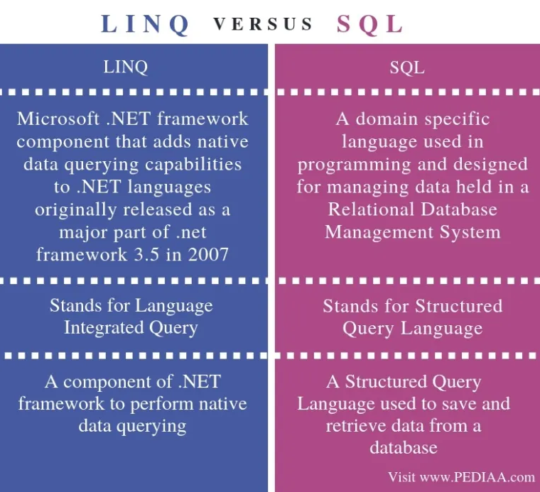

** Before C# 2.0 we had to use a **foreach** (loop for ) to traverse a collection to find a particular objects :

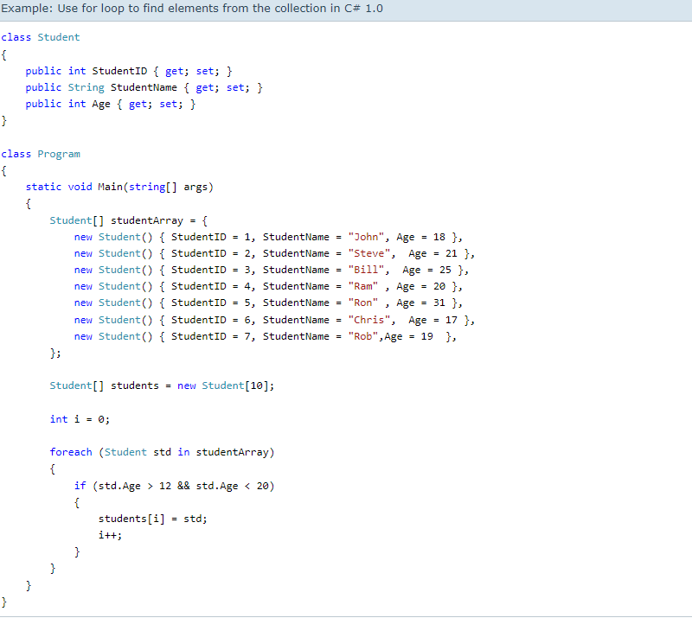

But now we don’t have to do that , we can do like that **thanks to linq query** with a anonymous methodes ( lamda expression ): **so less coding  here!!!**

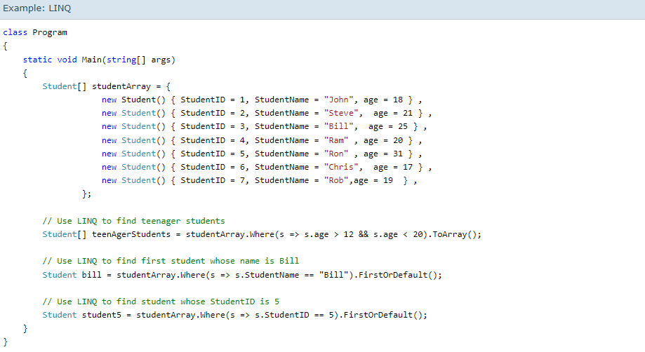

**SOURCE TO C# AND MORE :** [**https://www.tutorialsteacher.com/linq/why-linq**](https://www.tutorialsteacher.com/linq/why-linq)

**** **ToListAsync() : UNE METHODE ASYNCHRONE FOURNIE PAR EF CORE pour executer une requete LINQ asynchrone et retourner ses resultas sous forme d’une liste d’objets**

**using Microsoft.AspNetCore.Mvc;**

pour importer l’espace Aspnetcore pour créer les **controlleures** et les **actions pour une application ASP.NET Core .**

**using Backoffice_ANCFCC.Models;**

importer l’espace de noms Backoffice_ANCFCC.models pour **les classes** afin de representer **les models** de donnes dans l’app

**using System;**

pour importer l’espace de noms système , contient **les classes fondamentales** et **les types de donnees primitifs de .NET**

**using System.Linq;**   
  
importer l’espace de noms System.Linq contient les **classes et les methodes pour interroger les collections d’objets… this namespace includes the following classes and interfaces required for LINQ QUERIES..**

**using Microsoft.EntityFrameworkCore;**

**bach ndkhel la base de donnee**

**importer l'espace de noms Microsoft.EntityFrameworkCore, qui contient les classes pour accéder aux bases de données à l'aide d'Entity Framework Core (EF Core).**

**Tokens : comment authentifier et autoriser des microservices :**

**Les microservices :   
  
*** problemes :**??? les applications sont generalement crees de manière **monolithique** : tous les elements de l’application qui peuvent etre deployes resident dans cette **seule application**. Donc sont **volumineuse** , **dififcile a traiter rapidement** **les problemes qui surviennent .   
  
Solution :**  une approche base sur des microservices .   
**Le but :** decomposer les applications en elements les plus simples , independants les unes des autres… contrairement a une approche monolithique classique …

**\*\*\* Architecture logicielle et approche** … pour developper les applications distribuees et modulaires (divise en modules c’est a dire parties independants developpees , deployees , maintenues separement…

**avantages** : repartire la charge de travail sur plusieurs machines d’où flexibilité dans le développement et la maintenance de l'application

**Les microservices**: fonctionnent en **synergie** c’est-à-dire chaque **microservice fonctionne de manière autonome** pour fournir une fonctionnalite specifique et travaille avec les autres microservices pour fournir une application plus complete …

**Pourquoi cette approche  ?** developper des applications complexes vue les avantages donnes

** Les microservices peuvent etre deployes et mis a l’echelle independamment les unes des autres.   
** On peut maintenir chaque service a part sans affecter les autres services .

** Developpes dans differentes languages de programmation   
** Les autres services continuer a fonctionner meme un service est en panne ..

**L’authentification dans un environnent de microservices :**

**1…. Choix d’un protocole d’authetification :**

Depend des besoins de l’application et de la securite requise …

** Protocole OAuth2 pour les applications Web et mobiles   
** Protocole JWT (JASON WEB TOKEN) pour les API RESTFUL

**2-Créer une service d’authentification** dediee pour gerer le processus d’authentification pour l’ensemble de l’application de microservices … et peut etre appellee par les autres services pour valider demandes d’authentification ….

**3-implimenter l’authentification dans chaque service en utilisant protocole d’authentification choisi**

Verifier la validite des jetons d’authentification et refuser les demandes non authentifiees

**4-UTILISER DE LA GESTION DES IDENTITES ET DES ACCES :** IAM

Des services et des protocoles permettant de gerer et de controller **l’acces au ressources de l’application** … peut aider a gerer les autorisations et **les roles des utlisateures dans les differentes services …**

**5-Utlilisation de la securite des communication ,,** proteger les donnes echangees entre les differentes services( Communication) de l’application en utilisant les protocoles de chiffrement tels que **TLS ( Transport Layer Security )**

**Comment cela ?? :**

l’utilisateur demande authentification lorsqu’il accede a l’application…   
  
l’application redirge l’utlisateur vers le service d’authentification pour qu’il s’authentifie

service d’authentifiction demande a l’utilisateur de fournire nom_user et mot de passe pour authentifier l’utilisateur

si reussi , le service d’authentification **renvoi un jeton d’acces OAuth2** a l’application

l’app utilise le jeton d’acces pour acceder **aux servies proteges**   
  
les services de l’application verifient la validite du jeton d’acces pour autoriser ou refuser l’acces aux ressources protegees …

**EXEMPLE PRATIQUE :**

Lorsqu'un utilisateur se connecte à Facebook, il est redirigé vers un service d'authentification dédié où il peut saisir ses identifiants de connexion. Si l'authentification réussit, le service d'authentification renvoie un jeton d'accès OAuth2 à l'application de Facebook. Ce jeton d'accès est ensuite utilisé pour accéder aux services protégés de Facebook, notamment la gestion des amis, les publications, les commentaires, les messages, etc.

**Authentication in Microservices :**

**Generals :**

**the difference between authentication and authorization :**

**Both terms will come to mind when talking about **securing applications …**

** **authentication** : the idendity of the user is checked to provide access to the system **(who you are ?)**

** **authorization** : the process of verifying if the authenticated user is authorized to access specific information or be allowrd to execute operation and determine which **permission the user has ..**  **(what you can do ??)**

1//// **AUTHENTICATION service in traditional Architecture :**

** When enterprises developed services .. all the functions were implemented in the same application ,,,

***colled **monolithic model**… a single unit ..

**the only advantage of a **monolithic application** is that it is easy to deploy and itereate ….

2 //// **AUTHENTICATION on in microservice architecture :**

**Why : ???**

**\*\*To build a secure microservices-based application**

**\*\* Involves : implementing authentication protocols , validating access tokens , enforcing authorization rules , securint communicaion …..**

**\*\* In a microservices based application, each microservice should be responsible for authenticating incoming requests .**

**\*\* acheived by implementing an authentication protocol on each microservice like OAuth2 , Open2ID , Connect or JWT**

**\*\* EACH microservice should validate the access token and ensure that the access token is valid , or has not expired …**

**\*\***

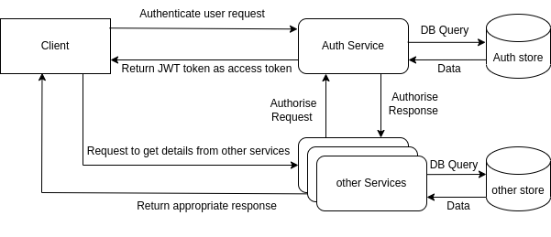

***\*\* we have three authentication methods to choose from :***

**a./// implement authentication on each microservice**

USE A **SHARED AUTHENTICATION** LIBRARY LOADED ON EACH MICROSERVICE .

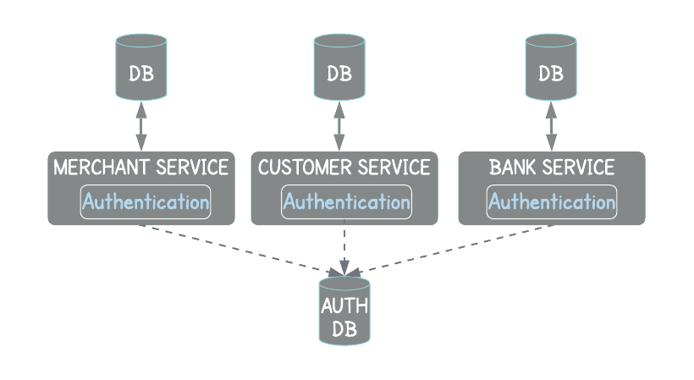

**b. /// global authentication and authorization service :**

talk with all the services to specify what rule are allowed for the user … but this increases the **latency** ( the delay before a transfer of data begins following an instruction for its transfer … وقت الإستجابة )of processing requests ..

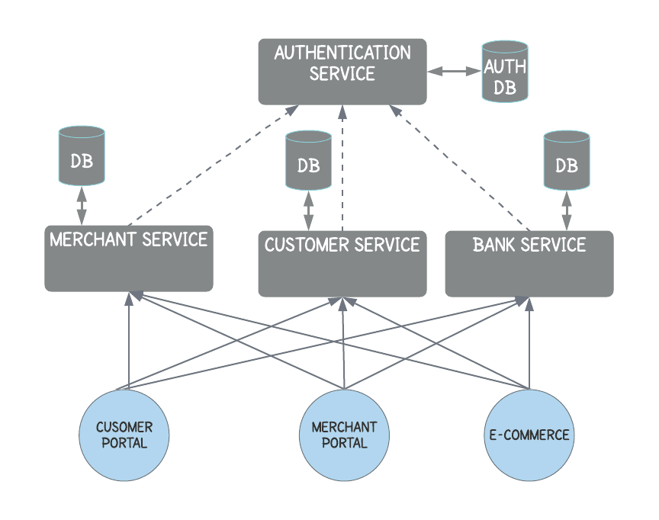

**C// global authentication (API GATEWAY) AND AUTHORIZATION PER SERVICE**

**\*\*\* API GATEWAY IS A SINGLE ENDPOINT ENTRY b7al chi nihaya dyal lbedya d chi haja comme une porte**

**\*\* PROVIDES FLEXIBILITY BY ACTING AS A CENTRAL INTERFACE FOR CLIENTS USING THESE MICROSERVICES .**

**\*\* INSTEAD OF HAVING ACCESS TO MULTIPLE SERVICES , CLIENT SENDS A REQUST TO THE API GATEWAY RESPNSIBLE FOR ROUTING IT TO THE DOWNSTREAM SERVICE (SERVICE CALLED BY ANOTHER SERVICE)**

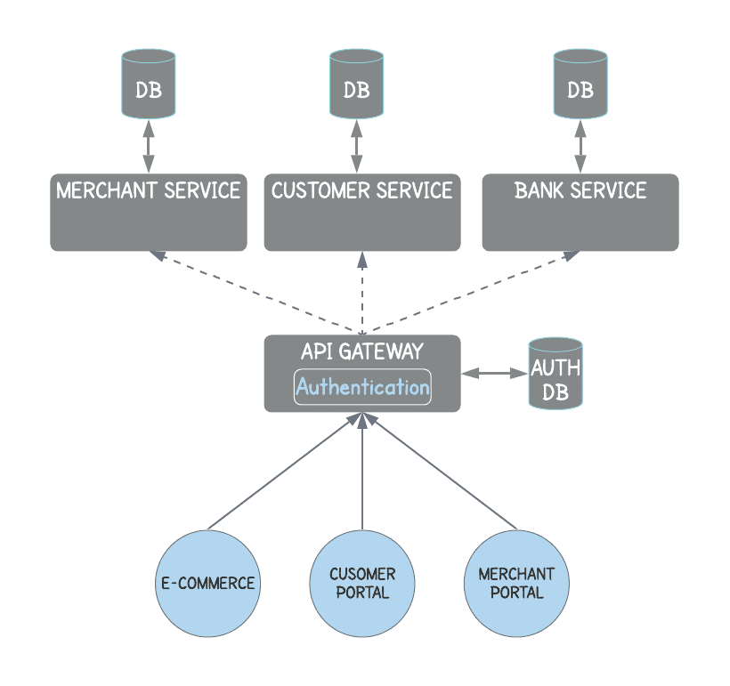

Biiig problem….. 7yeed dik concous id men lclass model dyalha concours   
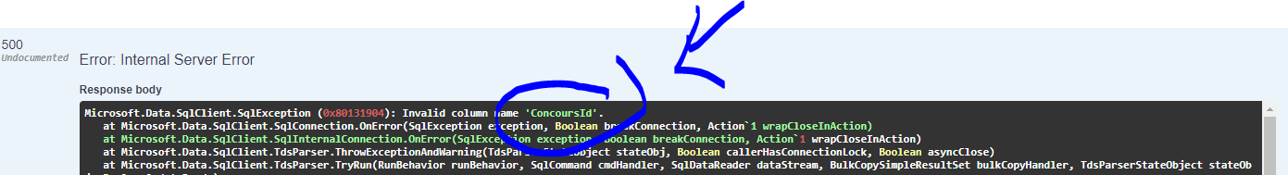

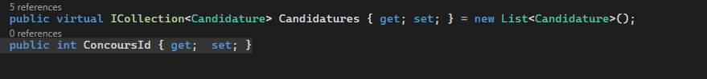

7yeed dik ConcoursId hit makaynach f classe candidat model kayl9aah kaytbloka hit makaync fla base de donne ye3ni rah kaytwassel m3a models 3ad kaymchi la base de donne

Lblan dyal objects f les api ghir bach anank mat7tajch dir classse wila dertiha rwina kehla f la base donne li mafihach asaln donc c’est mieux hakda katkhliih anonymous mjhouul kaytcrea fel khafaaaae

**Note ;;;**

**The ?. operator is a shorthand way of writing an if statement to check for null before accessing a property or method:**

**Circular problem in the APII**

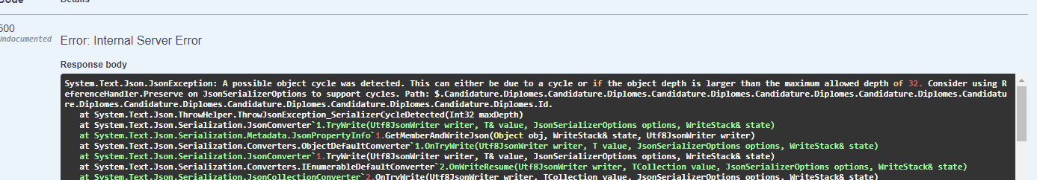

YOU NEED TO ADD THIS SERVICE IN PROGRAMS.CS



**SQL PROBLEME : CONFLITCT IN DATABASE :**

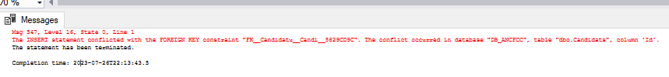

**OR JUST ADD A VALIDE CANDIDATURES AND VALIDE CONCOURS ID FROME THEIR ORIGINALES TABLES …**

**RANDOM REFERENCE AUTO GENERATED :**

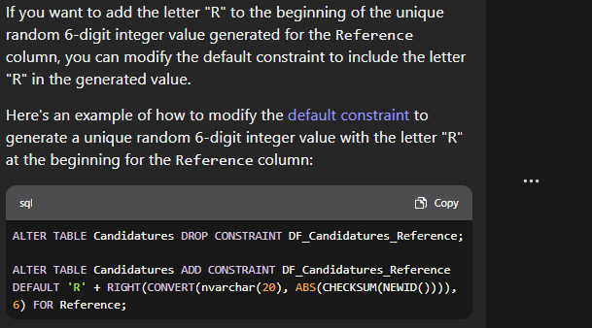

**HADA KEYTI 7ERF R MORAH 6 L2AR9AAAM , GENERA AUTOMATIQUE FACH KADKHEL UNE NOUVELLE CANDIDATURE**

**Arabe solution rows :**

**INSTALL DEFAULT COLLATION FOR THE A LANGUAGE**

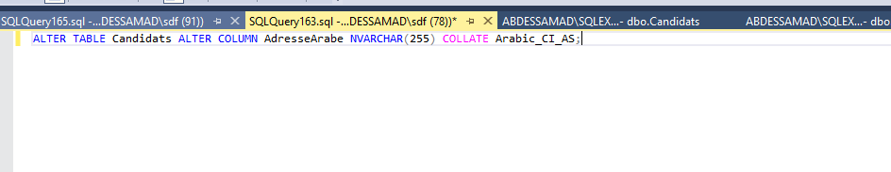

**JWT : JASON WEB TOKEN :**

**IS A METHOD TO SEND DATA TO SERVER AND RECEIVE DATA SECURLY**

**B7AL CHI KHEZNA FIHA DATA OSADHA BSAROT ,,, SAROT HOWA JWT**

**JWT KADDAR F AUTORISATION HOMA SALA7IYAT LI ENDEK APRES DAK LOGIN**

**B7AL L’IDEE DYAL FACEBOOK Wach KADDER NDIR LIKE COMMENT OLA LA …. YE3NI LES ROLES DYALEEEEK … O MACHI AUTHENTICATION .., (PROCESS DYAL NDKHEL LSYSTEME OLA NKHREJ MENNO …. )**

**JWT KADDAR F AUTORISATION NOT AUTHENTICATION …**

**9bel JWT KAN ENDNA LE PROCESS SUIVANTES WLI KATN BA9I LI KAYSTE3MLO LI HOWA :**

**ANNA CLIENT OLA BROWSER KAYSIFT post li fih email and password l server had server kaysrtocker had les infos f session f wahed blassa katsemma server memory w kaysift l’id dyal session ID come un cookie hit howa lli unique pour kola user … donc daba safiii yla kan true rah user dkhel o authentifie alors daba user aybda yconsommer fles fonctionnalite dyal site par exemple ydir like , comment , ….**

**Mais a chaque fois kaydir hakda ,,, rah fel backround par exemple dar like alors rah client (browser) kaysft request m3a dak session id cookie li te3taaah bach server yverifier wach endo l’acces ldik foncionnlity par exemle o kayred server l dak client Response dyalo 3la hssab ach dayer nta fel back end**

**DABA AVEC JWT : ???**

**Bima annaha kaddar f autorisation donc tma aykoun la difference …   
apres login ye3ni apres maghadi tdar post l server ….…**

**Server aycreer jwt for the user with secret li aykoun unique o machi ID b7al chh7al hadi o kaysift lik JWT ysiftha l browser (client) n9der nkhzno fima bghit cokies , memory , storage …**

**Daba user bghi ydir like fel backround ghadi ykoun : send jwt l server wach endek le droit dir like … ye3ni kaddar l verification ldak jwt Bach dir dak like ola la ye3ni pour chaque fonctionnalite like , comemnt , … and server ghadi ysift lik response 3la hssab nta achdayer fel back si OK donc rah endek le droit dir like w ghadi ydar sinon atl9a reponse b7al lblan dyal fach kat7dder men facebook madirch like exemple**

**Strudcture of The JWT JASON WEB TOKEN :**

**Compose ola katl9a fiha header o payload o signature o kolhoum des objets :**

**Header : kaychffer data li kayna f payload**

**Exemple :**

**{**

**‘ alg’ : ‘HS246’ //ALOGRITHME HOWA : TYPE DYALO LI KHDEMNA BACH NCHEFROO BIH DATA …. O HOWA LI ME3ROOF BZAAF HS246 MAIS KAYN BZAAF**

**‘typ’ : ‘JWT’ //CONSTANTE ,,, HADA TYPE DYAL SECURITY LI HOWA JWT …**

**}**

**PAYLOAD :**

**SUB : ADRESSE L3ONWAn DYAL HAD DATA**

**NAME : DYAL DATA**

**ADMIN TRUE OR FALSE ?**

**IAT : EXPIRED DATE FOA9CH ATSALI**

**EXEMPLE :**

**{**

**‘SUB ’ : ‘123456789’   
‘NAME ’ : ‘George white’**

**‘ADMIN ’: true ,**

**//the user represented by the payload has administrative privileges and can perform administrative tasks, such as managing other users, modifying system settings, or accessing sensitive data.**

**‘IAT ’: 26422836292**

**}**

**O Signature ;**

**Endana header fih type dyal algo o payload fih data o signature howa lghlaaf li 7ami payload b7al gelti header o payload wast signature ….**

**Howa kaydir 7imaya l deux les deux li déjà me7myiin …**

**Structure dyalo dayra hakda : atl9a westo <header> <payload> o <secret key> hanta chefti bli kolchi dakhel westha donc …**

**Mais chanhowa secret key :**

**hadak secret key kaykoun déjà server bach y9der y7edded client dyalo howa w y3erfoo donc client kaysift secret key li kaykoun f server kaydiro admin bach jason li jaya dkhel server w yt3amal m3ah donc machi kolchi 9adder ydir actions avec secret key …**

**li m3ah secret key howa ydkhel lserver…**

**donc rah signature mes2ool 3la security w khlass security fo9 security …**

**chwiya dial pratique :**

**dkel lsite dyalhoum jwt.io :**

**hadik base64Url bach ndiro hashing ldakchi li entre parentheses**

**dakchi li f encoded howa hashing lidar 9bel dot .**

**rah mokin tmodier f signature w rahh kolchi bayn f les couleurs bach madokhch ..**

**TOKEN  :**

**Howa rah string …..**

**GELNA DÉJÀ RAH SERVER KAYJAWEEB W KAYSIFT CHI HAJA LI HIYA JWT W BDEBT KAYSIFT TOKEN ….**

**SERVER KAYCREER JWT ALORS RAH KAYCREER TOKEN TAHOWA W KAYSIFTO**

**LI FIH TROIS PARITE LEWLA HEADER MAIS KAYCHEFRA (haching) kaywelli encoded o hta la partie 2 w hta la partie 3 li homa header o payload o signature**

**Kayjme3houm d dot .**

**Ofach tnebghi ndir une action like ola chi haja farah kansift tani token li fiha dok li trois parties dyal jwt …**

**Conclusion :**

**Rah kaysift jwt labess token bach hacker ola chi haed ma3rofch data hadi hiya security …. Neftardo annaho wakha 3aref no3 dyal algorithme farah khasek signature key bacha hakda dir decoded w tchuff data … donc security fort dyal had secret key !!!**

**chwiya dyal pratique : bah tfheeem ;**

**dkhel par exemple : base 64 decode encode :**

**hez men site le9dim dyal jwt header o dir lih decoded ghadi tel9aha hiya nit jwt type algorithme …**

**hez daba payload o ndiro decode ghadi ytle3 lik dakchi**

**hez daba signature ghadi ytle3 lik klaam ga3 mamfhouum !!! hit la bghiti tfekko khassek ykoun endek secret key darori !!! donc vooillaaaaaaaaaaaaaaaaaaaaaaaaa**

**daba dir l3amaliya l3ekssiya ched header odir lik encode ghadi ytle3 wahda kher hit kaykoun 3echwa2ii aslan donc logic hadii**

**ASP NET CORE :**

**1**

**DEKHEL CLIQUE DROIT 3LA PROJET MEN DIK EXPLORER O DIR EDIT PROJET FILE  GHADI TCHUF HNA :**

**F PROPRETY GROUPE KAYN FRAMWORK BACH KHDDMA .**

**ITEM GROUP FIH GA3 PACKAGES LI KHDAMMIN BIHOUM F PROJET**

**CLIQUE DROIT 3LA DEPENDCIES MEN DIK EXPLORER TAHIYA GHATBYEN LIK LES PACKAGES LI RAK KHDDAM BIHOUMM**

**MEN DIK APPLUNCHSETTING F PROPRIETES ATE3REF BLI MOMKIN ANNAI NDIR RUN L APPLICATION B DEUX METHODE : IIS Express ou bien the default li howa mssmi b smiiiya dyal application dyalek momkin tbdel le nom tchuf authentification chkun momkin ydkhel…**

**Le dossir** [**www.root**](http://www.root) **fiha ay haja static files b7al css, javascript, libraries , o rah mafihach c# code attention …. Ye3ni tzid imaages ay haja static farah hna**

**Appssettings strings : all your applications secrets….. add all of the connection strings like api keys , sendGridkeys , paymentskeys , or any static keys that you want to save …**

**Programs .cs :howa li me2ool 3la running the application , hna fin kandiro dependancy injections b7al register database li kenna déjà derna bach ytconencta m3a la base de donne , ola email ,… w hadchi kandiroh bin builder.seervices et var app = builder.Build()**

**Hadakchi li teht buil kaytsemma pipeline li kaykon fiha middlewares … ye3ni kifach app ghadi testajeb l chi weeb token , b7al les tubes , kadoz men west had tube browser kaysift request , West had tube endna AUTH , MVC , staticfiles**

**Int the pipeline endna des middlewares , kaybdaw b app.X b7all dyal auathentification … the order hna rah moeheem bzaaaf attention , et aussi hna kaykoun app.UseAuthetification() 9bel men app.Authorization () tres important  ;**

**3ad fllekher app.mapControllerRoute( name … )**

**Hada fih the default ye3ni lamakyn hta chi haja provided li howa default f name and it should call the index action methode for example , and go to controllerHomme to call it**

**Routing in MCV ???**

**CONSIDERED AFTER THE DOMAINE NAME**

**FOR EXAMPLE :** [**HTTPS://LOCALHOST:55555/CATEGORY/INDEX**](HTTPS://LOCALHOST:55555/CATEGORY/INDEX)

**THAT’S MEAN THE CONTROLLER IS CATEGORY AND ACTION IS INDEX AND ID IS NULL , BECAUSE THERE IS NOTHING AFTER INDEX (… INDEX /3 )**

**THE PATTERN defined in app.MapControlllerRoute() in programms cs IS LIKE THAT :**

**HTTPS://LOCALHOST:5555/{Controller/{Action}/{id}**

**The id is optional**

**If the action is not set so the action is index automatically , like this**

[**HTTPS://LOCALHOST:55555/CATEGORY/**](HTTPS://LOCALHOST:55555/CATEGORY/)

**If the url is like this :**

[**HTTPS://LOCALHOST:55555**](HTTPS://LOCALHOST:55555)

**Hada howa le but dyal dik name : default li kayna app.MapControllerRoute()**

**Bach la kan khawi ye3ni url hakdak ye3ni default alors ghadi y 2affiche la page index men home controller ,**

**If the url is like this :**

[**HTTPS://LOCALHOST:55555/Home/INDEX**](HTTPS://LOCALHOST:55555/Home/INDEX)

**so programme hakifach kheddam aymchi l hommeComtroller aydkehl lih ay9lleb 3la index method li fiha par exemple return View () ye3ni aydkhel ldossier view w ydkhel l Homme w yjjbeed index.html , w yfetha**

**shared folder used for partielview , a view that you can call within a view in multiple places in the application and also te undescore layout , ,,,,**

**we have layout.cshtml inside we have header and , div , footer , javascript , head , body , ….**

**Hadchi li f shared folder kan3eyto lih kolma htajinah f les pages dyalna , bach blach kola merra nketbo dak lcodeo n3awdooh , kat3yet lo f les pages dyalek b dik @ o déjà katkoun dayrha hta f les partial views dyalekk …**

**O endna viewImports li fih the global namespace right here ye3nii chi namespace dema mesta3mel b7al using _Db_ANCFCC.MODELS …. bach matb9ach kola merra tktebhoum f les controller s,, li endek ,,,**

**Mais le plus impostant howa tag helper  :**

**Khdaw concept men angular li kaytsmmaw fih angular directives ,,, o react hit l9a najah kbir ,**

**Kifach lien is provided on the navigation  , ??? by using tag helper anl9aw**

**La line f layout.cshtml :**

<**a** class="nav-link text-dark" **asp-area**="" **asp-controller**="Home" **asp-action**="Privacy">Privacy</**a**>

**Li fiha asp_action o asp controller , so this is it how provided ,**

**View start : default master page Layout = -layout ye3ni aweel haja atban fach antapper lien sans controller sans action**

**ACTION RESULT :**

**F MVC KANDIRO IACTIONRESULT Index ()}{**

**Return View() ;**

**}**

**IActionResult : IS A generique type that implements all of the other return types …**

**ViewResult Index : to return View … specifique**

**Endna type lakher li howa razor page appplication o kayn hta mvc li khdammin ghir bach tfhem la differenee f razor page application**

**Andiro :**

**Public PageResultt OnPost (){**

**Return Page() ;**

**Bach nreddo page**

**}**

**Action result is a parent class for many of the derived classes that have associated helpers ….**

**HAD LA METHODE MAKATDIHACH F WACH F L’IMPLIMENTATION LI RETOURNEE GHADI T3AMEL M3A AY TYPE GHADI YRJE3 F RETURN …**

**IN MVC : EXAMPLES :**

**PUBLIC IACTIONRESULT INDEX (){ If (true) {retrun RedirectToAction (‘INDEX’) ;**

**}RETURN VIEW() ; //ZE3MA HAD LVIEW LI NTA FIHA DABA}**

**SIGNIFICATIONS :**

**public DateTime? DateModification { get; set; }**

**?  : indicates that the variable of that type can also have a value of nullwhich means it can either have a valid DateTime value or a null value.**

**The Administrateur property is a nullable reference type.**

**This is useful when you don't have a value for the property yet, or when the property is optional and does not need to be set.**

**Endna bzaf dyal les attrunutes b7al :**[Key]

public int Id { get; set; }

[Required]

public int? CandidatsId { get; set; }

**public virtual Administrateur? Administrateur { get; set; }**

**used to mark a method or property as overridable by derived classes**

**ye3ni another class can inherit the administrateur table , that mean that i can override the object administrateur proprty because it’s type is administrateur and provides it’s own implementation . so :**

**The virtual keyword in the Administrateur property indicates that the Administrateur property can be overridden in a derived class.**

* **: kayt9ra goes to**

**Yla 9aditi les models f modals w bghiti ttcreer base de donne sql server ye3ni bla mat3awed temchi t9adha f sql server managment**

**Adkhel nuget package manager o executer migrations :**

**Add-migration AddCandidatureToDatabase yla awal merra farah ytle3 lik error khassek t2anstaller wahed package li howa MICROSOFT…. /// .TOOLS**

**APRES ATLEE3 LIK BUILD SUCCECED …**

**AYKOUN DOSSIER MIGRATION FIH MIGRATION DKHEL LIHA FIHA DEUX FONCTIONS UP ET DOWN :**

**UP : FIHA CRÉER TABLE ET LES COLUMNS LI EDNA F MODALS …**

**APRES YLA KAN KOLCHI MZ1 DIR F LA COMMANDE update-database**

**Build succeced ..**

**Daba chno tra ???**

**Ghdi ytconnecta lserver li kayn f appsetting Json hit tma kayn server li 3titih donc ghadi ycreer la base de donne en se basant 3la servername li 3titih wli kaykoun une fois t7eel l’application SSMS ,**

**PROCESS BACH ANNAK TCREER VIEW MODEL ET CONTROLLER :**

**AWAL HAJA CRÉER LA METHODE F WEST CONROLLER :**

**SMIYA DYAL LA METHODE TKON NEFSSA SMIYA DYAL LVIEW LI GHADI TCREER MENBE3D** public async Task<IActionResult> Index()

Async : katssere3 l’istijaba dyal web application, en effet l’operation query katconsumer lwe9t alors une kandiro async ye3ni synchrounous katkhelli server ydir other request et au meme temps kaytessenna operation li tlebna tkmeel ..

Ye3nii : katkhelli l’method to perform non-blocking operations, leading to better server responsiveness and performance.W

W KAKHELLIK t utiliser await : wli kate3ni attendre la fin de l’operation asynchroun sans bloquer l’execution de tread actuel (sont des unites d’execution independantes qui s’executent separament au sein de meme process ) , permet une execution en parallele dans un programme , d ou ameliorer la efficacite ..

IActionResult : indiquer le resultas dyal http request et la generation d’une reponse http ...

TASK : ye3ni la methode raha asynchrounous … automatiquement faire des operations non bloquantes…

Donc Task<IActionresult> kat3ni anna la methode retourne une un object task asynchroune et donc produire une resultat en implementant l’interface IactionResult..

**CNC : Par conséquent, avec Task<IActionResult>, votre méthode d'action est capable d'exécuter des opérations de manière asynchrone, ce qui améliore la capacité de réponse du serveur et permet de renvoyer une réponse appropriée à la requête HTTP. C'est un pattern couramment utilisé dans les applications ASP.NET Core pour améliorer la performance et l'extensibilité.**

Les méthodes asynchrones permettent au serveur de continuer à traiter d'autres requêtes pendant l'attente d'opérations potentiellement longues.

**.Include(c => c.Candidats)** : ye3ni katgol L EFCOE inclut moi et dkhel liya les donnes dyal la table Candidats mnin tebcghi tchargeer les entites dyal la table candidatures hit kayn 9bel menha : var candidatures = await _DB_ANCFCC.Candidatures

**Donc maghadich nhtajo des requetes suppplimentaires dyal SQL DONC AVANTAGE TRES IMPORTANTS !!!!!!!!!!!!!!!!!!!1**

.ToListAsync() : METHODE ASYNCHROUNE UTLISER DANS EFCOE FAIT PARTIE DE SYSTME.DATA.ENTITY , M3A LES REQUETES LINQ … BACH NRED LES REDULTAS SOURS FROME UNE LISTE ET LE BUT HOWA ASNCHROUNE, OPERATION NON BLOQUANTE ….

return View(candidatures); YE3NI SIFTLIYA LES RESULTATS DYAL LA VARIABLE CANDIDATURES L VIEW ,, WLI GHADI TCHARGA BHAD LES DONNES LI 3TITIHOUM F CONROLLEER

.Select(c => new CandidatureViewModel HADI F CONTROLELR DONC KAT3NII ANNAK CREATII NEW MODEL LI HOWA LHYKEEL W SHAP B7AL LES BONS DYAL L’APPLICATION

W LI FIAH LES VARIABLES LI BGHITIHOUM TYCHAFOO W TKHDEM BIHOUM :   
 public class CandidatureViewModel

{

public string Reference { get; set; }

public string CandidatNom { get; set; }  
……. Etc

**RED LBAL LHAD LA FAUTE :**

**return View(candidatures);** YLA KANT VIEW N’EST PAS DEFINIE FARAH LE PROBLEME C’EST QUE L VIEW KHASS T HRITER MEN CONTROLLER O MACHI CONTROLLERBASE ..

**\*\* rjee3 daba lcontroller dyalek sir la methode li kayna f controller cliqur droit 3la nom dyal view li bghtii et add view ye3ni associeter daba dak l’view m3a lcontroller dyalha …**

**Alors fhad lview katheet lhtml dalek li bghitih ybaan katbda hna b :**

**@model List<Backoffice_ANCFCC.Models.CandidatureViewModel>**

**Ye3ni anan bghti nred une liste dyal les objets li defifni f candidatureviewmodel …**

**@if (Model.Count > 0) :**

Model : kat3nni les donnes passes men controller vers la vue si oui rah kber men zero … dakchi 3lach kayn dak lien bin controlelr o view b cliqur droit w li kaydik nichan ldak la variable li derti f controller

**\*\* Apres matnsach tmechi layout li f dossier shared o tmodifier : par exemple :** <li class="nav-item">

<**a** class="nav-link text-dark" **asp-area**="" **asp-controller**="Agent" **asp-action**="Index">Candidatures</**a**>

</li>

Ana enddi controlelr Agent ol action smitha Index…

Chwiya dyal angular :

BACH TNAVIGUER MEN PAGE PAGE FARAH LI RESPONSABLE HOWA APP ROUTING :

KATHET FIH LA PATH LI BGHITI TCUFHA : { path: 'candidature/:reference', component: CandidatureDetailsComponent }

O k’timporteh lfoo9 f imports   
import { CandidatureDetailsComponent } from './candidature-details/candidature-details.component';

**Khdemti bchi haja men dakchi li importiti khassek dekhli f ts li m3a html attention ….**

**http params hit ghadi dwzz chi haja comme parametere**

**dayman lier variable li raj3in men json b7al variables dyal apii : probleme dyal tableau li search**

**yla biti chi component tcharkha ka declariha w exportiha f shared**

**o ghathez daba shared o theto fl module li bghiti tkhddem fiha dik lcomponent o khayysssek fl module importiha**

**blam dyal get makatbgich t 2amplimenta solution howa : darori dir component f shared yla kenti dertiha f ng on init //**

**server dyalek f la bd ;** ABDESSAMAD\SQLEXPRESS

**L’AUTHENTIFICATION :**

**1…INSTALLING ;**

**Install-Package Microsoft.AspNetCore.Authentication :**

mettre en œuvre des fonctionnalités d'authentification sécurisées dans votre application ASP.NET Core, ce qui est essentiel pour protéger les données et les ressources sensibles de vos utilisateurs.

fournit les bases pour mettre en place différents mécanismes d'authentification, y compris l'utilisation de cookies, de jetons JWT (JSON Web Tokens) et d'autres méthodes d'authentification personnalisées… en va utiliser JWT…

permettent de configurer et de gérer l'authentification pour votre application web.

**Install-Package Microsoft.AspNetCore.Authentication.JwtBearer :**

enable JWT (JSON Web Token) authentication in ASP.NET Core applications.

**NOTES :**

**LE PROTOCOLE http EST SANS ETAT CAD STATLESS PROTOCOL …**

**PAS DE LIENT AVEC LES REQUETES PRECEDENTES OU SUIVANTES ..**

**CHAQUE REQUETE EST TRAITEE D’UNE MANIÈRE INDEPENDANTES …**

**COMMENT LE SERVEUR GERE LA CONNEXION ENTRE PLUSIEURES REQUETES SANS DEMANDER A L’UTILISATEUR DE SE RECONNECTER LORS DE CHAQUE REQUETE ….**

**LA SALUTION EST JWT ….. C’EST GRACE A LUI …**

**SE CONNECTER 🡺 SERVEUR , VERIFCATION LOGIN ET PWD => LA BASE DE DONNE => DONNER LE OK AU SERVEUR => SERVEUR GENERE TOKEN JWT VIA UN CLE SECRETE =>**

**JWT AU CLIENT => LE CLIENT DONNE UNE REQUETE AVEC UN JWT DANS L’ENTETE (TOUJOURS… ) => LE SERVEUR VALIDE JWT VIA LA MEME CLE SECRETE ET TRAITEMENT DE LA REQUETE .. => GENERER LA REPONSE .**

**JWT CONTIENT 3 PARTIES … HEADER .. PAYLOAD … SIGNATURE …**

**PROBLEME :**

System.Reflection.ReflectionTypeLoadException: 'Unable to load one or more of the requested types. Could not load file or assembly 'Newtonsoft.Json, Version=9.0.0.0, Culture=neutral, PublicKeyToken=30ad4fe6b2a6aeed'. The system cannot find the file specified.' in this line of prgrams.cs : app.MapControllers();

**SOLUTION :**

Solution : install **Newtonsoft.Json**

**The probleme :** The system is unable to find the specified file for this assembly.

**2…:**

**Class responsible for handling user authetication and autorisation :**

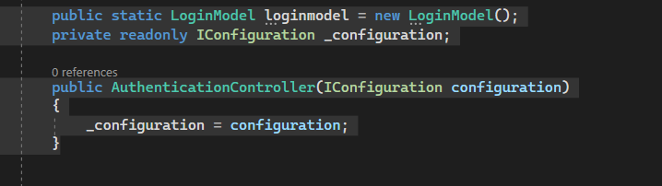

**public static LoginModel loginmodel = new LoginModel();**

**Create a static instance of the LoginModel class to store login information for the current instance of the AuthenticationController Class…**

**private readonly IConfiguration _configuration;**

**private field holds an instance of the ICONFIGURAION interface to access configuration settings like applicaiton settings or connections strings defined in the configuration files of the application …**

**because :**

**the code needs to generate JSON WEB TOKENS FOR AUTHENTICATION … IT REQUIRES SECRET KEY WICH IS STORED IN THE APPLICATION’S CONFIGURATON SETTINGS …**

**CONNECTIONS STRINGS ALSO .. NOT DIRECTLY USED IN THIS CODE IT’S FOR INTERACTING WITH THE DATABASE BUT STILL YOU CAN USE THIS APPROCH ..**

**public AuthenticationController(IConfiguration configuration)**

**CONSTRUCTOR OF THE AUTHENTICTIONCONTROLLER CLASS , ACCEPTE AN ICONFIGURATION PARAMETER INJECTED VIA DEPENDENCY INJECTION ASSIGNED TO THE _configuration FIELD , TO ALLOW THE CONTROLLER TO ACCESS CONFIGURATION SETTINGS THROUGHOUT ITS METHODS ….**

**NOTE : THE DEPENDENCY INJECTION : SOFTWARE DESIGN PATTERN GIVE MODULARITY IN APPLICATIONS … THE ROLE IS :**

**INSTEAD OF CREATING AND MANAGING DEPENDENCIES WITHIN A CLASS ,**

**THE NECESSARY DEPENDENCIES ARE INJECTED INTO THE CLASS FROM AN EXTERNAL SOURCE… SUCH AS HERE : ICONFIGURAION INTERFACE PROVIDE ACCES TO CONFIGURATION SETTINGS : APP SETTINGS AND CONNECTION STRINGS …**

**OVERALL , BY ACCEPTING AN ICONFIGURATION PARAMETER THROUGH DEPENDANCY INJECTION , THE CODE ACHIEVES BETTER SEPARATION OF CONCERNS AND IMPROVED MAINTAINABILITY …**

**3…:**

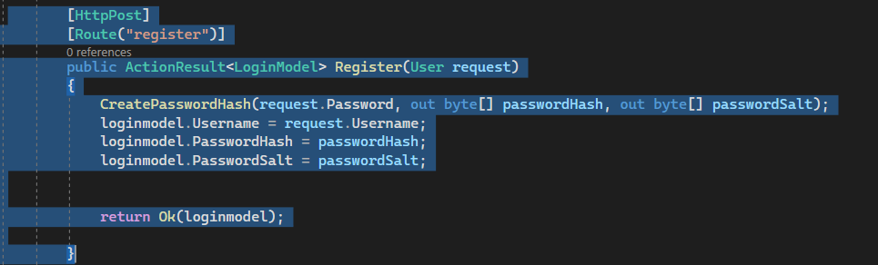

**public ActionResult<LoginModel> Register(User request)**

**METHODE EXPECTS A USER OBJECT CONTAINING REGISTRATION DETAILS (USERNAME AND PASSWORD ) AS A PARAMETER AND RETURNS AN ACTIONRESULT<LOGINMODEL>**

**IT MEANS THAT IT RETURNS AN ACTION RESULT THAT ENCAPSUATES AN INSTANCE OF LOGINMODEL , SO THE METHODE PROVIDE BOTH DATA (INSTANCE OF LOGINMODEL) AND ADDITIONAL INFORMATION BECAUSE OF THE ACTION (http STATUS CODE , HEADERS….) TO BE SENT BACK AS THE http RESPONSE TO THE CLIENT THAT MADE THE REQUEST …**

**CreatePasswordHash(request.Password, out byte[] passwordHash, out byte[] passwordSalt);**

**CREATE A PASSWORD HASH AND SALT BASED ON THE PROVIDED PASSWORD..**

**AND AFTER LOGIN.MODEL.USERNAME .. WE STOCK THE INFORMATIONS TO THE LOGIN MODEL INSTANCE**

**WHY PASSWORD HASH AND PASSWORDSALT ? :**

**PASSWORDHASH : METHODE FOR HASHING**

**STORING THE PASSWORDHASHES INSTEAD OF ACTUAL PASSWORD ENHANCES SECURTIY , EVEN IF THE HASH IS STOLEN , IT IS DIFFICULT FOR AN ATTAKER TO KNOW THE ORIGINAL PASSWORD…**

**WHEN A USER LOGS IN , THEIR ENTERED PASSWORD IS HASHED AND COMPARED TO THE STORED HASH …**

**THE PASSWORD IS HASHED USIG A CRYPTOGRAPHIC HASHING ALGORITHM SUCH AS BCRPT , SHA-256… IN OUR CASE WE USE HMACSHA512…**

**BUT HOW I KNOW IT THAT I USE HMACSHA512 ?**

**IN THE CODE I HAVE THIS : ??**

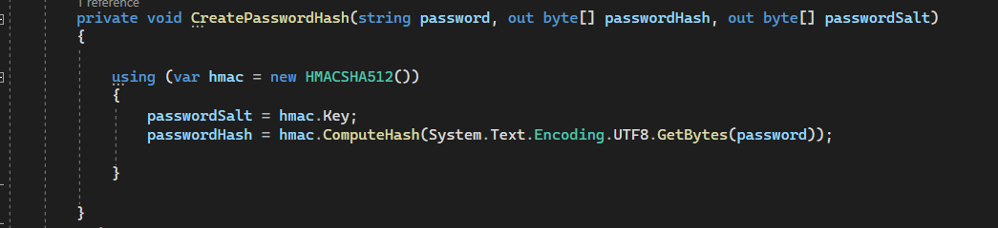

**PASSWORDSALT : RANDOM DATA GENERATED FOR EACH USER COMBINED WITH THEIR PASSWORD BEFORE HASHING .**

**SALTING ADDS A LAYER OF PROTECTION AGAINST DICTIONARY ATTACKS AND BRUTRE-FORCE ATTACKS.**

**THE SALT IS STORED ALONGSIDE THE PASSWORD HASH AND BOTH ARE USED TO VERIFY THE USER’S CREDENTIALS DURING LOGIN ..**

**BOTH : BEST PRACTICE FOR SECURELY STORING USER PASSWORDS IN DATABASE… TO PRETECT USER DATA EVEN IF THE DB IS COMPRIMESED .**

**A USER LOG IN ??**

**THE PASSWORD COMBINED WITH THE SALT =🡺 RESULT IS SALTED PASSWORD IS HASHED**

**THE HASHED SALTED PASSWORD IS COMPARED TO THE STORED PASSWORD HASH IN DB**

**IF THE TWO MATCHE , THE USER LOG IN ..**

**SOOOO**

**STORING PASSWORDS DIRECTLY IN THE DATABASE IS CONSIDRED INSECURE…**

**INSTED THE BEST PRACTICE IS TO STORE PASSWORD HASHES AND PASSWORD SALTS…**



**THE MODELSTATE IS TO RESPECT THE MODEL AND NOT ALLOWS THE ACCESS UNTIL THIS CONDITIONS ARE ALLOWED :**

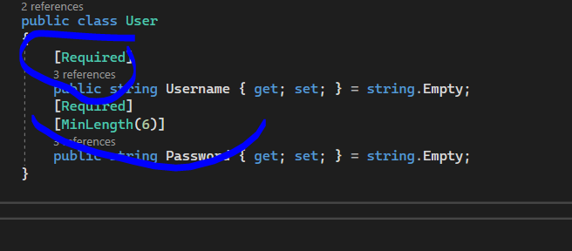

EN RESUME CHUFHA COMME TRY CATCH BLOCK HHHHHHHHHHH

**CONCEPTE TRES IMPORTANTE: LOGGERS ;**

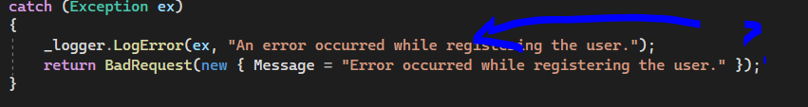

**LOGGER :**

**USE TO LOG AN ERROR MESSAGE WITH DETAILS EXCEPTION . (THE VARIABLE EX NOW IS USED … YEEEEEEEEEEY )**

**COMMON PRACTICE IN SOFTWARE DEVELOPMENT TO HELP DIAGNOSE AND TROUBLESHOOT ISSUES ..**

**WHEN I WILL SEE THE ERRORS ? HERE :**

**I INTENTIONALLY DO AN ERROR INSIDE TRY :**

throw new Exception("An error occurred during registration.");

**AND THIS IS THE RESULT IN THE CONSOLE :**

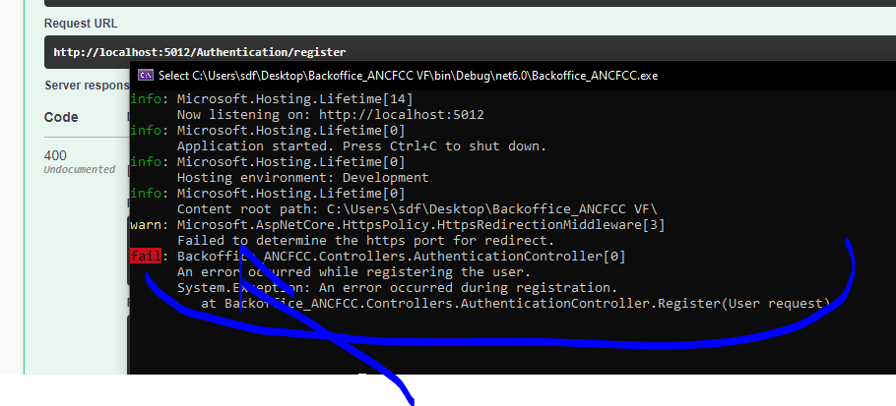

**YOU SEE IT MAKE YOU KNOW THE ERROR DIRECTLY WHERE IT IS !!!**

**SOOOOOOOOOOO :**

**I want to save it in text file so that when i get lost i back to it  , but the console it’s gone after close the program and console !!!**

**So : STORE LOGS IN TEXT FILE ;**

**IN PROGRAMS.CS ADD THIS :**

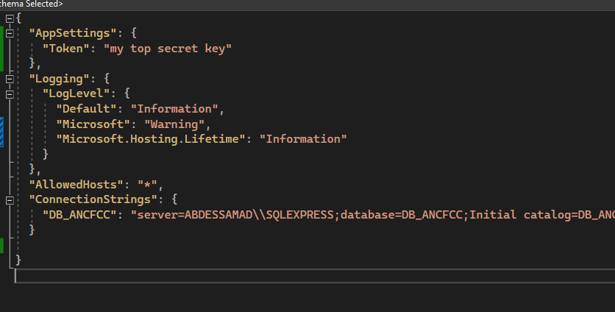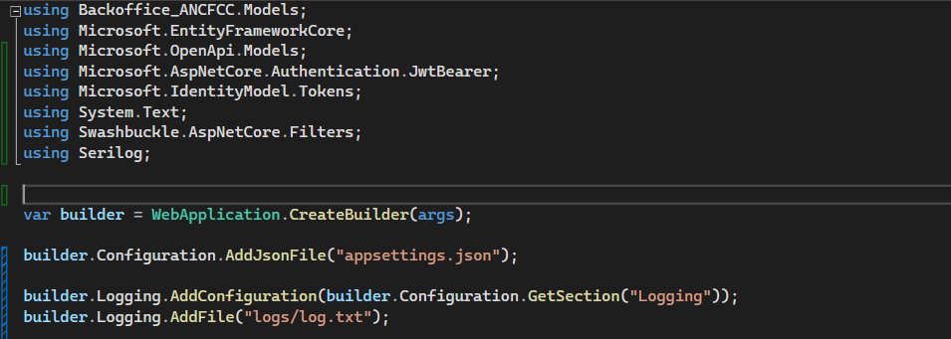

**IN APPSETTING.JSON ADD THIS : THE LOGGING :**

**In this case all the activity will be stored in text file dont worry … !!!**

**And in the console we gonna had just the what we want by adding this :**

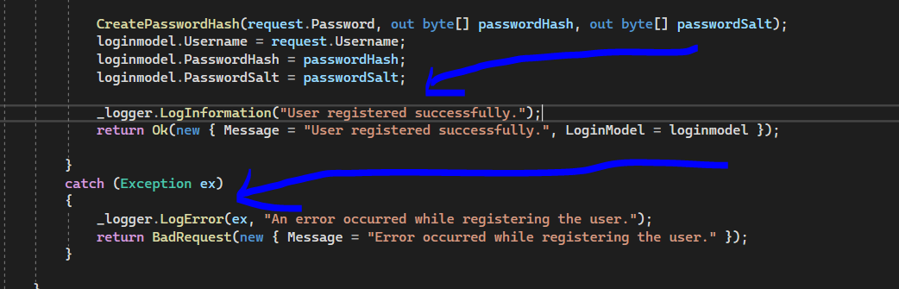

**The result in logs file :**

**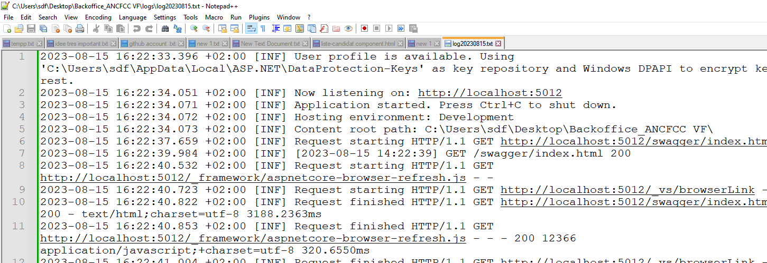  
  
MAIS YLA BGHIT ANA NSEJJEL HTA DAKCHI LI KAYDKHEL HOWA F REQUEST BODY ???   
  
add this to your programs.cs :** 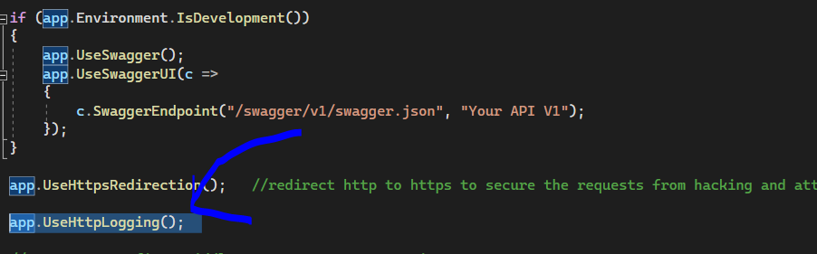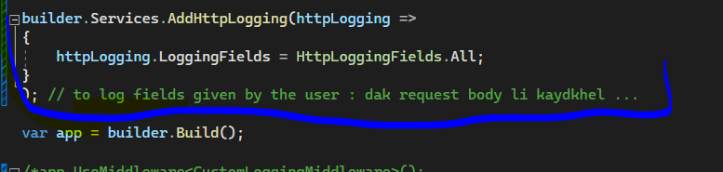

**The result in the console : but you need to add ‘information ’ in your app settings :**   **"Microsoft.AspNetCore": "Information"**

**Username :   
password :**

**Email : ……….**

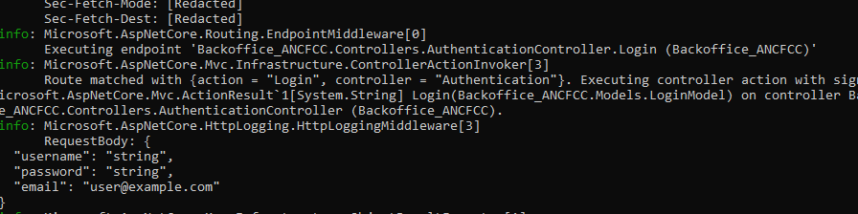

**ENABLE HTTPS ASP.NET CORE : TO WORK MORE SECURLY :**

**RIGHT CLICK TO THE PROJET == > click PROPRIETES === > ENABLE USE SSL (SECURE SOCKET LAYER )..== > RUN THE PROJECT WITH THE IIS (INTERNET INFORMATION SERVICE)   
  
WHY ? AND HOW ? : NOW YOU ADDED A LAYER OF SECURITY TO THE REGULAR http PROTOCOLE BY ENCRYPTING DATA BETWEN THE SERVER AND THE CLIENT’S BROWSER…   
YOU WILL SEE THE PADLOCK ICON AND HTTPS THAT’S MEAN YOU HAVE A VALID SSL CERTIFICATE, SO THE COMMUNICATION IS SECURE …**

**Claims part :**

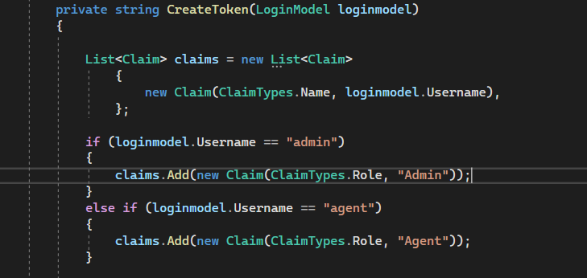

**Create a list of claims to store information that will be included in the jwt token**

**In this code we add the username as a claim …**

**And we check if it’s an agent or an admin and add to the claim…**

**Claims :**

**\*\* Informations about the user, to be included in the security token,( like jwt)**

**\*\* Exemple of these inforamtions :  identity information : username , email address, user ID , any other identifier helps to identify the subject , first name , last name , date of birth . gender …. ,,, … also roles and permissions : admin , user , manager …. And the associated permissions read , write , delete… also login time (authenticaion time) , token expiration (expiration time…) …**

**The but is for exemple know that the user authentications is john doe so it ‘s a name**

**\*\* important for authentication and authorization processes , they provide context and authorization information that can be used by the system to make decisons about access and permissions..**

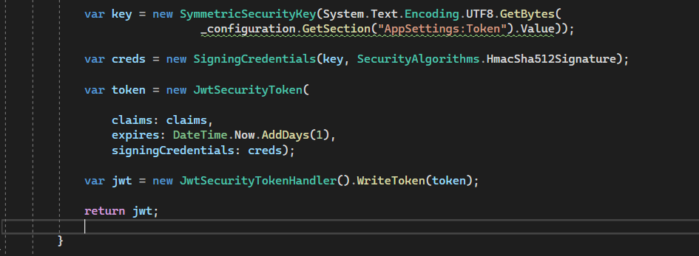

var key = new SymmetricSecurityKey(System.Text.Encoding.UTF8.GetBytes(

_configuration.GetSection("AppSettings:Token").Value));

**\*\* CREATE a new symmetricSecurityKey object used as the secret key to sifn the jwt. , AND WE STORE IT IN THE KEY VARIABLE …**

**We retrieves the value from the apsettings : token (YOU FORGET MY SECRET TOKEN QUICKLY !!! HHHHHHHHHHH )and converts it from a string to a byte array using UTF-8 ENCODING (widely recommended..)_ …**

**\*\* AFTER WE NEED TO COMBINE THIS CODE (THE OBJECT SYMMETRICSECURITYKEY) WITH A SPECIFIC ALGORITHME FOR SIGNING THE JWT… WE USE HERE IN OUR CODE : HmacSh512Signature**

**IN THAT NEED , WE CREATE THE SIGNING CREDENTIALS OBJECT AND STORE THE RESULT IN THE CREDS VAR….**

**\*\*\* AFTER WE START CREATE THE TOKEN : A NEW JWTSECURITYTOKEN OBJECT REPRESENTS THE JWT THAT WILL BE GENERATED, AND WE SETS THE CLAIMS THAT WE HAVE , ALSO THE DATE EXPIRATION OF THE TOKEN FROM NOW , AND ASSIGNS THE CREDENTIELS OBJECT CREATED (SIGNINGCREDENTIALS TO signingCredentials parametre of te jwtSecurityToken)….**

**\*\*\* AFTER THAT CREATE A NEW JWTSECURITYTOKENHANDLER OBJECT , THIS CLASS HAD A METHODE CALLED WRITE TOKEN USED TO SERIALIZE A JWTSECURITYTOKEN INTO STRING…**

**SERIALIZE ?? : MEANS THAT’S CONVERT AN OBJET (JWTSECURITY TOKEN) INTO A FORMAT THAT CAN BE EASILY TRANSMITTEED OR STORED… IN THIS CASE TO A STRING ….**

**\*\*\* FINALY , GENERATE THE JWT STRING FORM THE METHODE ..**

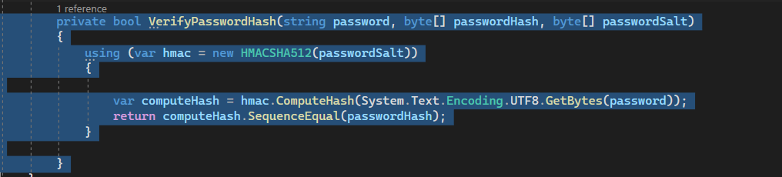

**\*\*\* METHODE TO VERFY WHETHER A GIVEN PASSWORD MATCHES A PROVIDED HASH AND SALT … ::: IT ‘S USED IN THE LOGIN POST ….**

**using (var hmac = new HMACSHA512(passwordSalt))**

* **CREATE NEW INSTANCE OF THE CLASS HMACSH512 (TYPE OF CRYPTOGRAPHIC HASHING ALGORITHME),,, IT USING THE PASSWORDSALT AS THE SECRET TO GENERATE TE HASH…**
* **Var computeHash = hmac.ComputeHash(System.Text.Encoding.UTF8.GetBytes(password));**

**THE PASSWORD GIVEN IS CONVETED TO BYTES USING UTF-8-ENCODING THEN CALCULATE THE HASH USING HMACSHA512**

**return computeHash.SequenceEqual(passwordHash);**

**COMPARES COMPUTE HAS WITH THE PROVIDED PASSWORDHASH FROM THE PASSWORD GIVEN ,, CHEKS WHETHER THE COMPUTED HASH AND THE STORED HASH ( STORED IN THE MEMORY LOCALLY OR IN THE DATABASE… ) ARE EQUAL OR NOT**

**THECHNIQUES :**

// acces the field if it's null (?) set it to 0 .

user.AccessFailedCount ??= 0;

**PROBLEM : THE TABLE AGENT AND ADMIN BOTH SEPARATED IN NOT A GOOD IDEA BECAUSE THAT MAKES :**

**API CODE REDEDANCY…**

**CHECK THE TABLE AGENT , AND CHECK THE TABLE ADMIN…**

**BOTH HAVE THE SAME COLUMNS….**

**SOLUTION : CREATE ONE TABLE CALLED USERS WITH THE SAME COLUMNS BUT WE GONNA ADD A ROLE COLUMN : AGENT OR ADMIN .**

**NB : DO A BACKUP ! RIGHTCLICK ON THE DB name => TASKES 🡺 Backup**

**QST 1 : HOW TO TRANSFER DATA FROM TABLE AGENT TO TABLE ADMINS ?**

**ASSURE THAT YOU HAVE THE SAME NAME COLUMNS .**

**COMMAND SQL :**

**-- Insert data from Agent table into Administrateur table**

**INSERT INTO Administrateur (**

**Nom,**

**Prenom,**

**Email,**

**PasswordHash,**

**PasswordSalt,**

**Username,**

**VerifiedAt,**

**VerificationToken,**

**PasswordResetToken,**

**ResetTokenExpires,**

**AccessFailedCount,**

**LastLoginDate,**

**IsLockedOut,**

**LockoutTimestamp,**

**LastLoginAttemptDate**

**)**

**SELECT**

**Nom,**

**Prenom,**

**Email,**

**PasswordHash,**

**PasswordSalt,**

**Username,**

**VerifiedAt,**

**VerificationToken,**

**PasswordResetToken,**

**ResetTokenExpires,**

**AccessFailedCount,**

**LastLoginDate,**

**IsLockedOut,**

**LockoutTimestamp,**

**LastLoginAttemptDate**

**FROM Agent;**

**QST 2 : CHANGE THE NAME OF THE PRIMARY KEY (ADMINISTRATEUR ID INTO USER ID ) ?**

**EXEC sp_rename ‘Administrateur.AdministrateurId’, ‘UserId’,’COLUMN’**

**QST 3 : CHANGE THE NAME OF THE TABLE FROM ADMINISTRATEUR TO USERES ?**

**EXEC sp_rename ‘dbo.Administrateur’ , ‘Users’ ;**

**QST 4 : THE PRIMARYKEY OF THE TABLES ADMINISTRATEUR AND AGENT ARE A FOREIGN KEY IN THE CANDIDATURES TABLE , YOU NEED TO DELETE THEM :**

**--drop the constraint because it’s a foreign key .**

**ALTER TABLE Candidatures DROP CONSTRAINT FK_Candidatures_Administrateur ;**

**ALTER TABLE Candidatures DROP CONSTRAINT FK_Candidatures_Administrateur ;**

**-- drop columns now**

**ALTER TABLE Candidatures DROP COLUMN AdministrateurId ;**

**ALTER TABLE Candidatures DROP COLUMN AgentId ;**

**QST 6 : MAKE THE USER ID MORE SECURE AND CONCISE :**

**Don’t touch the userID and make another columns named : UserUnique Code :**

**To add the new Column :**

**ALTER TABLE Users**

**ADD CONSTRAINT DF_Users_UserUniqueCode DEFAULT 'U' + Right(CONVERT(nvarchar(20), ABS(CHECKSUM(NEWID()))),6)**

**FOR UserUniqueCode;**

**To Update te UserUniqueCode Column for the existing rows in your table :**

**UPDATE Users**

**SET UserUniqueCode= 'U' + Right(CONVERT(nvarchar(20), ABS(CHECKSUM(NEWID()))),6)**

**WHERE UserUniqueCode IS NULL;**

**QST 5 : ADD A COLUMN NAMED ROLE TO STORE (AGENT OR ADMIN):**

**ALTER TABLE Users**

**ADD Role NVARCHAR(50) ;**

**UPDATE Users**

**SET Role = ‘Agent’ ;**

**QST 6 : ADD THE USERID LIKE A FOREIGN KEY IN THE CANDIDATURE TABLE  :**

**-- Command code in ssms :**

**ALTER TABLE Candidatures   
ADD UserId INT ;**

**ALTER TABLE Candidatures**

**ADD CONSTRAINT FK_Candidature_UserId FOREIGN KEY (UserId)**

**REFERENCES Users (UserId) ;**

**QST 7 : MAKE THE EMAIL UNOQUE TO PREVENT DUPLICATED EMALS :**

**ALTER TABLE Users**

**ADD CONSTRAINT UQ_Email UNIQUE (EMAIL)**

**PROBLEME :**

**In my old controller AUTHENTICATION , u have alot of logic code , a lot of methods inside the api logic code like : CreateToken , VerfierPassowrdHash, GetUserByEmail and username.**

**So all this functions we regroupit in one class it’s called a Service for authentication.**

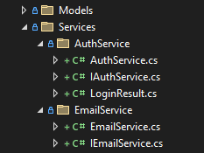**Why doing that ? :**

**Unit testing easier for each functions , more manageable than testing everything within a controller.**

**Keep your controlleres focused on handling http requests and responses.**

**Dependency injection**

**Better organization , code reuse , testability,**

**Steps :**

**Create a folder inside Service called AuthService .**

**Create an interface callad IAuthService .**

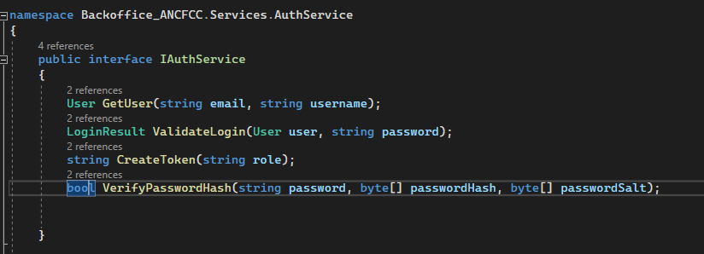

**Create a class called AuthService class that impelents the IauthService interface : create your funcions and your methodes .**

**The loginResult class : is a common practice in software development and has several benefits. Is to encapsulate the result of a login attempt**

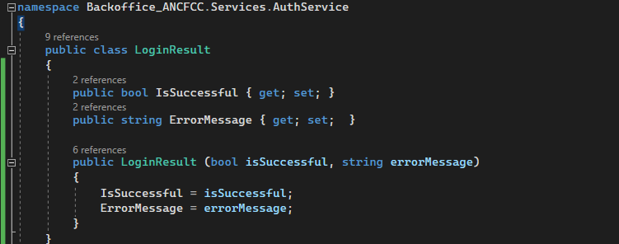

**It’s benefits :**

**Return a boolean with a message to be displayed .**

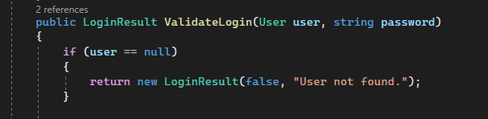

**RATE LIMITNG :**

**Is an essential security measure that can prevent many attacks and block force attacks from hackers , by returning the 429 error. And also to not occupy the sever.**

**HOW TO ACHEIVE IT ? :**

1. **Install ASPNET CORE RATELIMIT PACKAGE.**
2. **IN YOUR PROGRAM.CS ADD THIS LINES :**

**BUILD THIS SERVER.   
  
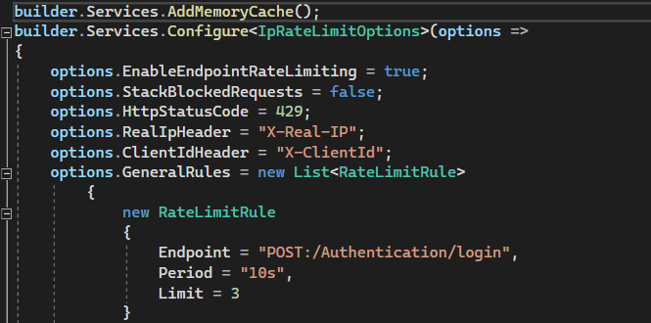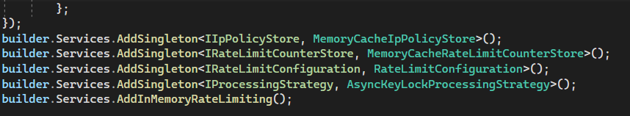  
  
 : Line by line :   
  
- Adds the in-memory cache to store and retrieve data in memory.   
- Configure the IpRATE limiting using the Iconfiguration pattern.   
- Enable rate limiting by set it to true.**

**- Blocked requests should be stacked or not :  
True : means blocked requests will be stacked and will be served after the rate limit.   
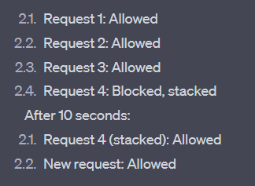**

**False : blocked requests will be rejected immedialtely.   
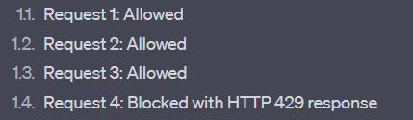  
  
- Set the code 429 means : « Too MANY REQUSTES .   
- Specifies the heade names to be used for identifying the real IP address and client ID, in order to identify clients when behind proxiees or load balancers.   
-Define rate limiting rules for specific endoints : in our case 3 requests every 10 seconds.**

**-Add the in-memory rate limiting middleware to the application in order to use it after ie call the middlware after by USE .**

**USE THE MIDDLEWARE THAT YOU CREATED IN THE SERVICE.  
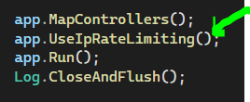**

**TESTING : ERROR 429 :**

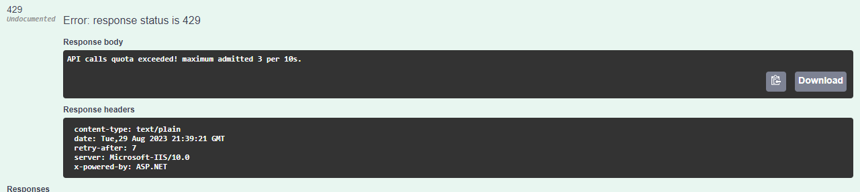

**EMAIL SERVICE :  
USING MAILKIT AND SMTP**

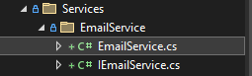**1 . Install mailkit package.   
2. Create a folder called Sevices and inside this folder, create a folder called EmailService and inside this folder create an INTERFACE and the classe.**

**3. The interface :   
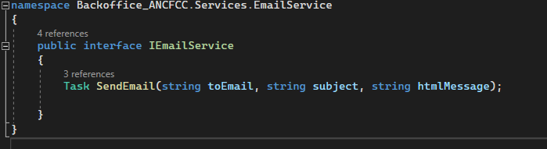**

**4. The classe :**

**Why using classes and Interfaces separatly ?**

**To follows key principles of software design :   
Abstraction : the process to hide internal details and show only the functionaliy . HOW ?**

**Contexte : first , of course your code is designed for the client to work with it . good !  
imagine you want to build an application of drawing shapes, of course it’s shapes need its own logic because the circle , the square , the rectangle are not the same !   
the fisrst idea comes to mind is to create methods to these shapes ! great ! but you gonna bother the client by this logic , he don’t want the logic we want the functionnlity . and imagine with if after months he want to draw a new shape you gonna add it’s methode to the code and see it again ! it’s difficult !! right !! so you need to add new shapes easily without modifying existing code, and ensure that each shape class implements the necessary methods consistently. And also keep it in mind the client doesn’t need to know how the shapes are drawn ; it just knows that shhapes can be drawn using the DRAW method that’s all .**

**Solution : Absraction and Interfaces :**

**INTERFACES : defines a contract that specifies methods that a class must implement .**

**\*\* Create interface IShape and declares a Draw method . this ensures that every class implements the Draw method :**

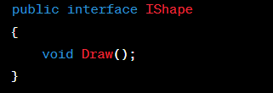

**\*\* Create shape Classes : the cercle , the rectangle …**

**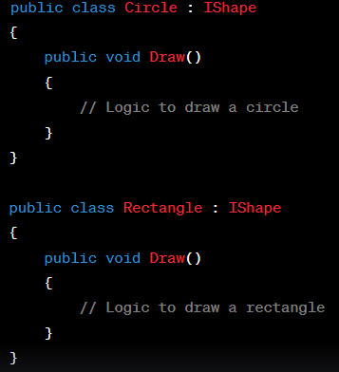  
the client is not considered to see this or work with it .  
  
The client code is this :   
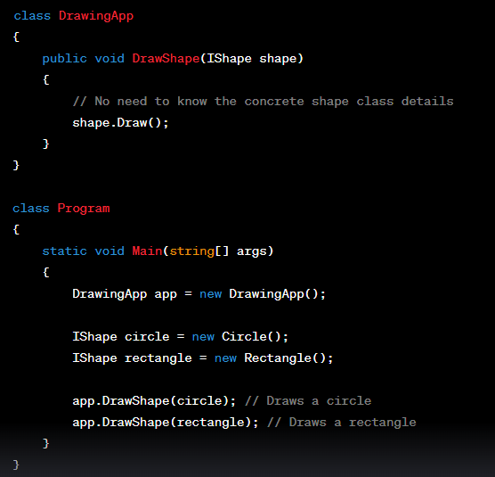**

**The client doesn’t need to know the concrete shape class details.   
that’s why we have the DrawingApp class that has the DrawShape Methode , the client gonna only pass the shape object to be drawn as an argument to handle the apppropriate methode from the interface IShape.  
so this the abstraction provided by the interface IShape.   
  
IN OUR CONTEXTE : EMAIL SENDING :**

**We create the service that contains the interface and the class code ,**

**The client code (API CODE LOGIC) doesn’t need to know how the email is actually sent , it only need to call the function SendEmail  method that’s all .   
so i can update or change the implementation of the Email service without affect the cliet code (API CODE LOGIC)  
  
SUMMARY : SO THIS WHY WE CREATE INTERFACES AND CLASSES IN OTHER FOLDERS AND CALL IT SERVICES !!   
  
  
   
Encapsulation :**

**Bundling data and methodes into a single unit called a class.  
The process of hiding internal details of the classes.**

**The circle and rectangle classees and it’s variables are hidden form external code (of course this variables are declared private , only the classes has the access) but to access to this varaibles we have the sitters and the getters (only get or set the value of the private variables.)**

**So the encapsulation hides the implementation details from the outside world (main code = API LOGIC)**

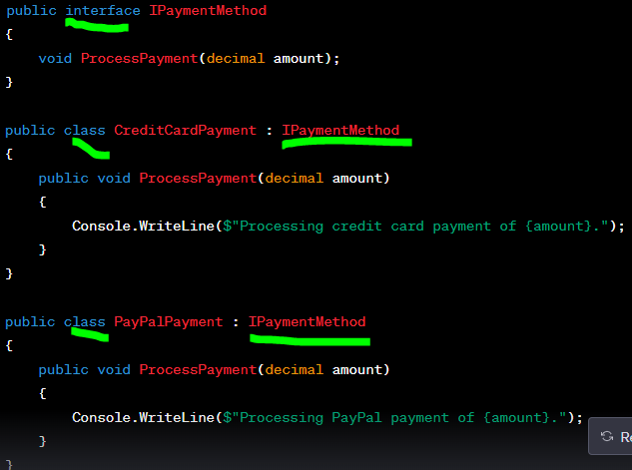 **Loose coupling :   
 minimize the dependencies between different components,   
 interfaces enable loose coupling by noticing that , the client code   
 depends on the interface not the concrete class.**

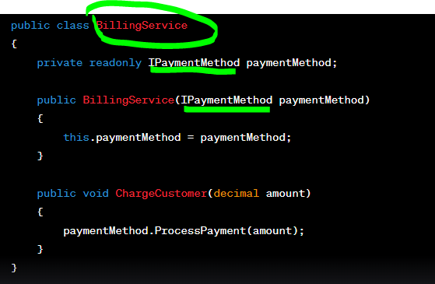

**In this example the BillingService class is loosely coupled with different payment methods through the interface IPaymentMethod.   
we create instances of CreditCardPayment or paypalPayment and inject them into BillingService**

**Difference :**

**Tightly coupled approch : the client code directly interacts with the billing service’s implementaion details .**

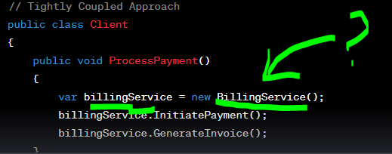

**Loosely coupled Approach : the client code interatcts with the billing service through an interface . the client doesn ‘t directly instantiate the implementation but relies on dependency injection or some other mechanism to provide the actual implementation.**

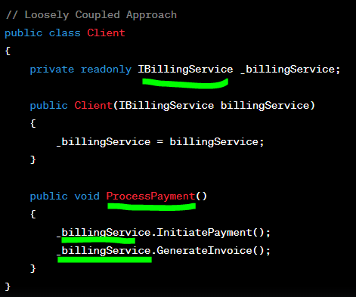

**In our context , the email sending messages :  
  
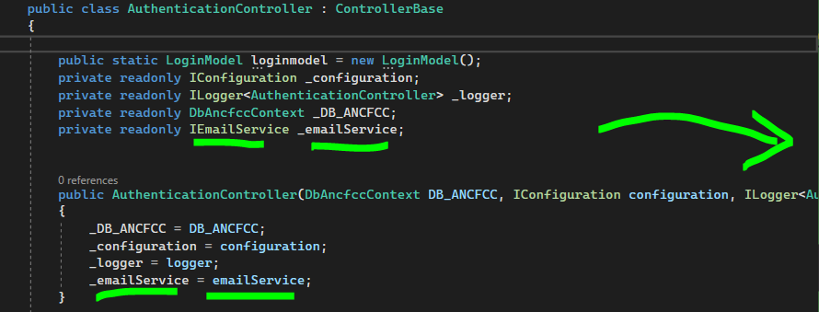**

**In the authentication api code logic , we have the dependancy injection to instantiate the implementation of the emailservice … in order to call the method class .  
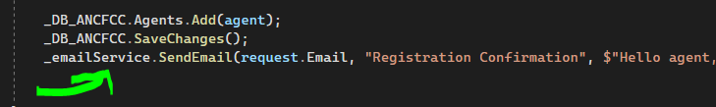**

**ASP.NET CORE BASICS :**

**CHAPITRE 1 : ASP.NET Core Fundamentals**

**When you click "Run" on an ASP.NET Core project ?**

1. **COMPILATION : THE CODE OF YOUR ASP.NET IS COMPILED INTO AN EXECUTABLE CODE ( IT MEANS HERE : TRANSFORM CODE C# CODE TO A FORM UNDERSTOOD BY THE COMPUTER. )**
2. **HOSTING : ASP.NET CORE APPLACATIONS CAN BE HOSTED USING DIFFERENT WEB SERVERS. WHEN YOU RUN YOUR PROJECT , WEB SERVER LIKE KESTREL IS STARDED TO HANDLE INCOMING http REQUESTES …**

**KESTREL ? : THE DEFAULT WEB SERVER USED BY ASP.NET CORE APPLICATIONS , AND ADDED AUTOMATICALLY TO YOUR PROJET , FIRST WHEN YOU CREATE AN APPLICATION … SO YOU DON’T NEED TO ADDED MANUALLY , IT ;S INCLUDED BY DEFAULT …**

**HOW CAN I KNOW THAT’S EXISTS IN MY PROJECT ?  
IN YOUR PROGRAMS.CS YOU MUST FIND LIKE THIS LINES**

**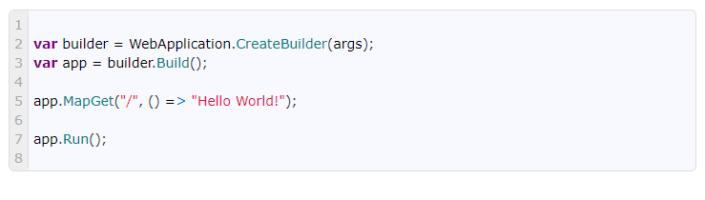  
AND AFTER RUNING A PRGRAMME , YOU WILL FING THE URL WITH THE PORT : LIKE THIS :** [**http://LOCALHOST:5000**](http://LOCALHOST:5000)

**HOW KESTREL AND ASP.NET CORE WORK TOGETHER :**

**- THE USER SEND AN http REQUEST TO YOUR APPLICATION , THE REQUEST IS SENT TO THE SEVER WHERE YOUR APPLICATION IS HOSTED.**

**- KESTREL WEB SERVER : RESPONSIBLE FOR RECEIVING INCOMING REQUESTS FROM CLIENTS AND FORWARD THEM TO YOUR APPLICATION FOR PROCESSING.. ,,**

**AND ALSO IT DECIDE WICH PART OF YOUR APPLICATION SHOULD HANDLE THE REQUEST**

* **ASP.NET CORE’S ROUTING SYSTEM DETERMINES WHICH CONTROLLER AND ACTION METHOD SHOULD HANDLE THE INCOMING REQUEST … SO , ROUTING MAPS THE URL PATH TO SPECIFIC CONTROLLER ACTIONS…**
* **THE SELECTED CONTROLLER’S ACTION METHODE IS INVOKED. THIS METHOSE PROCESSES THE REQUEST , AND INTRACTS WITH THE DATABASE IF NEEDED AND PREPARE THE RESPONSE …**
* **BEFORE AND AFTER THE CONTROLLER ACTION IS EXECUTED , THE REQUEST PASSES THROUGH A SERIES OF MIDDLEWARE COMPNENTS.. EAC MIDDLEWARE CAN PERFORM TASKS LIKE AUTHENTICATION , LOGGINS , DATA TRANSFORAMTIONS … THEY ARE REPRESENTED IN THE PROGAMS.CS…**

**MIDDLEWARE ? : WE CAN BE THOUGHT OF A SERIES OF PIPES :** 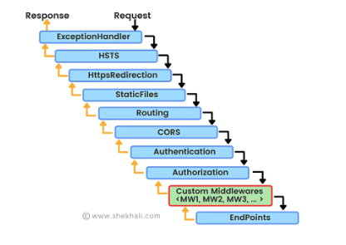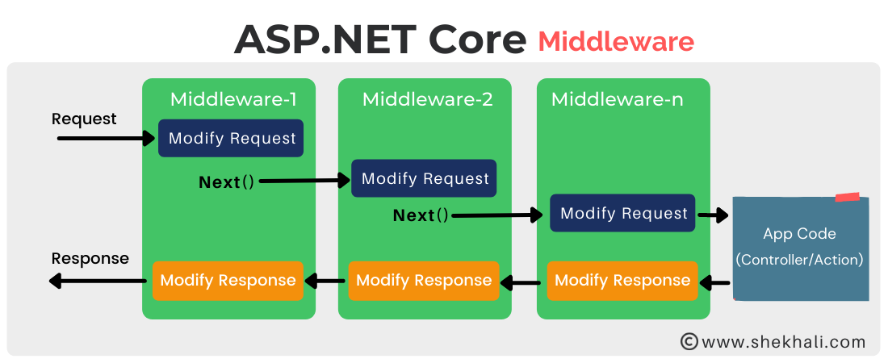

**Middlewares build the request pipeline. The request processing is like this :   
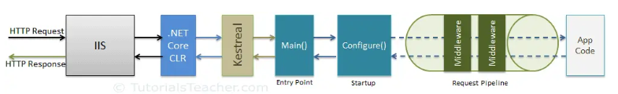   
IIS :  
 ** INTERNET INFORMATION SERVICE… MICROSOFT WEB SERVER RUNS IN WINDOWS TO EXCHANGE BOTH STATIC AND DYNAMIC WEB CONTENT WITH INTERNET USERS..**

**\*\* IT COMMUNICATES VIA PROTOCOLES LIKE http , SMTP , FTP ….**

**\*\* USED TO HOST , DEPLOY , MANAGE WEB APPLICATIONS USING ASP.NET AND PHP …**

**WHY IIS ?  :   
ANALYZING IIS LOGS FOR SERVER AND SITE INFORMATION , SO AIDING IN TROUBLESHOOTING…**

**.NET CORE CLR : COMMON LANGUAGES RUNTIME :**

**IT’S A COMPONENT , A RUNTIME FOR .NET CORE . IT INCLUDES THE GARBAGE COLLECTOR , JIT COMPILER , PRIMITIVE DATA TYPES , LOW LEVEL CLASSES , OFFER TYPE SAFE ALTERNATIVES TO FUNCTION POINTERS , IN ORDER TO SIMPLIFY THE DEVELPMENT PROCESS.**

**HOW TO CREATE A CUSTOM MIDDLEWRE----CREATE YOUR OWN MIDDDLWEARR :**

1. **THE FIRST WAY :   
     
   CREATE IT DIRECTLY IN THE PROGRAMS.CS :**

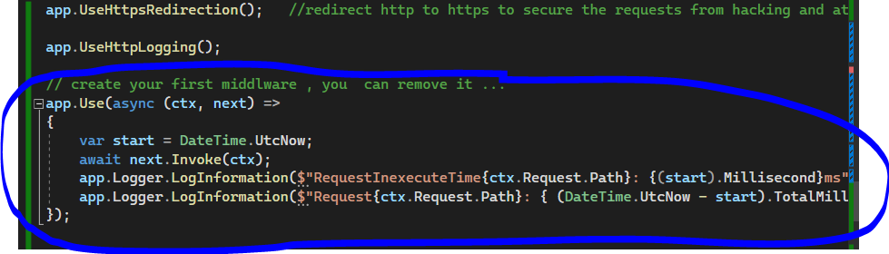

* **APP.USEHTTPSREDIRECTION() : IS A DEFAULT MIDDLWARE … ALL THE APP.USE...**
* **TO CREATE A MIDDLWARE : we use the function app.Use**

**2.**

**THE SECOND WAY :**

**TO CREATE AN EXTERN CLASS , AND INVOKE IT IN THE PROGRAMS CS .**

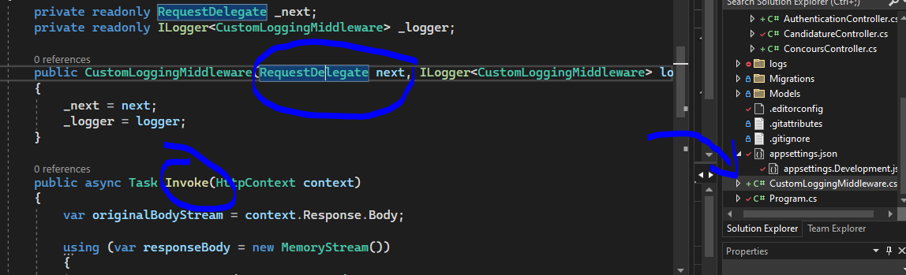

**AND INVOKE IT IN THE PROGRAMS.CS :**

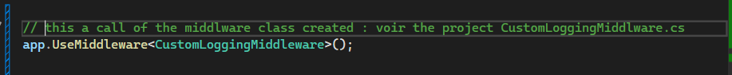

**IMPORTANTS POINTS :**

**^ MIDDLEWARE IS NOTHING BUT A . NET CLASS , WITH INVOKE() METHODE.**

**^.NET OFFER A TEMPLATE OF THE MIDDLWARE TO CREATE IT .   
^ TO EXECUTE NEXT MIDDLWARE IN A SEQUENCE , IT SHOULD HAVE REQUESTDELEGATE IN THE CONSTRUCTOR….**

**3 .   
THE THIRD WAY : NEXT TIME  
 IN YOUR CODE PROGRAMS.CS YOU GONNA FIND LIKE THIS CODE :   
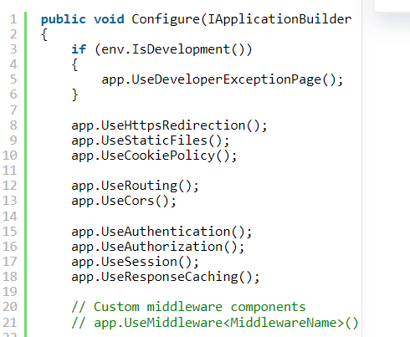**

* **IF THE CONTROLLER RETURN A VIEW , THE RAZOR VIEW ENGINE (OR OTHER TEMPLATE ENGINES ) PROCESSES THE VIEW’S MARKUP AND DATE TO GENERATE THE HTML THAT WILL BE INCLUDED IN THE RESPONSE ..**
* **The CONTROLLER ACTION OR THE MIDDLEWARE GENERATES AN http RESPONSE , INCLUDING THE APPROPRIATE STATUS CODE, HEADRES , AND RESPONSES BODY (HTM L , JSON , OR OTHER CONTENT……….)**
* **NOW THE KESTREL SENDS THE GENERATED http RESPONSE BACK TO THE CLIENTS WEB BROWSER OVER THE NETWORK…**
* **DISPLAY CONTENT TO THE USER… HTML , JSON DATA, IMAGES ….**

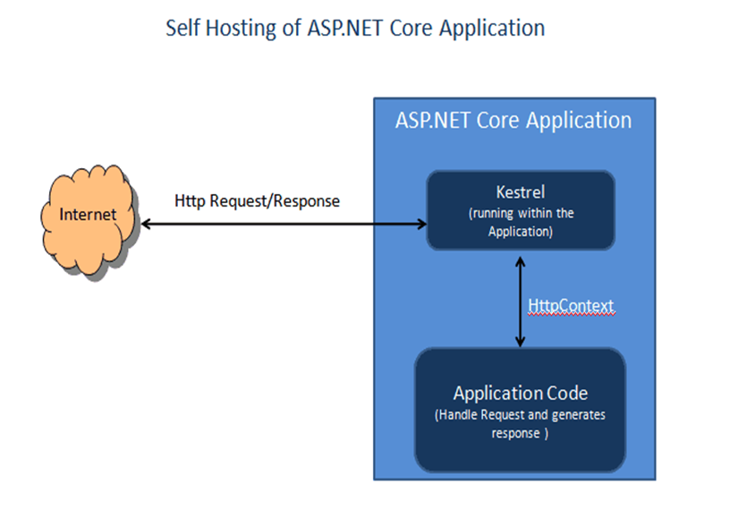

**BUTTT !!!!!!!!!!!!!!!!!!!!!  ATTENTION :**

**FOR SECURITY AND REASONS AND SCALABILITY AND PERFORMANCE AND MANAGEABILTY….**

**BECAUSE KESTREL IS DESIGNED TO BE A LIGHTWEIGHT TO HANDLES THE CORE PROCESSING OF HTTP…**

**YOU NEVER USE THIS KESTREL ALONE !!! IN THE PROJET IF YOU WANT TO DEPLOY IT AND MAKE MORE EFFICIENT….. SO WE USE REVERSE PROXY LIKE :**

**IIS , NGINX , APACHE … LIKE THIS :**

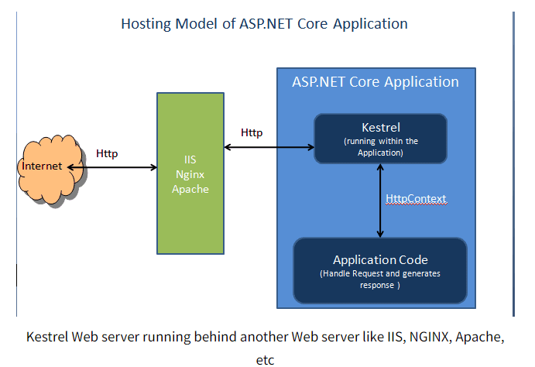

1. **Startup Class.CS   :**

* **IS EXECUTED FIRST WHEN THE APPLICATION STARTS**
* **IS MUST INCLUDE A CONFIGURE METHOD AND CAN OPTIONNALY INCLUDE CONFUGURESERVICE METHODE…**

**- ASP.NET CORE APPLICATIONS FOLLOWS A CONVENTION BASED APPROACH FOR CONFIGURATION . YOU DEFINE HOW YOUR APPLICAITON SHOULD BE CONFIGURED AND HOW THE REQUEST PROCESSIG WILL BE HANDLED . YOU SPECIFY THINGS LIKE ROUTING , MIDDLWARE , SERVICES ….**

1. **DEPENDENCY INJECTION :**

**Helps us to develop loosely coupled software components .**

**Reduce the tight coupling between the software compoents.**

**Loose Coupling :   
Is the best one , means two objects are independent of each other.   
Changing one object it will not affect another object.**

**Manage future changes easily.**

**Manage the complexity of the application.   
to acheive this process , we create interfaces and classes implement this interface … it’s the base of any maintable application .   
Tight Coupling :**

**Means two objects are dependent on each other.**

**A class is dependent on another class .   
Changing the dependent object , need to change the classes where this object is being used .**

**Why dependency injection ! :**

**Is the pattern used to remove the dependencies between objects.**

**How to do it ?   
  
Example of how you add a dependancy injection :   
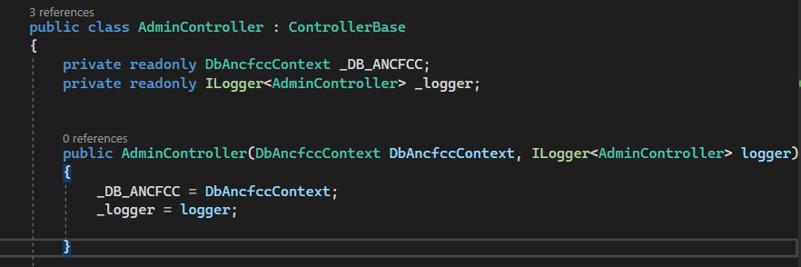  
  
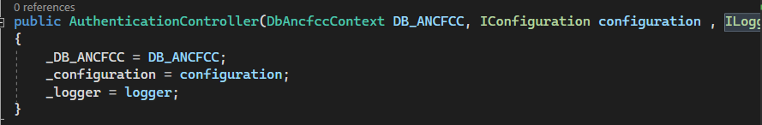**

**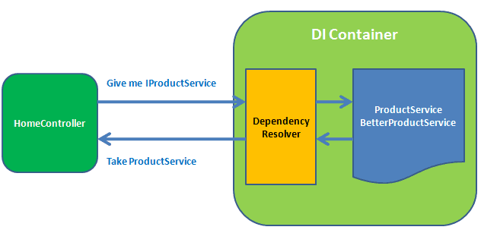  
In this example : is the same as you have :**

**Authentication controller**

**Di container have database service to interact with it , and give the Db_ANCFCC**

**EXPLANATION :   
In this code , we have implemented dependecy injection in the AdminController.**

**In the constructor in AdminController class we have two parametres represent dependecies that we want to inject : DbAncfccContext and ILogger<AdminController>.**

**This dependecies are provided to the when it’s created.**

**We use DB_ANCFCC an instance of DbAncfccContext and _logger instance of Ilogger<adminController> to interact with the database and log information.**

**SO, The controller is more loosely coupled now wit its dependencies , and make the code easier to maintain and test .**

**NOT USING THE DI :**

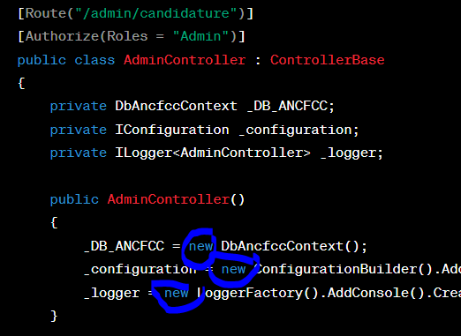

**In this version , we create instances of our dependencies directly within the controller ,the controller create its own dependencies , which makes it harder to test and change , and lead to tighter coupling and less flexibility .**

**And also if we have multiple controlleres needing the same dependencies, we end up duplicating instatiation code.**

**Hard to isolate and test its behavior.**

**THE ICONFIGURATION INTERFACE  :**

**it’s a part of the .net core configuration system.**

**is the way to access configuration settings and value stored in confuguration source, might include things like database connection string, api keys , applicaiton settings and more . (appssetting.json)  
   
HOW TO USE IT :   
  
this is the authentication controller .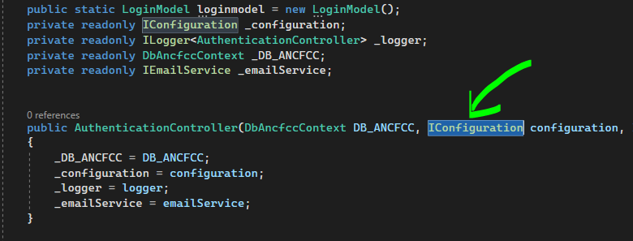 why call it ? because we need to acces to the token : MY SECRET TOKEN in the appsettings.json   
  
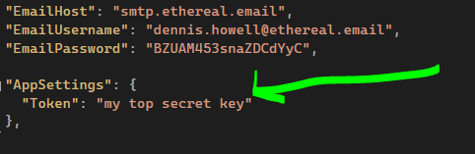  
the configuration data is organized as a hieararchy, similar to a dictionary ( ? ) with keys and values.   
  
 ? the dictionnary : is a generic collection that consists of elements as key/value pairs that are not sorted in order : example :   
  
  
  
  
 ? Example of creating the dictionnary in c# :   
 1.. we need the namespcae : system.collections.generic   
  
 2.. // create a dictionary :   
  
 Dictionary<dataType1, dataType2> dictionaryName = new Dictionary <dataType1, dataType2>()  
  
 3.. datatype1 : datatype of keys   
 datatype2 : datatype of values**

**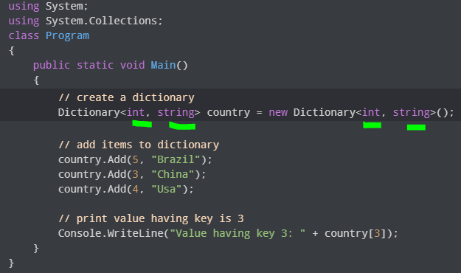  
the output is : Value having key 3 : China**

**Why use it ? :   
  
Following and ensure the dependency injection pattern so it promote modular and testable code .**

**Making configuration changes without code changes.**

**THE ILOGGER INTERFACE :**

**it’s part of the .net core’s logging infrastructure.**

**allows you to log various events , messages , and informations during the execution of you applicaiton .   
it help on debugging and understand what’s happening**

**we can log messages in files , console , database, etc…   
  
the instantiation of ILogger :**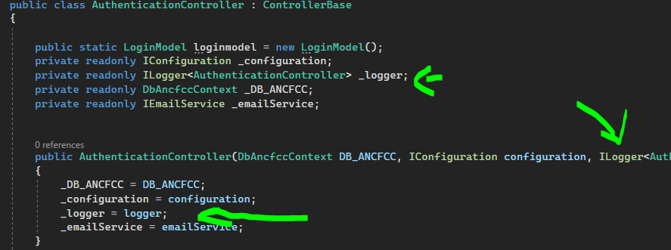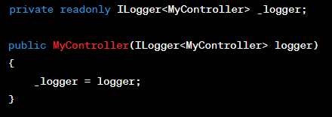

**we inject the instance into the constructor of a class (in this case : controller ) through the mecanisme of the dependency injection provided by the framwork core .**

**Usage of the ILogger :   
  
we can log information , warnings and errors and other messages :**

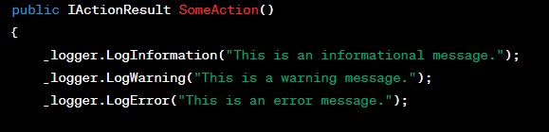

**NB : FOR THE DATABASE THERE IS NO SINGLE INTERFACE LIKE I LOGGER AND ICONFIGURATION…INSTEAD WE INTERACT WITH THE ENTITY FRAMEWORK CORE TO PROVIDE OWN ABSTRACTIONS LIKE DBCONTEXT AND DBSET TO INTERACT WITH THE DATABASES USING LINQ QUERIES AND ENTITES.**

**SO THE DATABASES INTERACTIONS ARE ABSTRACTED AWAY USING AN ORM (OBJECT RELATIONNEL MAPPINGG) LIKE ENTITY FRAMEWORK OR MICRO ORM LIKE DAPPER , AND THE DEPENDENCY INJECTION IS USED TO PROVIDE THESE ABSTRACTIONS TO DIFFERENTS PARTS OF THE APPLICATION.**

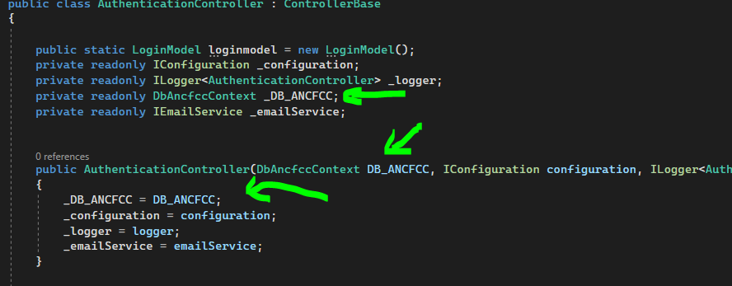

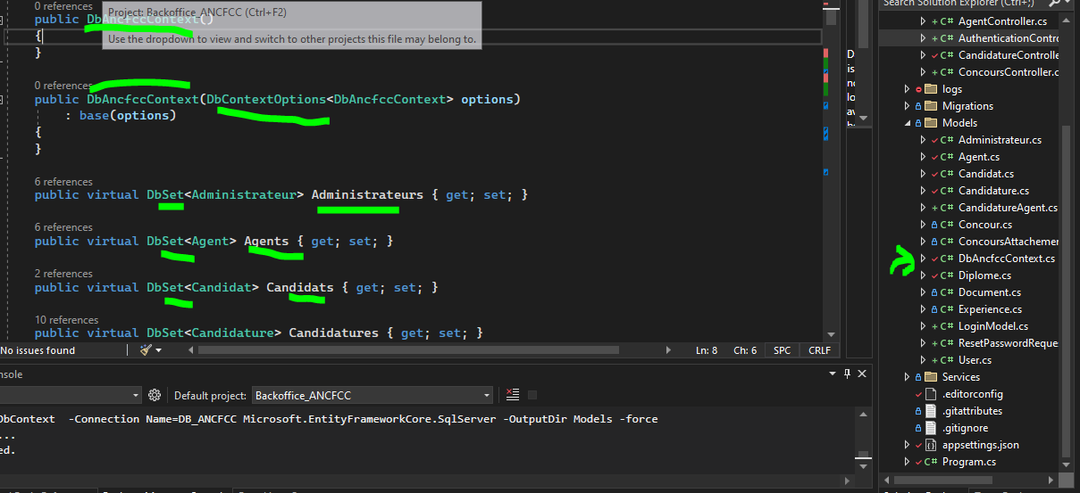

**SERIALIZATION AND DESERIALIZATION OF DATA**

**Serialization : process of converting structured data ( like objects or data structures ) into a format that can be easily stored on a file , database , memory , and transmitted across the network .   
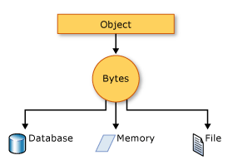**

**Deserialization : the reverese process : serialized format to the original from .**

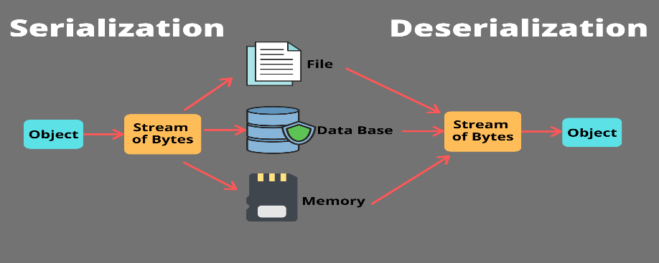

**The client sends his request to retreive books .**

**After retrieving the data (the list of books) ASP.NET CORE’s built a serialization mechanisms (oftern The JSON seialization) : convert the C# objects into JSON format.**

**This JSON (java script objects notation ) is now ready to be included in the http response .   
  
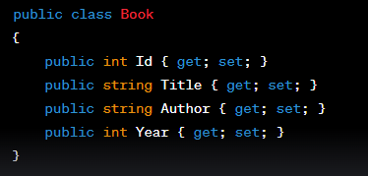  
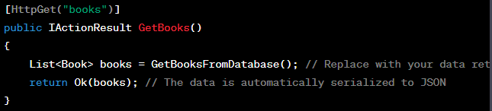**

**HOW TO CONFIGURE CONTENT NEGOTIATION (DETERMINING THE FORMAT OF THE RESPONSE DATA )?**

**NB : JSON can be configured as the default content type for your API or application .**

**ASP.NET Core uses the System.Text.Json library for JSON serialization by default without needing extensive configruration .**

**HOW CAN MANUALLY CONFIGURE JSON SERIALIZATION ?**

**NB : PLEASE NOTE THAT THIS LEVEL OF CONFIGURATION MIGHT NOT BE NECESSARY IN MANY SIMPLE ASP.NET CORE PROJECTS ! . THE FRAMEWORK OFTEN PROVIDES SUITABLE DEFAULTS FOR JSON SERIALIZATION .   
  
IN YOUR PROGRAMS.CS OR STARTUP.CS :   
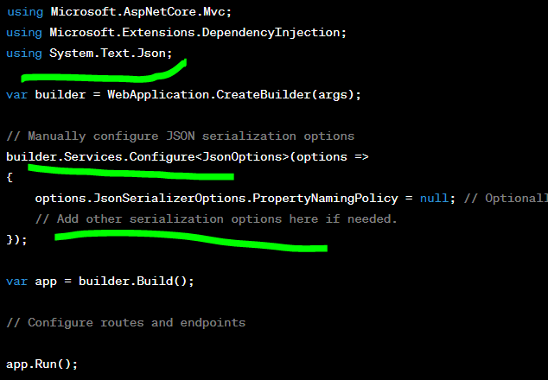  
  
UNDERSTAND MIGRATIONS, RELATIONSHIPS, AND DATABASE SEEDING :   
  
Migrations :**



**NB : Migrations are enabled in EF CORE by default.**

**To ensure that the migrations will work successfully, you may install :**

**4 packages to the project :**

**Microsoft.EntityFramerworkCore.**

**Microsoft.EntityFrameworkCore.SqlServer.**

**Microsoft.EntityFreamewokCore.Tools.**

**Microsoft.EntityFreameworkCore.Design.**

**A way to manage the schema of your database over time . especially when your application evolves and your data model changes .**

**ASP.NET CORE , Entity framword provides a migration system to create , update, and apply database schema changes.**

**Migrations used to enhance or alter your database schema by adding , eliminating, or altering database elements like tables, indexes, columns and associations.**

**Using migrations, developers can precisely log changes to the database schema, implement those changes in a well-organized manner and also undo any changes or modifications if required.**

**Create a Migration : TWO METHODS :**

**In your package Manger Console :  
 Add-Migration MyDemoMigration**

**In your command line in the dotnet CLI  :   
dotnet ef migrations add Nameofmigrations**

**Result : generate a migration file containing the changes to the database schema.   
  
Appying Migrations :**

**In your command line : dotnet ef database update .**

**In your PMC : Update-Database  
Result : apply the pending migrations to your database .**

**Rolling Back Migrations :**

**In your cammand line : database update previous_migration_name.**

**Remove a migration : TWO METHODS :   
  
purpose : if you need to undo the last migration applied**

**In your PMC : Remove-Migration**

**In your command line : dotnet ef migrations remove**

**STEPS :**

**YOU WANT TO MAP A MODEL CLASS NAMED MYMODEL TO A DATABASE TABLE ?**

**\*\* CREATE A MODEL CLASS IN ASP.NET CORE**

**\*\* CREATE A MIGRATION IN ASP.NET CORE :**

**Dotnet ef migrations add CreateMyModel**

**This will generates a migration file .cs with the name CreateMyModel**

**\*\*REVIEW THE MIGRATION :**

**Open the generated migration file . there is two methods : UP and Down**

**The Up methode contains code to create the table for your model .**

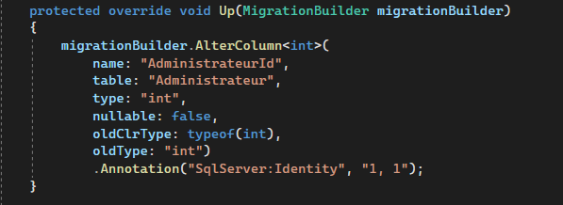

**\*\* Apply the Migration :**

**Run this in the commande to apply the migration and create the table**

**dotnet ef database update**

**EF Core relies on a database connection string provided in your application’s   
 configuration to determine which database to use when creating tables and**

**Applying migrations.**

**EF will execute the UP methode from the migration file , to create the table.  
 now , the model MyModel is mapped to a database table named MyModels.**

**ADD A NEW PROPERTY IN YOUR MODEL AND UPDATE THE COREESPONDING DATABASE TABLE ?**

**\*\*ADDING THE PROPERTY TO YOUR MODEL .   
**CREATE MIGRATION :**

**Dotnet ef migrations add AddNewPropertyToMyModel**

**\*\*REVIEW THE MIGRATION : INSIDE THE UP METHODE , YOU’IL FIND AN OPERATION TO ADD THE NEW COLUMN OR ALTER IT TO THE TABLE .**

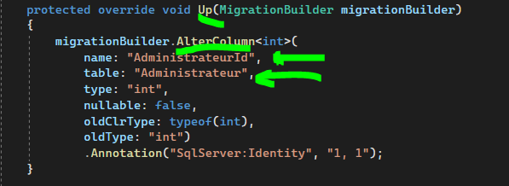

**\*\* Apply the Migration : dotnet ef database update**

**NB : There is other method besides the UP method :**

**UP METHODE : creating tables , adding columns , setting up relationships , execute any other SQL operations to update the database .   
 Down METHODE : the exact opposite operations of the Up method**

**If the up method adds a column , the down method   
 should remove that column .   
 The down method helps you maintain a history of  
 migrations and allows you to roll back to previous  
 schema states if necessary**

**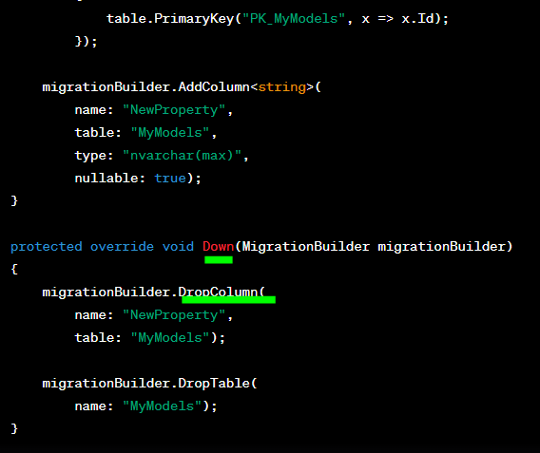  
NB : THE UP AND DOWN MEHTODS SHOULD BE PRESENT TOGETHER.**

**UPDATED : WHEN YOU APPLY THE MIGRATION UP**

**ROLL BACK THOSE CHANGES : WHEN YOU NEED TO UNDO THE  
 MIGRATION DOWN**

**EXAMPLE : CALLING THE UP AND DOWN METHODS :**

**\*\* ADD A NEW PROPRETY AND YOU WANT TO ADD TO PRODUCT TABLE :**

**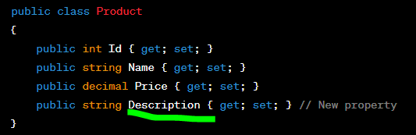  
** CREATE A MIGRATION :   
dotnet ef migrations add AddDescriptionToProduct**

**\*\* Apply the Migration = Apply the Up Method**

**dotnet ef migrations update**

**\*\* the column has been added to the Product table .**

**ROLL BACK THE MIGRATION :**

**NOW YOU WANT ROLL BACK THE MIGRATION TO REMOVE THE DESCRIPTION COLUMN, TO DO THIS YOU NEED TO APPLY THE DOWN METHODE OF THE MIGRATION .   
  
** find the migration name before the AddDescriptionToPoduct  
** dot net ef database update PreviousMigrationName   
  
HOW TO KNOW THE PREVIOUS MIGRATION ? :   
In your CLI OR PMC : dotnet ef migrations list**

**Give you the list of migrations in order chronological ,**

**From the oldest to the newest**

**WHAT’S THE DIFFERENCE BETWEN MIGRATIONS AND SCAFFOLD DB_CONTEXT ?**

**Migrations : manage changes to the database shema over the time : create , update , rollback database schmea changes.**

**Exemple : you added a new ;Author; entity to your data model . You create a migration to add the ;Author; table to the database. By creating an SQL Scripts migration and them apply it to crate the table.**

**Scaffold Db_Context :**

**When you are starting a project and want to create entity classes and a DbContext that mirror an existing database structure .**

**Exemple : if you have an existing database with tables for Books and Authors , you can use Scaffold-DbContext to genereate C# classes for theses tables and a DbContext that allow you to query and modify the data.   
  
RELATIONSHIPS :**

**Define how tables (entities) in your database are connected.**

**Types of relationships : one-to-one , one-to-many , many-to-many .**

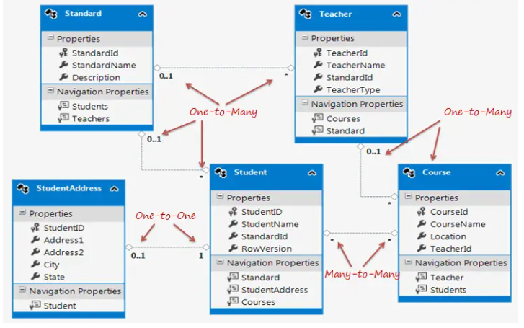

**Entity Framework Core (EF Core) Fluent Api : powerful way to configure the mapping between entity classes and database tables .**

**Provides fine-grained control over how your entity classes are mapped to database tables and how relationships are defined .**

**Is typically done within the OnModelCreating method of your DbContext class.**

**Configure properties : .HasColumnName() , .HasColumnType() , .HasMaxLength() , .IsRequired(),**

**KeyConfiguration : .HasKey() : define a primary key**

**Index Configuration : .HasIndex()**

**Relationship Configuration : .HasOne(), WithMany(), HasMany() , HasForeignKey(),**

**Table Mapping :**

**.ToTable() : Customize the table name for an entity   
.ToSchema() :   conifgure schema names**

**ONE-TO-MANY RELATIONSHIP :**

**A candidature can have many diploms , many documents, many experiences .   
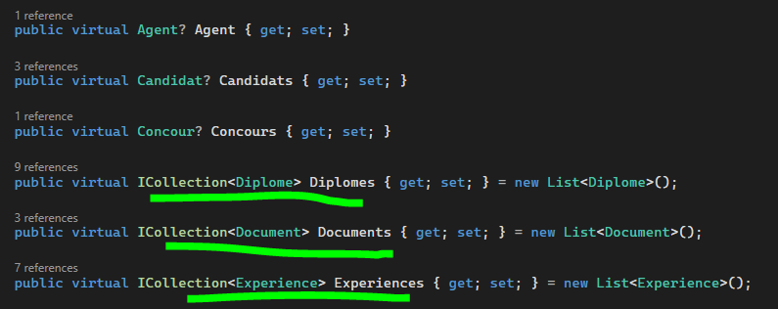  
  
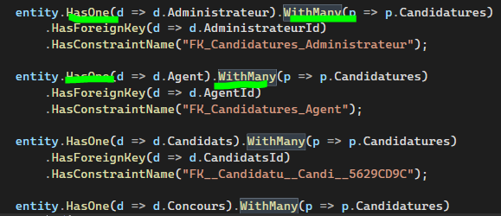**

**MANY-TO-MANY RELATIONSHIP :**

**Student can enroll in multiple courses , and a course can have multiple students.**

**Methode 1 :**

**If you need to create 3 classes in one file class . or creating 3 seperate classes in 3 classes files .**

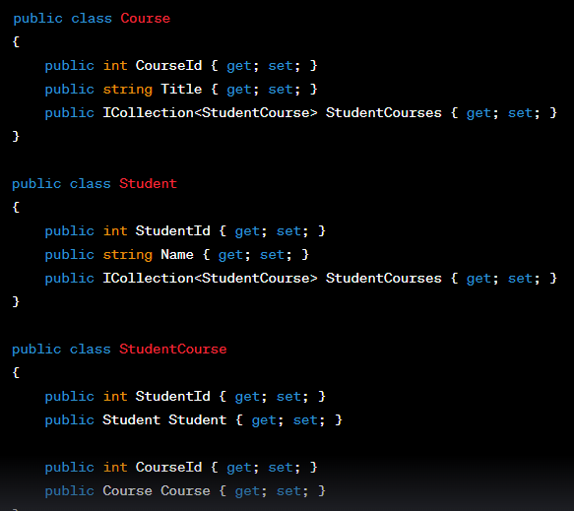

**The join table will be named after the joining entity (StudentCourse) by convention.**

**The relaionship also needs to be configured vie the Fluent API for EF Core to be able to map it successfully : in your DbContext’s ‘OnModelCreating’**

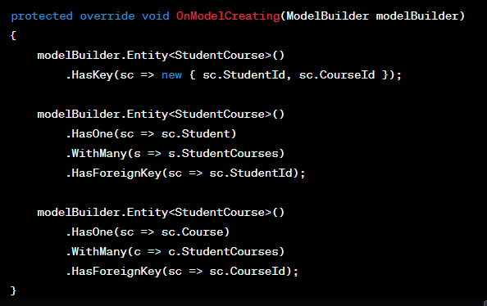

**Methode 2 :**

**if you have the Course and Student entities defined in separate class files and you want to establish a Many-to-Many relationship betwen them :**

**Solution : define the relationship between Coure and Student entities directly in DbContext’s ;OnModelCreating; Method :**

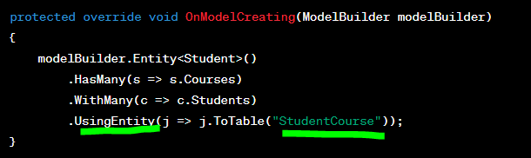

**ONE-TO-ONE RELATIONSHIP :**

**Each Author has one AuthorBiography, and each AuthorBiography belongs to one Author .**

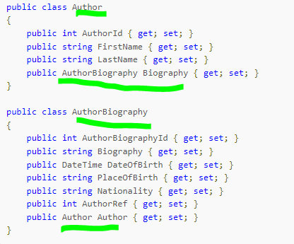

**EFCore will not be able to detect the dependent entity in the relationship. It is configured using the Fluent API like this :**

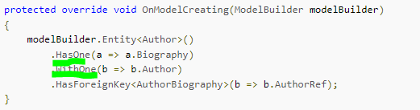

**HasOne method is chained with the WithOne method**

**DATABASE SEEDING :**

**Is the process of populating an initial set of data into the database when the database is first created (usually )or when a migration is applied .**

**This data serves as a baseline and can be user for testing, and development.**

**Ensures that your database starts with predefined data . and this data is available as soon as the application interacts with the database.**

**Example : suppose you are building an e-commerce application, and you have a Product entity with a Status property , which can be Active or Inactive .**

**Problem : You want to ensure that, by default all new products are created with an Active status .**

**Solution : DATABASE SEEDING :**

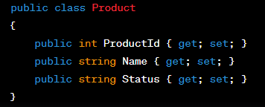

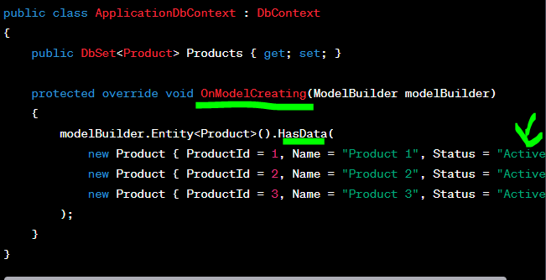

**apply migrations or crate the database, these products will be automatically inserted into the product table .**

**after completing these steps , your database should be set up with the initial data you dpecified in the ‘HasData’ method .**

**This ensures that when the application starts, it has a consistent set of products with default Active status .**

**NB : The Active status is set in the database during the seeding process, not after running the application . The seeded data is available when the application starts and interacts with the database .**

**These steps are typically performed during the development phase and might also be part of your deployment process when deploying to new enviromments .**

**CHAPITRE 2 : C# PRGRAMMING**

**A : LINQ QUERY**

* **Language integrated query fundamental part of C#.**
* **Give the opportunity to retieving data from various sources : GET INFORMATION from differents places :   
  COLLECTION OF OBJECTS (LINQ TO OBJECTS) , FROM DATABASES (LINQ TO SQL), AND informations stored in XML FILES (LINQ TO XML) :   
  XML : EXTENSIBLE MARKUP LANGUAGE : LANGUAGE DE BALISAGE .**

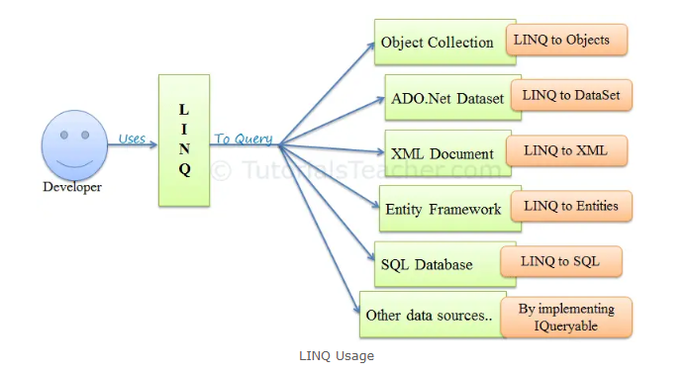**KNOWN BY : <BOOK> <CATALOG> , <XML>,…..**

* **SQL is used to retrieve data from databases only ! , but LINQ offers the advantage to retrieve data from diverse sources like we mention above.**
* **LINQ Queries return the result as OBJECTS , SO you don’t need to transform different formats of results into objects .**



**LINQ API IN .NET :**

* **Write queries for classes that implement either the IEnumerable<T> or IQueryable<T> interface .**
* **Part of the System.Linq namespace for linq.**
* **Enumerable<T> : types are for in memory collections like List, Dictionnary….**

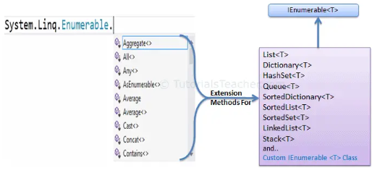

* **IQueryable<T> : types are for querying remote data sources like databases.   
    
  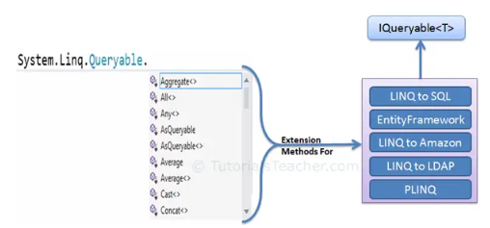**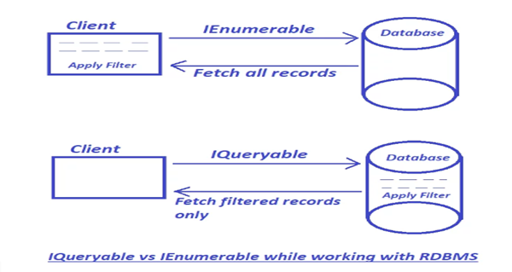

**Qauntifier Operators : return a boolean value to indicate if some or all elements satsfy the condition.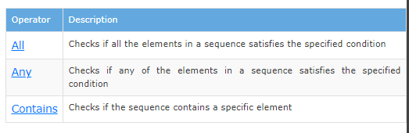 First & FirstOrDefault :**

**The diffrence : FirstOrDefault : if no one satisfy the condition returns a defaults value , for example : for int is 0 , for object is the empty objetc…. But the First returns exception.** 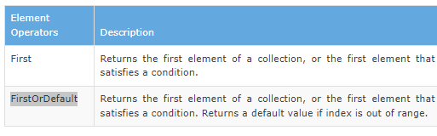

* 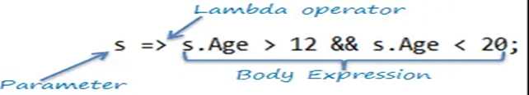**The lamda expression : to represent anonymous method , used to retrieve data , you can see without any name !**

**Unit Testing and Test-Driven Development (TDD)  
1..UNIT TESTING FRAMEWORKS xUnit**

**Unit Testing : is a software testing technique whwre individual components or units of code are tested in isolation to ensufre they work correctly .**

**Helps identify bugs early in the development process , maintain code quality .**

**Mocking : the practice of creating simulated or (Mock) objects to replicate the behavior of real objects or components .**

**The purpose is : Isolation for Testing – Controlled Behavior – Isolation from External Systems (test your code without relying on databases or swagger or any external systems . ) – Make your test faste .**

**The AAA  pattern : (Arrange, Act, Assert) : commonly used structure to organize test cases and make them more readable and maintainable and make it easy to understand .**

**1..Arrange :**

**The initial setup phase of your test case . focused on arranging the necessary preconditions for your test and avoid performing any actual testing.**

**Set up the required objects .**

**Configure dependencies (Using mocks or stubs).  
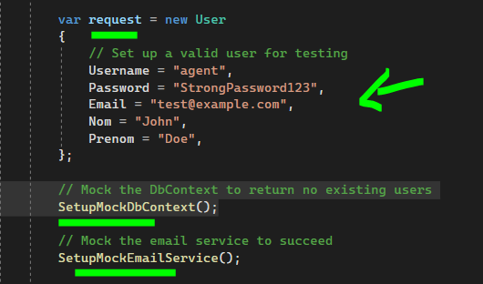**

**The fucntions : SetupMockDbContext() and SetupMockEmailService() .**

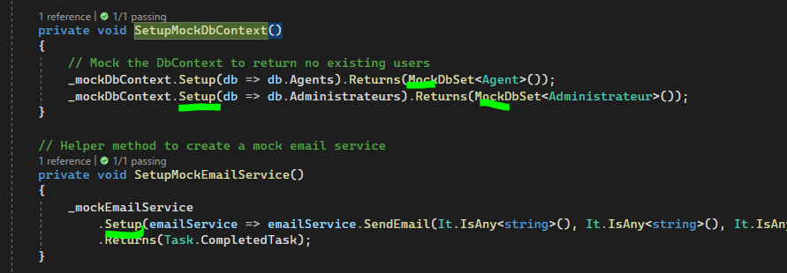

**2…Act :**

**Perform the action or behavior that you want to test.**

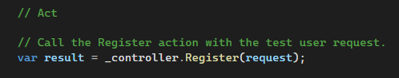

**3..Assert :**

**Verify the result or the outcome of the action you performed in the previous step .**

**Comparing actual values or states to expected values or states. If they match , the test case passes ; if not, it fails.**

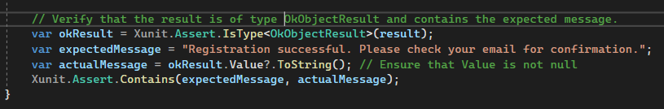

**In this example : we verify if the result is an okResult (OkObjectResult) . The expectedMessage is compared with the actual message if they match (passed) or not (Failed) .**

**NB : when you ae working with Entity Framework Core and want to isolate your code from the actual database.**

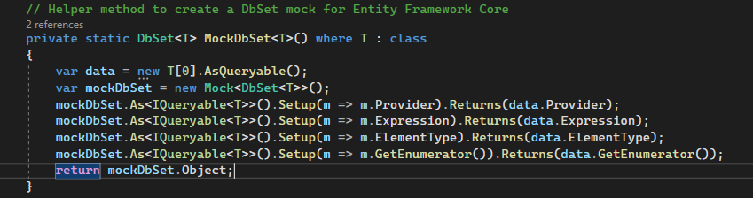

**The MockDbSet : is used to create a mock DbSet<T> objects and a mock database context , and working without touching the database .**

**Explanation  of the Code :**

**\*\* Create an empty array of type T (The entity type) and converts it into an IQueryable<T>. This represents an empty dataset .**

**Why empty ? : because the data is a IQueryable<T> instance representing an empty set of data . It doesn’t contain any actual records or data.**

**\*\* Create a mock object for the DbSet<T> class . this mock object will emulate the behavior of a database table.**

**\*\* Return the Provider of the empty data IQueryable . this emulates the provider for querying data .**

**\*\* Return the Expression of the empty data IQueryable . this emulates the LINQ expression tree .**

**\*\* … Emulates the type of elements in the query .**

**\*\* … Allows iteration over the empty dataset .**

**\*\* return mockDbSet.object : returns the mock DbSet<T> object as a DbSet<T> , create a mock DbSet that behaves like a database table but contains no actual data.**

**QUESTION : USING THE READONLY KEYWORD FOR FIELDS : ?**

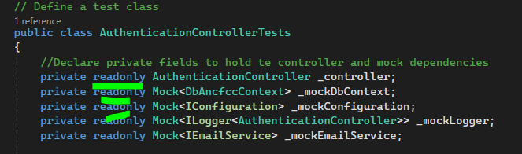

**Using readonly : in c# : indicate that field’s value should not be modified after it’s initialized .**

**Don’t use readonly ! for fields that may need to change their values or references during the lifetime of the class .**

**NB : These fields  it’s common to make them readonly becaouse once you initialize a mock object for a specific type , you usually don’t need to change it during the lifetime of your test class .**

**QUESTION : THE NULL OPERATOR  : ?**

**Explain this example :**

**return user.Claims.FirstOrDefault(c => c.Type == "name")?.Value;**

**1 : Claims are key-value paires that conatin information about the user like the name , the email , role … used in the authentication systemes .**

**2 : c => c.type : is lambda expression that define the conditon for selecting a claim . checks the type of the claim . is equal to name or not ?**

**3 : ?.Value : the null conditional operator , access the Value property of the result of the function FirstOrDefault . if true (null result ) : wont’t throw a null reference exception. Isntead it returns null .**

**Did You know ? :**

**Using ActionResult<object> as a return type and returning an anonymous object with the desired data , the API will return JSON data automatically (return an Object and ASP.NET CORE WILL TAKE CARE OF SERIALIZING IT INTO JSON FORMAT !, MAKING IT CONSUMABLE BY FRONTEND APPLICATIONS OR OTHER CLIENTS THAT CALL YOU API )**

**As long as the return type of your action is ActionResult, ActionResult<T>, IActionResult, IActionResult<T> . The framwork will automatically serialize your data to JSON when return an object from the action method . and pay attention to use Ok (new {}) in the return.**

**We also make this explicitly by using return Json (new{}) ; instead of return ok (new{}) ; .**

**The key is to ensure that the return type of your action method allows for returning JSON data, which is achieved by returning an object that can be seialized to JSON.**

**You need to know that returnig a JSON response from your API is a common and recommended preactice when building APIs for web applications. Because it’s eay to work**

**With in both backend and frontend development and easily consummed by a wide range of programming languages and platfroms and framworks like React , Angular , and Vue.js.**

**HOW TO USE AUTHENTICATION AND AUTHORIZATION TO RETRIEVE DATEA INFOMARTION , AN KNOW WHO MAKING THE REQUESTS : LA TRACABILITE ?**

1. **Create an interface and a class that implents it’s logic in the service file – the reason way : because we gonna use it in all controllers so we need a clean code and less code repitition.   
     
   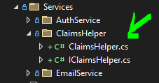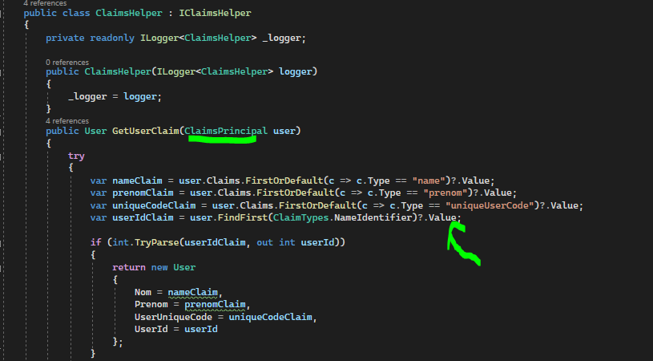  
   but how the class responsible for building the application know that i have add a new service , I think we need to insert it in the Build logic code ? without it we gonna have a problem :  
   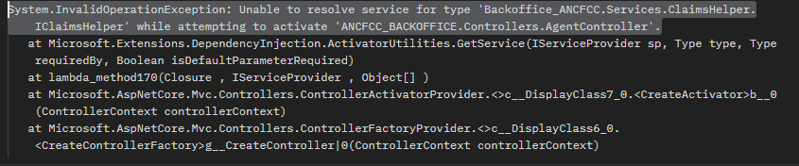  
   so the solution is : in the program.cs we need to add this line :   
   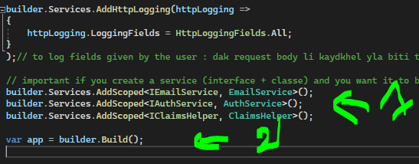  
     
   Yes exactly , so we can ensure this by add it to the appsettings.Json file :  
   ClaimsPrincipal : important concept in identity and access management within ASP.NET and many other authentication systems.   
   it’s the identity of a user , consists of one or more clamis about the user .  
   created during the authentication process when user logs in .**
2. **So how can we accesss this claims to know who is authenticated ? , in other words , how we can encapsulate the information of the user and know his activities ?   
   Response : claims can be accessed through the User Propery of the Controller class in ASP.NET Core . and you need to add this line to benifts from the it in your APIs :   
   ClaimsPrincipal user = HttpContext.User ;   
   and You need also to add variable to stock the result of calling the claimsHelper class .**

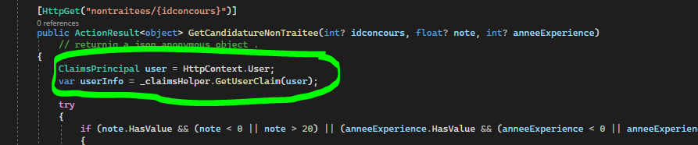

**USING DTO CLASSES INSTEAD OF ANONYNOUS OBJECT ?**

**DATA TRANSFER OBJECTS.**

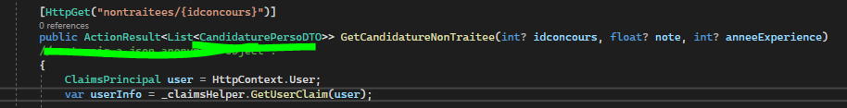

**WHY ? :**

**DTOs are commonly used in software development .**

**Sercurity : help you control what data is exposed to different parts of the application. You might have sensitive data in your database that should not be exposed direclty in the front end . so DTOs allow you to fileter out such data before sending it.**

**Testing : easy to test , we can create mock DTOS for testing various scenarios.**

**Documentation : the future - You and Front-End developers can have a clear understanding of the data structure .**

**Provide type safety (you know explicitly the date type of the object) and runtime errors .**

**Reusibility : can be reused across different parts of the application .   
DTos can be easily serialized into JSON or XML for data transfer over the network .**

**Anonymous objects : is quicly for a specififc front-end component it’s mean that you need one-time transformations, they are suitable if you don’t need to maintain a structured class or ad-hoc* scenarious .**

**Ad-hoc : somthing that is created or done for a particular purpose or situation , in an impromtu or temporary manner rather than being part of a pre-planned , structured or permanent solutions .**

**USING STATIC : CALL A CLASS IN OTHER FILE THAT’S NOT IN THE SAME FILE .CS  :**

**Problem : in the Controllers Admin and Agent we noticed that there is a common process between them which is building the query to filter candidatures by note and experience .**

**How we can reduce the redandancy of the code and make it more concise ?**

**Solution : build other file class that contain the code pretended to be common for both Agent and Admin .** 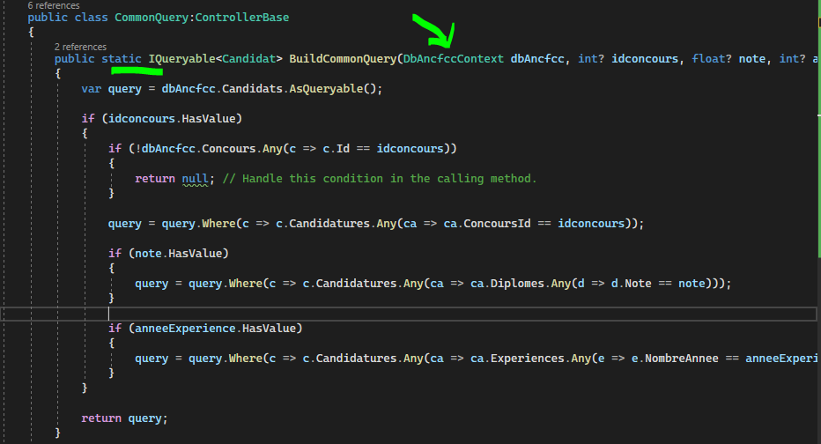

**Why USING STATIC ? AND WHY WHEN WE REMOVE IT THERE IS AN ERROR AND WE CALL THE METHOD FROM THE CONTROLLER ?   
in C# , when the method is declared as static , means that the method belongs to the class itself.**

**We don’t need to create an instance of the class. So if you want to call the method, you have to access first to the Class then the methode like this :**

**CommonQuery.BuildCommonQuery  
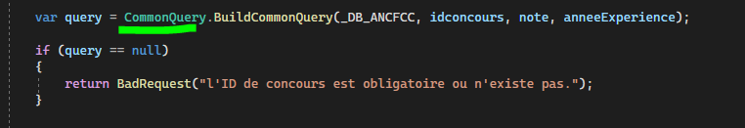**

**And if the methode is not declared static you need to create an instance of the class and then call the method like this :**

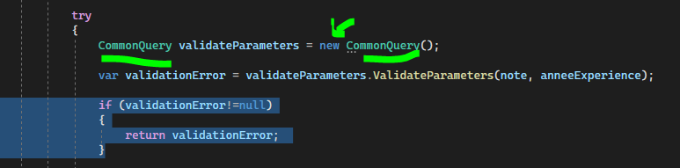

**But why you are using this approach , you can make the methode static like the old one ?**

**The problem is i have error when i declared static , which is an error with the badRequest Return :   
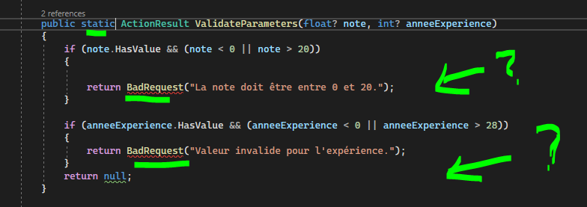  
WHY ? : the ActionResult type is typically used in ASP.NET CORE controllers to represent http responses and status codes like BadRequest. In this way you don’t have the access to the instance-specific methods and properties of a controller, because a controller is essentially a C# class that inherits from the ControllerBase class , when you define controller methods within this class , they are considered instance methods . so the solution is a non-static methods .**

**There is another technique to use the static by passing ActionContext in the methode , but is not commonly used .**

**Summary : to use BadRequst or other instance specific methods you either need to make the methode non-static which commonly used and good , or pass the necessary context to the static method (not used commonly ).**

**In the first image : WHY WE PASSED THE _DB_ANCFCC in the function BuildCommonQuery addition to note, idconcours , and anneeExperience ?   
The object dbAncfcc of type DbAncfccContext is being passed as paramete to the BuildCommonQuery method to allow methods to interact with a specific instance of the database context wich is DbAncfccContext .**

**So we ensure that you work with the appropriate context and retrieve infromation and interact with the database.**

**CACHING AND PERFORMANCE OPTIMIZATION :**

**CACHING : is the process of storing frequently used data or computataions in a temporary storage location .**

**WHY CACHING : serve faster without recalculating or re-fetching it from the original source  
reduce the time and resources needed to generate responses or fetch data.   
WHEN THE CACHING IS ESSENTIEL ? :**

**A data is fequently accessed by multiple users : User profiles , product catalog infos, settigs …**

**Database queries , especially those involving complex joins or aggregations.**

**External API Calls .**

**Dynamic web pages .**

**EXAMPLE OF CACHING :**

1. **Install the package microsoft.extensions.Caching.memory from Nuget package to add Caching to the ASP.NET Core Application. Or by : donet add package Microsoft.Extensions.Caching.Memory from the Console (PM console)**
2. **Add the dependencies to configure Caching in Statrtup.cs or program.cs :   
   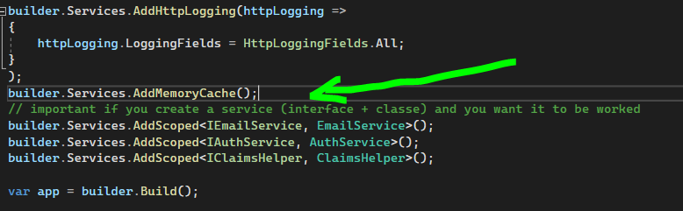**
3. **Use Caching to your controller :   
   a. Inject the IMemoryCache into the controllers’s constructor.  
   b. check if the list of the cancoures is already cached using : _ cache.TryGetV  
   c. if false : we create a cache entry option to make a duration for this cache   
   d. if false , if not cached , we fetch the data from a database , and store it in the cache with a specific expiration time using _cache.Set.   
   e . if true , if cached ? : for subsequent requests for the same data, the applicaiton cheeks the cache first before going to the original source.**

***LOGGING AND MONITORIG :   
The process of saving the status and the behavior of an action.   
HOW TO IMPLEMENT IT ? :*Chose a Logging library or framework like Serilog or Nlog from Package Manager Console or Nuget package .   
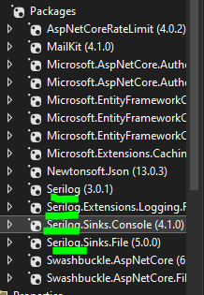  
Inject the Logging library in your controllers and configure it on the Startup.Cs or Program.cs and specify where log messages should be stored or sent . ( you can log to a fille, console, database or even a centralized log management system )  
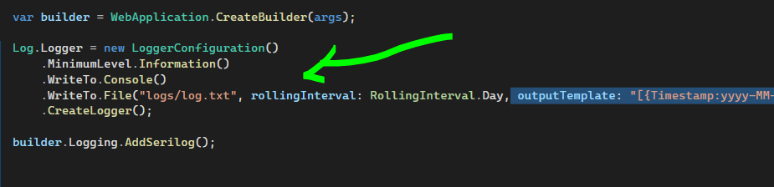  
In your controllers and methods,Implement logging at different levels (Debug, Info, Warning, Error, Critical) based on the siginificance of the events in your application.**

**Log important Events Like : log requests , responses, authentication events, exceptions…  
  
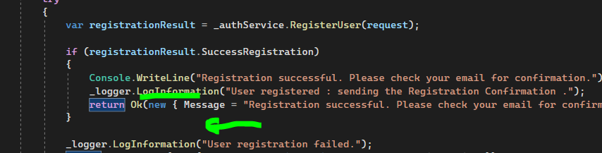**

***MONITORING :*The process of observing and collecting data about system’s performance, health and behavior .**

**HOW ? : tracking various metrics and logs to ensure that a system is operating as expected and identify any issues or amomalies And detect problems early .**

**HOW implement Monitoring ? :**

**A . chose a Monitoring tool : like Prometheus, Grafana,Application Insights , in my context we gonna use Application Insights which is integratied with Azure.  
B. if we’re using Azure , we can easily set up Application Insights for our ASP.NET CORE APPLICATION**

**C. Create an Application Insights resource in the Azure portal and obtain the Instrumentation Key**

**D. Install the Application Insights SDK package to ASP.NET CORE PROJECT.   
*dot net add package Microsoft.ApplicationInsights.AspNetCore.***

**E. YES EXACTLY , we need to configure Application Insights in the Startup.cs or program.cs with you Instrumentation Key :**

***Builder.Services.AddApplicationInsightsTelemetry(Configuration[‘’ApplicationInsghts : InstrumentationKey’’]) ;***

**F. Use the Application Insights SDK to log telemetry data and track events in your application :   
 In your Application, inject the variable in the constructor of your methods and controlleres  :   
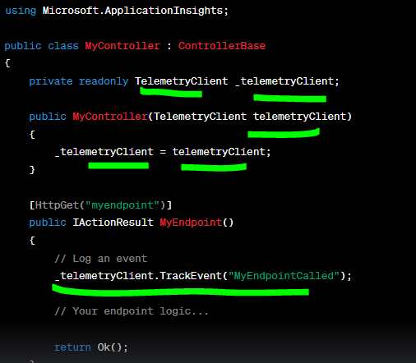  
 when the action is called , it logs an event to Application Insights.  
G. once your application is running and telemetry is being sent to Application Insights, we can view monitoring data , such as requests , exceptions, dependencies, and custom events in the Azure portal .**

**E. Create Alerts and Dashboards to get notified when specific conditions are met or to visualize key performance metrics.   
WEB SECURITY :**

**Common security vulnerabilities : How to prevent them ? :   
  
A. SQL INJECTION (SQLi) :**

**the attackers insert malicious SQL querues into input fields to manipulate the database .   
Prevention : Use parameterized queries to sanitize and clean user inputs.  
Example :**

**A login endpoint that’s vulnerable to SQL injection :   
  
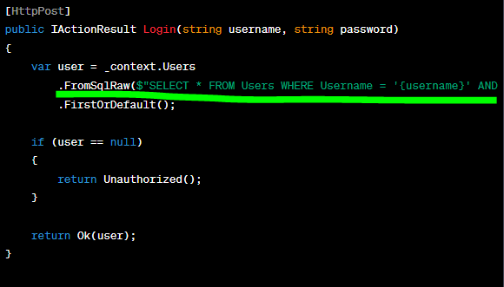  
  
Instead : use this parametrized Queries :** 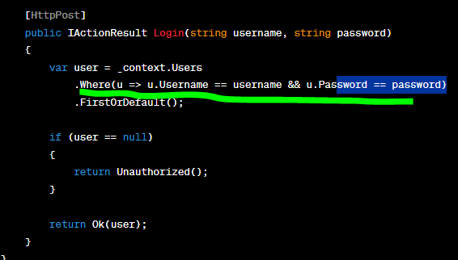

**The difference ? : use pareameterized queries or prepared statements in the code , instead of injecting user input directly into SQL queries. Bu using :  
*.Where (u=> u.Username == username && u.password == password)***

**HOW WE CAN LOGIN IN ACCOUNT WITHOUT KNOWING THE PASSWORD IF ENDPOINT IS VULNERABLE TO SQL INJECTION ? :**

**WE HAVE THIS SQL CODE : USERNAME = ‘ ’ AND PASSWORD ‘ ’**

**IN THE PROCESS OF LOGIN WE GONNA ENTER : MOHAMMED PASSWORD1234 .   
CORRECT PASSWORD .  
IF WE DON’T KNOW THE PASSWORD AND WE NEED TO LOGIN :   
we can inject the code of SQL : IN THE FIELD OF THE USERNAME WE ENTER :   
*USERNAME = ‘MOHAMED’ OR 1=1 #’ AND PASSWORD = ‘1234’*THIS MEANS : THE CODE SQL IS : MOHAMMED WICH IS TRUE , OR 1=1 WHICH TRUE , THE HASHTAGE IS FOR TELLING THE CODE SQL TO FORGET ABOUT WHAT’S NEXT WICH IS PASSWORD = ‘1234’**

**AND WE CAN ENTER IN THE PAGE .**

**BUT HOW THEY KNOW THEY CAN USE SQL INJECTION ?   
IN THE USERNAME FILED : WE ENTER THE CORRECT USERNAME AND ADD THE : ‘ .**

**IF THE ERROR IS : AN EXPECTED ERROR OR AN ERROR WICH IS RELATED TO SQL , SO THE SQL INJECTION IS THERE .   
  
B.. CROSS-STIE SCRIPTING (XSS) :**

**Allows attackers to inject (send) malicious scripts into web pages (scripts), it’s executed by the visitorr’s browser . leading to various attacks, such as stealing user data, session hijacking, or defacing websites.**

**HOW ? :**

**In the normal ways, i have a field that contain the name , we enter the name and the page retouren the message Hello, Chirstophe , and the endpoint GET is this :   
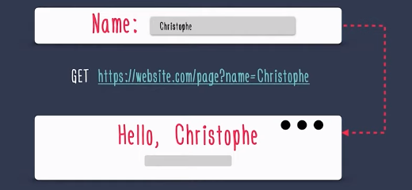**

**Now the attacker (any visitores can do the folllowing : ) :**

**In the name field , he gonna add a script : the common to test is : <script>alert(1)<script>   
 that make the endpoints like this, and the web pages after that gonna execute the code with milicious code injected by the user of the page . leading to view the behavior of the script , viewing the box with the number 1 .   
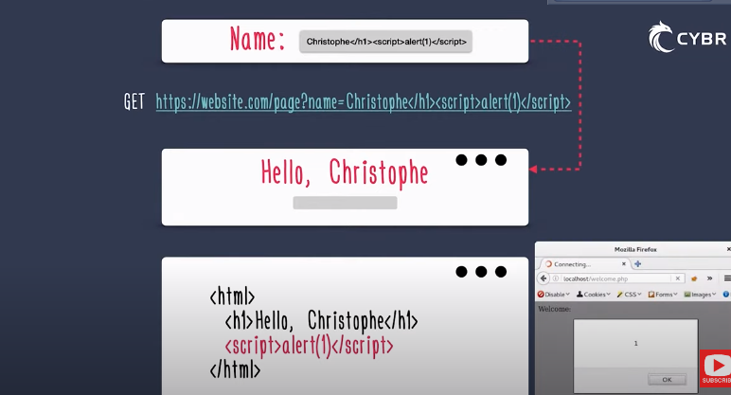**

**HOW THEY CAN STOLE MY INFORMATIONS ? :   
THE COMMON IS the attacker uses a form to store a script tag in the application database , then on a view page that script is rendered and executed . so the sensitive information are stolen .**

**\* WHY THIS IS HAPPENDED ? : Because the inputs are not sanitezed .**

**\*HOW TO SANITIZ THE INPUTS THEN ? :   
before sanizing : vulnerable to XSS ATTACKS :**

**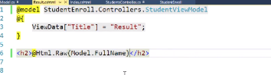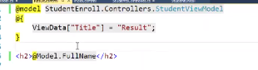  
@html.Raw OR using @Model directly === > vulnerable to XSS attack.   
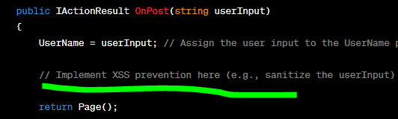  
AFTER SANITIZING :**

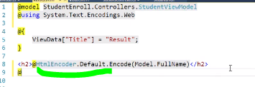

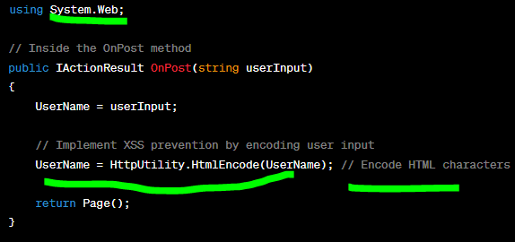

**Using HttpUtility.HtmlEncode to encode HTML characters in the ‘UserName’ Input , preventing potential XSS attacks , by encoding this symbols of the code malicious : <>/ …. <script>alert(1)</script>  
  
  
**PRACTICING XSS IS TYPICALLY MORE RELEVANT TO WEB APPLICATIONS WITH HTML AND VIEW , RATHER THAT, APIs .**

**C.. CROSS-STIE Request Forgery  (CSRF) :**

**The attacker tricks a user into performing actions on a website without theire consent or knowledge .   
  
HOW CSRF WORKS ? :   
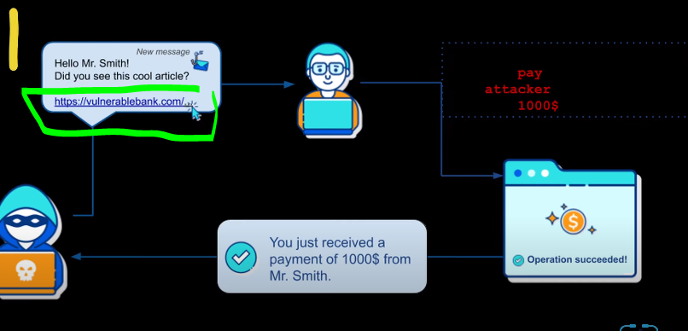  
The victim is already authenticated on a websie (e.g … banking or email accout … )  
The hacker sends a Malicious request to the target website , making the victim perfoem an unwanted action . if the victim cliks on the link , the link for example is for changing the victim’s email address or transfer money to the attacker’s account . the attackar’s request works because it’s sent from the victim’s browser (the victim click the link ) which is authenticated with the target website .**

**CSRF attacks primarily target web applications that use cookies to maintain user sessions .**

**HOW TO PREVENT CSRF ATTACKS ?  
USING ANTI-CSRF TOKENS : include anti-CSRF tokens in forms that modify data or perform actions These tokens should be genereate for each user session and validated on the server for each request .   
CHECK THE ORIGIN HEADER : verigy that the requests coming to your sever originate from your domain . by checking the ‘Origin’ or ’ Referer’ .   
  
Example :   
  
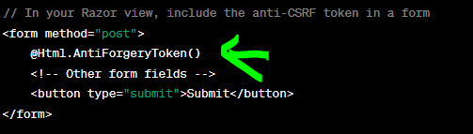  
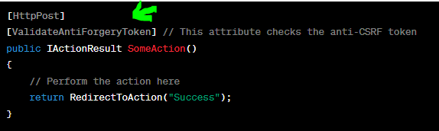  
this code generate and validates an anti-CSRF token in your form , ensuring that the request comes from a legitimate sourece .**

**WHEN YOU NEED TO PAY ATTENTION ? :**

**\*\* In your ASP.NEET CORE APIS of type POST it is advisable to use [ValidateAntiForgeryToken] to protect against Cross-Site Request Forgery (CSRF) Attacks, this attribure helps ensure that the requests made to your POST endpoints are legitimate and originated from your application .   
** In Your Controlller Actions that modify data or settings are more vulerable .   
** CSRF protection is more relevant when you have HTML forms that create, update or delete ressources on the server , not for API endpoints that perform actions based on data provided in the request body .**

**\*\* in a RESTful API without HTML forms , the usage of the attribure [ValidateAntiForgeryToke] may not be relevant. Instead we consider alternative authentication and authorization mechanisms like OAuth2.0 or JWT TOKEN , USING HTTPS, RATE LIMITING , PASSWORD POLICIES , VALIDATION (COMMON SECURTIY VULNERABILITIES LIKE SQL OR XSS ATTACKS), AUTHENTICATION TOKEN , A.   
  
HOW IT WORKS : ?   
When a POST request is made , ASP.NET Core automatically validated the anti-CSRF token included in the request against the token generated for the user’s session, if the token is missing or invalid, the request is rejected.   
this ensures that only requests originating from your web application with the correct anti-CSRF token are accepted to prevent CSRF attacks.   
  
  
API VERSIONING AND DOCUMENTATION :**

**Api versioning : Allow us to manage changes in a way that doesn’t distrupt existing users while enabling you to introduce new features or improvements .**

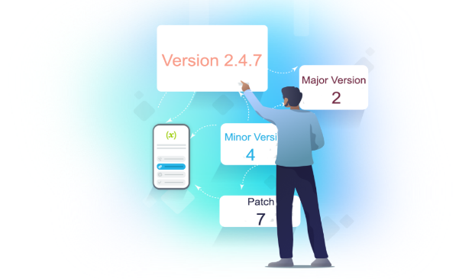 **the clients chose the version if he got time !   
HOW ? :**

**L’ets say you would like to offer your customers a way to get a list of their current processing ordres .**

**But one dat you need to make a breaking change of the list (add something , or remove something) , the first normal solution is to stop this menu until you do your modifications , but the users gonna be angry . wich is not good . they should be happy all the time.**

**What to do ? :**

1. **Talk with all customers and make change in all lists at the same time as we make the changes (deploy the new solution to our host ) 🡺 NOT RECOMMENDED.**
2. **Add new method (new URL ) in the API that serve the new model and ask the customer to update their app ( the menu) 🡺 NOT RECOMMENDE .**
3. **Make use of API versiooning and just give the customer the option to change the version parametre in the URL when they are ready for it . 🡺 RECOMMENDED .**

**So the benifit ?   
  
we can call the same method in the same way , but with a different verison number in the URL . so the developer is able to serve the data to clients that we would like , and our users also able to wait and update their applications when they got time for it in their systems. So all the people are happy .**

**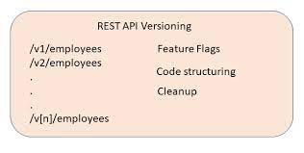  
  
The Signifiication of the error :   
if you to USE an API WITHOUT THE DECORATION : [ApiVersion( ‘1.0’)] wich is set in the program.cs , you will get this error :**

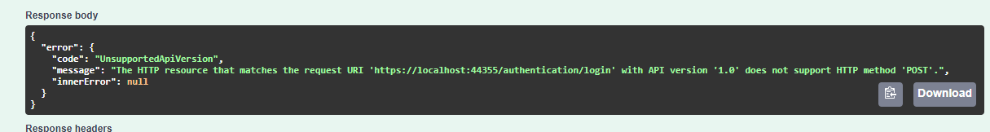

**Why ? :**

**You want to use an API wich is not configured by the version API 1,0 . also you have declared that the version is 1.0 in the program.cs .   
  
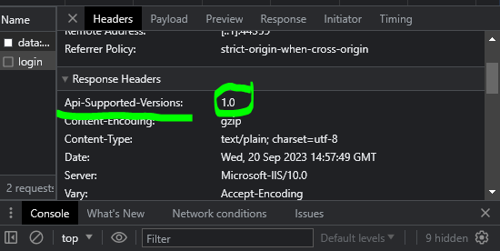**

**So how can i use two versions of the controllers ?  
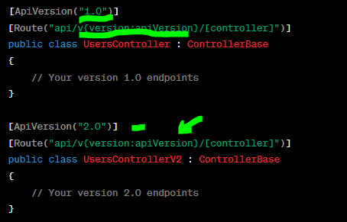  
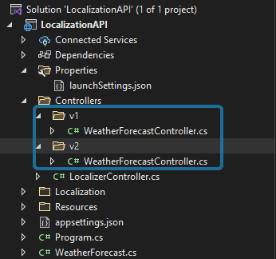**

**You need to enter the version in the field : for example enter v1.0 :**

**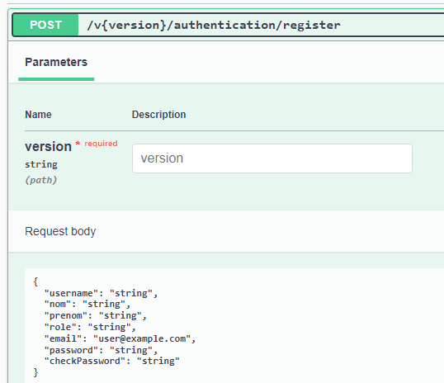  
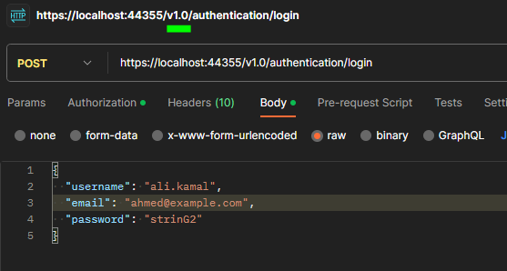**

**[MapToApiVersion] : provide the wat to explicitly specify the API version that an action methos or a controller should be mapped to .**

**When use it ? :**

**When you have different versions of the same resource or endpoint.**

**Give Code Clarity and readability , and developer quickly identify the intended API version.**

**Help in Documentation tools like Swagger to display information for each endpoint.    
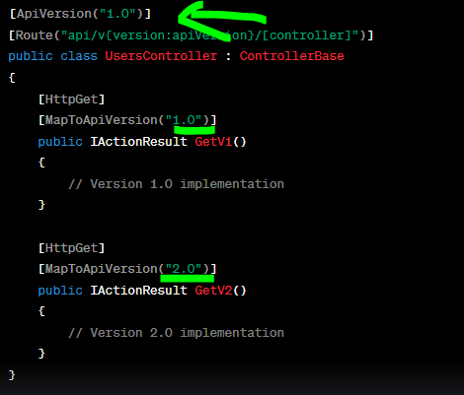**

**API DOCUMENTATION WITH SWAGGER :**

1. **ADD SWAGGER TO YOUR ASP.NET CORE PROJECT :**

**FROM THE NUGET PACKAGE MANAGER ADD : SWASHBUCKLE.ASPNETCORE  
 2. CONFIGRUE SWAGGER IN STARTUP.CS OR PROGRAMS.CS :   
  
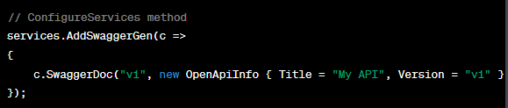**

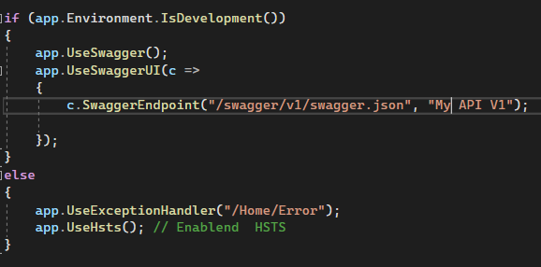

**3.How to document the project and make the ressources :   
you need to create a new OPEN API INFO in your startup.cs or programe.cs to set the title , version , description , contact :**

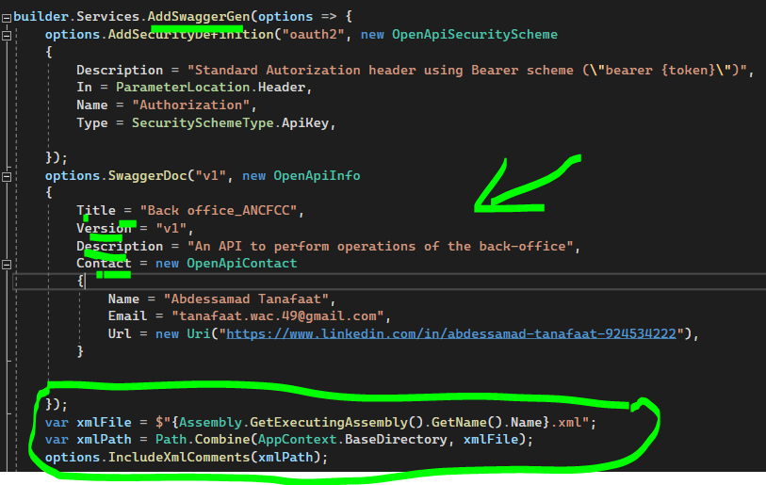

**The result :**

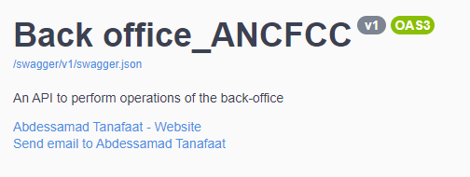

1. **How can I document THE APIs :**

**Describing response types : the developers who consume our APIs are usually more interested in what it returns (the response , types and error codes)**

**HOW ? :**

**We gonna use XML comments & data annotations.**

**First , You need to avtivate it , of courese in the programs.cs or startup.cs :**



**Second , use the xml files in the controllers and methodes :**

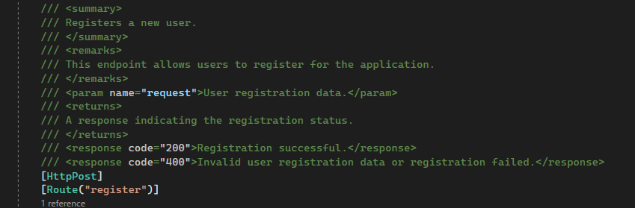

**<summary> : tag used to describe the purpose if the API method.**

**<remarks> : tag provides additional information about the endpoint.**

**<param> : tag to document the input parameter .**

**<returns> : tag explains what the method returns.**

**<response> : tag describe possible http responses and their meanings.**

**HOW I CAN ADD A TYPE RESPONSE OF THE http REQUEST ?**

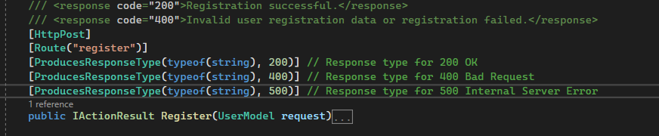

**The result :**

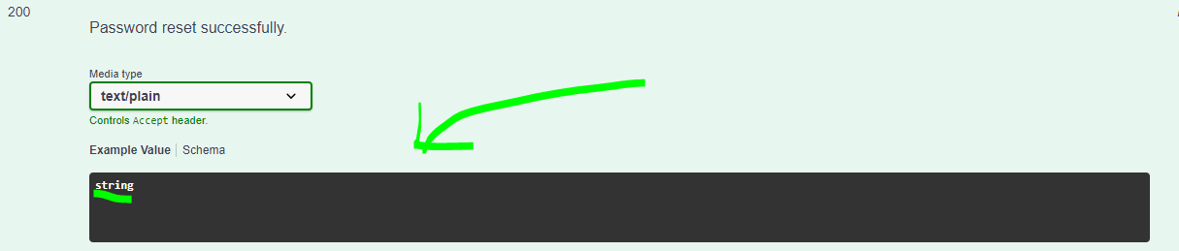

**Note : The tag <returns> will won’t be directly visible . Swagger focuses primarily on documenting the request and response parametres and their descriptions.**

**Background Processing and Queues :**

**Almost all applications need to do some sort of background work. Whethere it’s a long and tedious task or a repetitive job that we need to do every other day .**

1. **Background Processing :**

**Some tasks in web applications such as sending emails , processing uploaded files , or performing periodic maintenance can be time-consuming and should be executed in the background .**

**WHY ? : avoid blocking the main application – improve the performance , scalability , responsiveness of your application ensuring that tasks are executed in the background .**

**We can schedule backround jobs using some libraries like Hangfire or Azure functions to execute backround jobs.**

**Example : using Hangfire , we gonna use BackgroundJob.Enqueue : used for offloading non blocking , long running, background tasks , it’s mean that when you enqueue a backgorund job , the job will processed be a background processng system(e.g, Hangfire)**

**So you’re thinking of Public async Task method , GREAT !! :**

**Asynchronous Operations : The use of async and task in a method indicates that this method can perform asynchrounous operations , Like sending an email , storing data in database , or performing other I/O bound operations.**

**HANGFIRE : A TASK SCHEDULER FOR ASP.NET AND ASP.NET CORE , MULTI-THREADED , EASILY SCALABLE , SIMPLE TO USE .**

**STEPS :**

1. **INSTALL HANGFIRE NUGET PACKAGE IN NPM .**
2. **CONFIGURE YOUR PROGRAMS.CS OR STARTUP.CS :**

**THE ERROR FAILED TO LOAD API SOLUTION :**

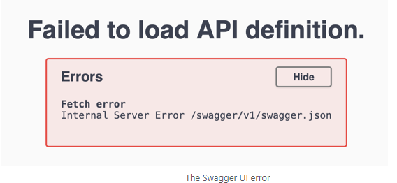

**TO KNOW QUICLY THE ORIGIN OF THE PROBLEM , YOU NEED TO SEE THE NETWORK PAGE , TO KNOW WHAT’S THE METHOD CAUSING THE PROBLEM IN YOUR CONTROLLERS .**

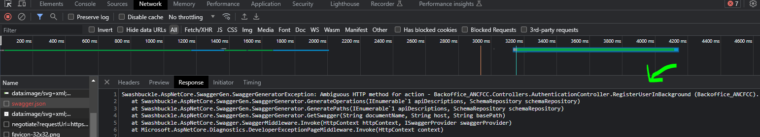

**THE SOLUTION THEN BASED IN MY PROBLEM :**

**EXCLUD THE METHOD FROM SWAGGER DOCUMENTATION BECAUSE THE REGISTERUSERIN BACKROUNG METHOD IS NOT INTENDED TO BE USED AS API ENDPOINT. BY USING THIS ATTRIBUTE :**

**[ApiExplorerSettings(IgnoreApi = true)]**

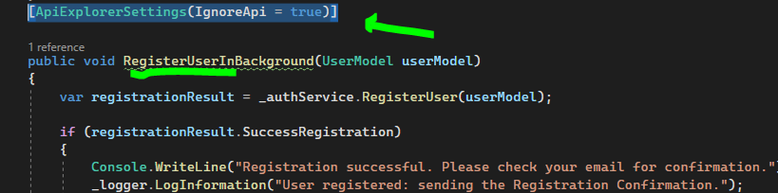

**HANGFIRE DASHBOARD :**

**Tool to managing and monitoring backgroung jobs in your application .**

**WHY ? :**

**When a post request is made to an endpoint. Instead of handling the registration process for example immediately , the API enqueues the registration task asynchronoulsy for background execution using a background job processing library like Hangfire .**

1. **URL DASHBOARD :   
   localhost:44355/dashboard.** 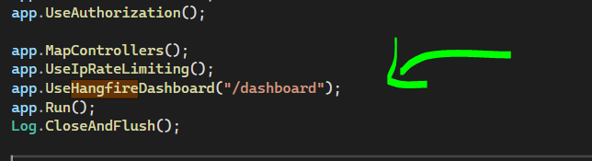

**And you need to add the service by using :**

**Builder.Services.AddHangfireServer();**

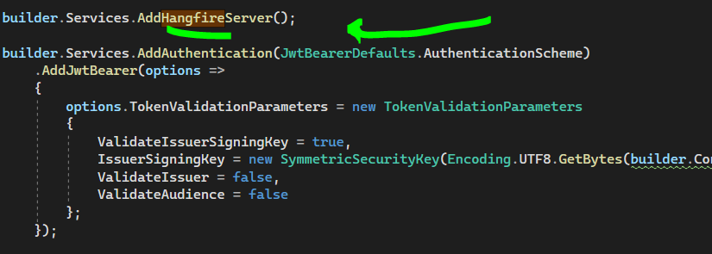

**Note : by default ,if you don’t change the name in the program., you need to use this url :**

**Localhost: 44355/hangfire**

1. **Dashboard Sectinos :**

**Dashboard Overview : the main page of the dashboard provides an overview of background job serves, recurring jobs, and queues.**

**Reucurring Jobs : diplays recurring jobs , which are jobs that run on a schedule .**

**Jobs : You Can view and manage background jobs in this section. You can retry , delete , or requeue failed jobs.**

**Enqueued Jobs : shows jobs that are currently enqueued and waiting to be processed .**

**Succeeded Jobs : Lists jobs that have successfully completed.**

**Failed Jobs : Displays jobs that have failed and provides error details.**

**Processing Jobs.**

**Scheduled Jobs : jobs that are scheduled to run in the future .**

**Sevrers : information about the Hangfire servers , including theur status and performance metrics.**

**Reties : if a job fails , hanfire can automatically retry it a certain number of times or based on a specific policy (we can mange it ) .**

**We can manually cancel or delete enqueued jobs or recurring jobs .**

**We can manually Pause / Resume background job processing globally or for specific recurring jobs.**

**We can custom Dashboard view and the appearance and behavior .**

**We can add security to secure Hangfire Dashboard to prevent unauthorized users . We can use authentication and authorization mechanisms to restrict acccess to authorized users only.**

**We can use extensions and plugins that can enhance the functionlity of the dashboard.**

**When deploting your application to production , ensure that you properly secure the Hangfire dashboard and deploy it on a separate server or instance to add more security .**

**Concurrency in Entity Framework :**

**The objectif : is to prevent two user from updating database in the same time .**

**The steps :**

**to handle concurrency using EF 6 databse-first approach :   
1. Create Column with rowversion with type data timestamp in the SQL Server .**

**Timestmp is an icrementing binary number which is incremented for each insert and update operation on a table contains a rowversion column .**

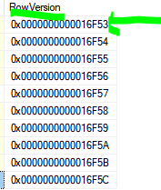

**2. By default The concurrency mode is fixed when we set the data type in timestamp .   
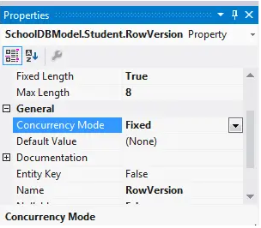**

**EF API will now include this RowVersion colun in the where clause in each UPDATE command and if the rowversion value is different than the existing value in the database, then it will throw DbUpdateConcurrencyException.   
3 . include the DbUpdateConcurrencyException in the method api PUT :**

**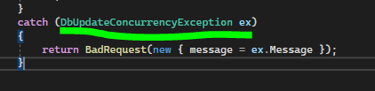  
4. You may occurred this error when you call the api :   
 *"RowVersion": [***

***"The RowVersion field is required."***

***]***

**To resolve this error :**

**In The DbAncfccContext.cs add the following line :**

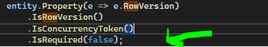

1. **To test it’s working add a debuging before saving the changes to database to make it stop . then update manually the fields , and after that click continue : 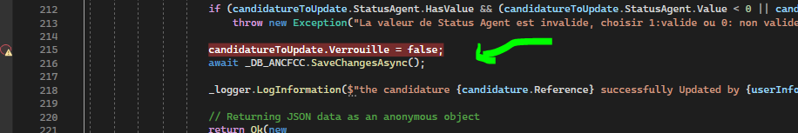 and you will get this error , that make sure that the UpdateCONCURRENCY IS WORKING :** 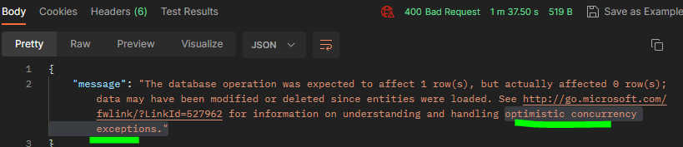

**CHAPITRE 3 : C# ENTITY FRAMWORK CORE  
Working with databases.**

* **ENTITY FRAMEWORK CORE (EF CORE) : is an Object-Relational Mapper (ORM) framework for data access in .NET Core applications .   
    
  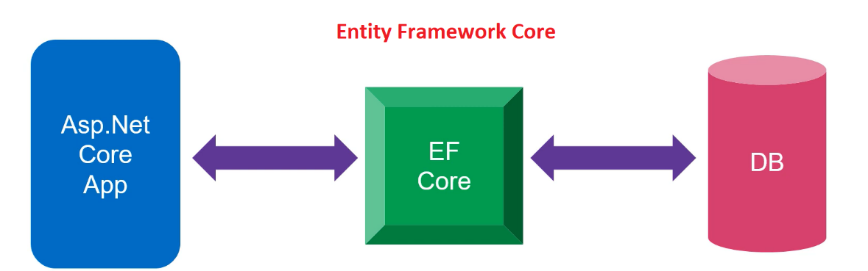**
* **ORM**: **Object Relational Mapper , is automaically generates classes based on   
  database tables and vice versa. So we don’t need extensive data acces code !  
    
   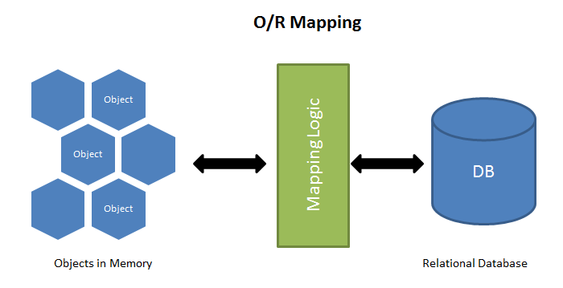**
* **WHY ORM LIKE EF CORE ? :   
    
  * reduce the need for writing repetitive data access code .**

**\* generate SQL to preform CRUD operations**

* **WHY ENTITY FRAMWORK CORE ? :   
     
  *simplifies data access by mapping objects to database tables.   
  * Automating database CRUD operations , genrate necessary SQL commands.**

**\* Supports LINQ to entitird for querying data .**

**\* Bridges the gap between application code and the database .**

**\* Supports various datavases types (relational and non relational).  
  
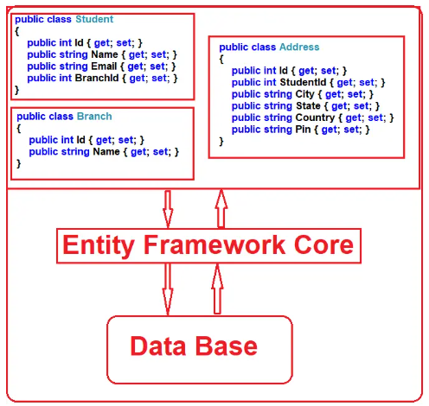**

* **Develpment Approaches in EF Core :  
    
  Code-First Approach : define your application domain classes and DbContext Class, then EF CORE create the database shema and tables based on theses classes using migrations.**

**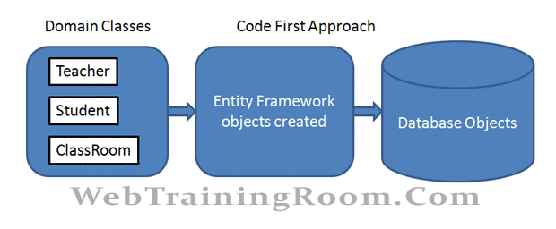  
  
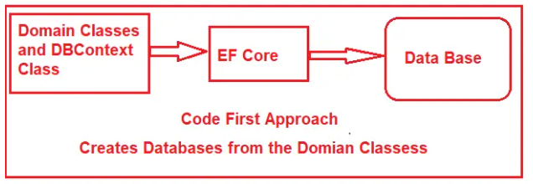**

* **Database-First Approach : if you have already existing database, EF Core generate Db Context and domain classes bases on the existing shema using EF Core Command.   
    
    
  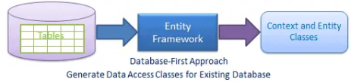  
    
  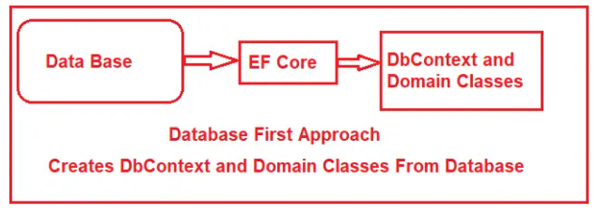**

**the famous methode is the database-first approch..  
  
  
HOW WE CAN CREATE MODELS FROM EXISTING DATABASE ?  :**

**1. Connect to the database :**

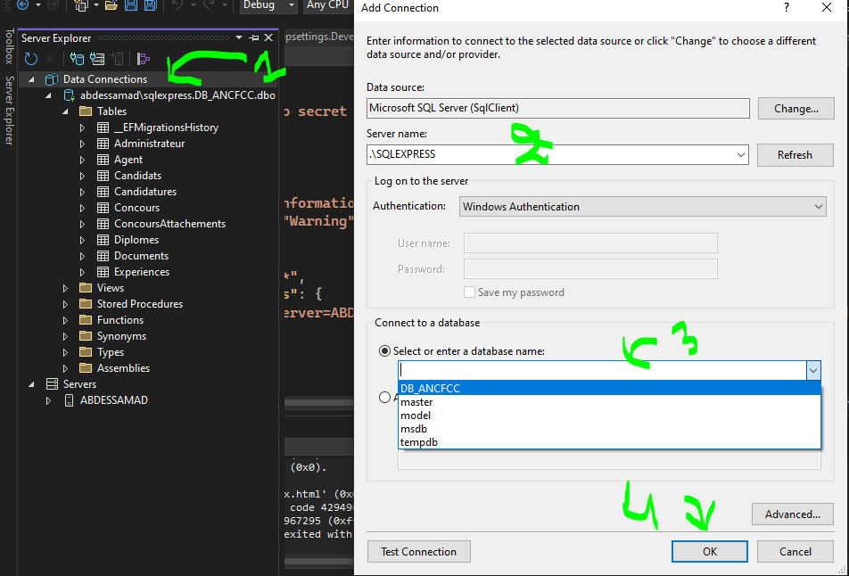

1. **Installing ENTITY FRAMWORK CORE SQL SERVER PACKAGE (working with SSMS) and ENTITY FRAMEWORK TOOL (to scaffold database) in the NUGET PACKAGE FROM TOOLS. Now you have 2 dependencies you can see them in dependecies column.   
     
   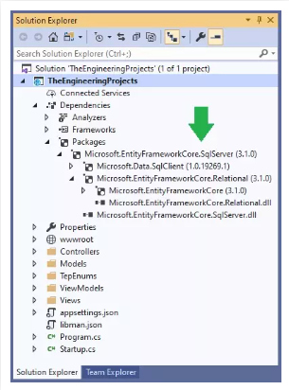**
2. **Modify the appsettings.JSON in your project  :**
3. **Scaffold the database : in the package manager console write :****Scaffold-DbContext "Server=.\SQLExpress;Database=DB_ANCFCC;Trusted_Connection=True;" Microsoft.EntityFrameworkCore.SqlServer -OutputDir Models**

**MY TEAM MADE MODIFICATIONS IN THE DB , HOW CAN UPDATE THE MODELS ?  :  
  
1 . write this in the PACKAGE MANAGER CONSOLE (PM) :**

**Scaffold-DbContext -Connection Name=DB_ANCFCC Microsoft.EntityFrameworkCore.SqlServer -OutputDir Models -force**

**Introduction to DevOps :**

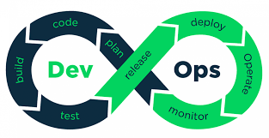

**DevOps (Development + Operations) :**

**DevOps is a set of practices and cultural that aim to automate and integrate the process of software development (Dev) and IT operations (Ops).**

**\*\* Devops enginner :**

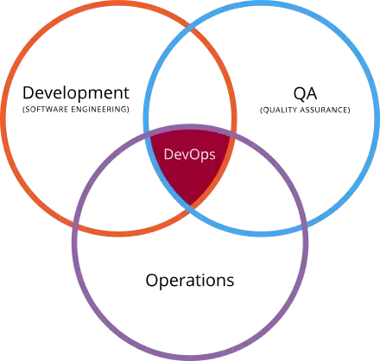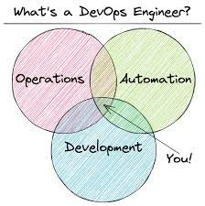

**\*\* The role of the QA in the DevOps :   
Qa verifies that the development team is delivering the technical requirements needed to satisfy the operational tema’s golas .**

**_ Their efforts contibute to the early detection and prevention of defects , ensuring that high-quality software is delivered rapidly and reliably to end-users.**

**WHY DevOps ? :**

**There was issues betwen the development team and IT oprataions . In the past they work separatly , work in isolation : Devolopers focused on writing code , while oprations teams responsible for deploying and maintaining software in production. Do this approach created comminicatio barriers and slowed down the release of new features and updates.**

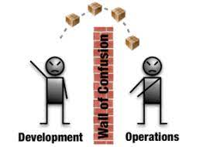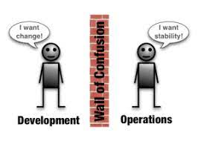

**The SDLC (SYSTEM DEVELOPEMENT LIFE CYCLE ) is more present . we need to pass throw this process step by step if we add a new feature (branch) , wich take a long time , and also it make the stability of the system down and we need long time to make it back to the normal because it’s take RAM , CPU , …** 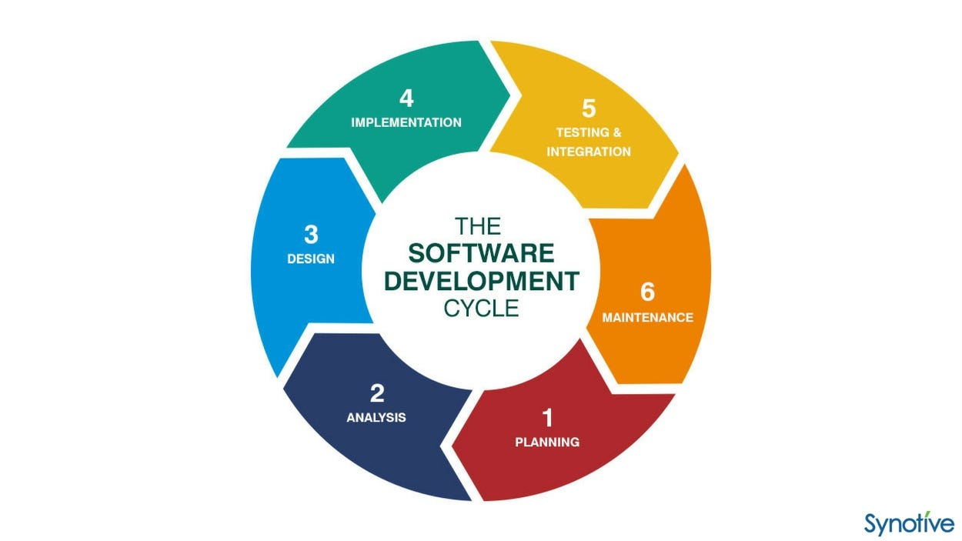

**To make those steps manually this take times so we need to automate the buildidng , testing , deployment of code changes . this reduces human error and accelerates the release process.**

**So here the DevOps comes to get the solution , wich is make the IT operator and Development in the same table . and make a relationship betwen them and improve collaboration , efficiency and the quality of software delvery .**

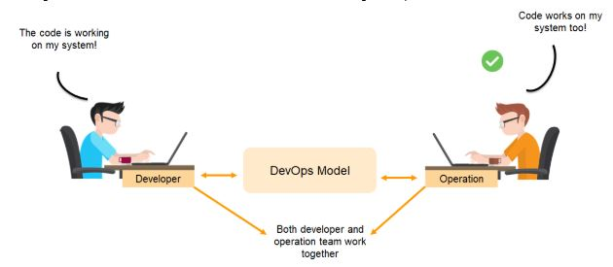

***THE DIFFERENCE BETWEEN AGILE AND DEVOPS ?***

***You need to understand why devops ?***

**To execute the life cycle (SDFC), we need to understand the waterfall .**

**The waterfall :**

**Requirements : Collect what you need to do your application . it may take long periode**

**Planing Or Design  : you need to build the plan in your paper .**

**Developement : write your code and your functions .**

**Test : test your code and find bugs and fix it .**

**Release Or Deploy : Make it visible for people . sometimes called deploy .**

**Maintenance : you can’t collect all the problems in test . you need this step.**

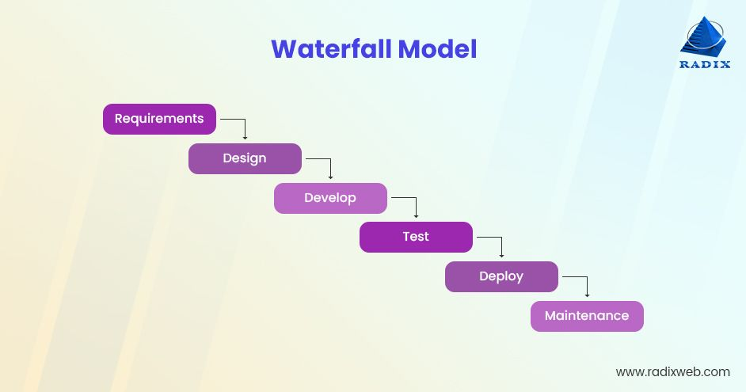

**NOTE : THIS STEPS ARE VERTICALLY ANT NOT HORIZONTALLY , BEACAUSE THE WATERFALL IS UP TO DOWN .**

**The big problem is : SO IF YOU APPLY A STEP YOU CAN’T BACK TO IT !**

**SO THERE IS A PROBLEME ? WICH IS THERE IS NO FLEXIBILITY BEACUSE YOU CAN’T BACK TO FIX OR UPDATE A STEP OF THOSE STEPS .**

**BUT WHY YOU WANT TO UPDATE A THING ? BECAUSE A STEP MAY TAKE MONTHS , AND THE CLIENTS WANT TO CHANGE SOMETHING IN THEIR PROJECTS .**

**THAT’S WHY WE NEED ANOTHER PHILOSPHY ? YEES THIS IS THE AGILE .**

**AGILE :**

**IS THE FLEXIBILITY .**

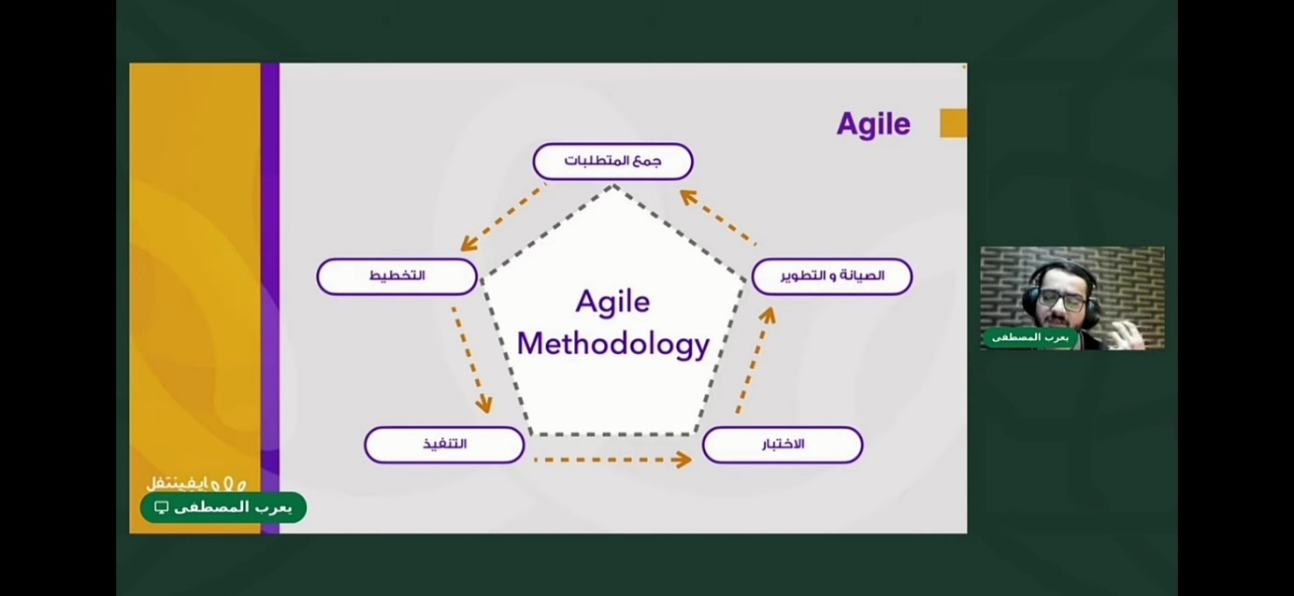

**RULE : YOU NEED TO BE FLEXIBLE MORE WITH THE STEPS .**

**We have the same steps like SDLC but the difference is : we make those steps to a  
 part of the project not the whole project . and after you need to give it to the client**

**To make his remarques and after complete this project based on the remarks of the**

**Project .**

**So there no waterfall we have a cycle . called the Agile Methodology .**

**What’s the problem of the AGILE ?**

**With the AGILE the responsables (developers) had to make a part of the project and give it the operators to deploy it .**

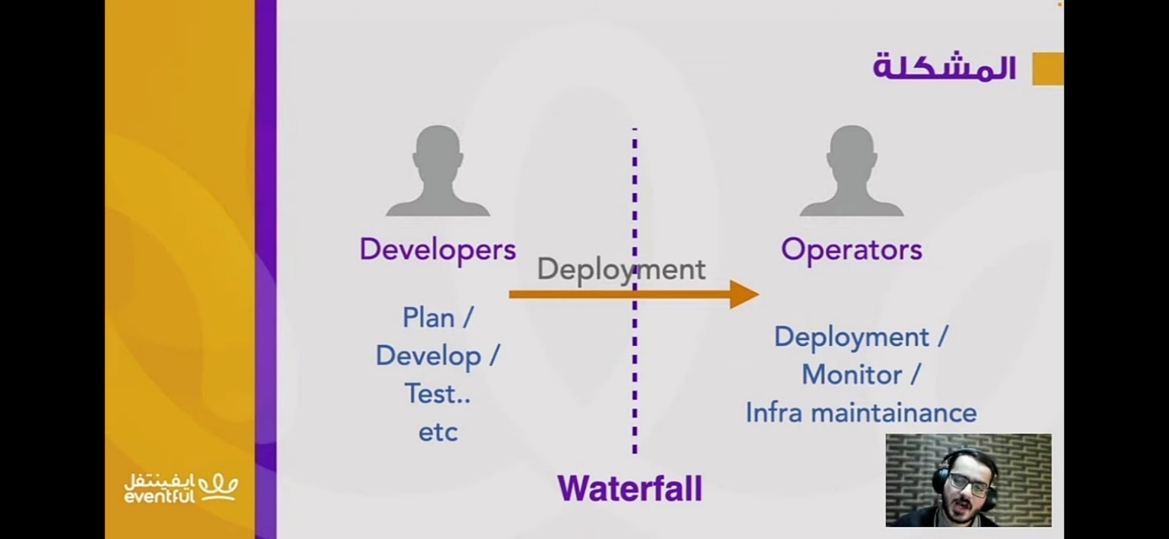

**WE HAVE TWO PEOPLE :**

**\*\* DEVELOPERS : write the code .**

**\*\* OPERATORS : focus on deployment in the piplines (CD/CI) , Monitoring if there pression on the server , and also Infra maintenance and monitoring .   
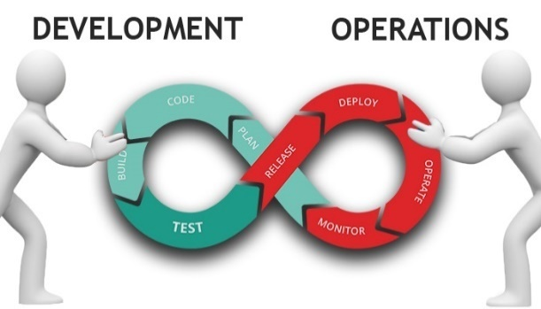**

**SO THE deployment is became so frequent ( kat3awd ). And the also the deployment process is so difficult . and also if the deployment is so frequent , this is make the system none stable and this a problem because always operators look for the stability , because if we make a deployment tha’s mean you do new feature in the staging branch and master branch . so there is new routes that affect the infra structure and their stability .**

**AND WHAT’S THE PROBLEM WITH AGILE EXACTLY ?**

**So the agile is so flexible for the developers and not for the operators and the operators wants stability and developers like to change their code frequently . this is a battle between them !! . So we need another new philosophy !! and here were the DevOps comes in !!**

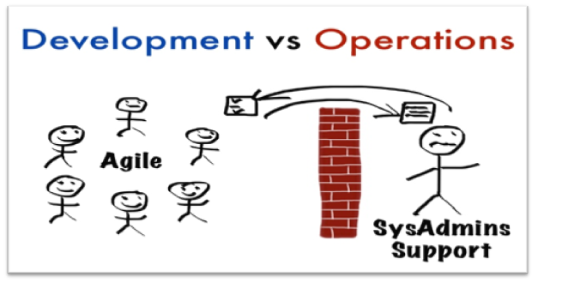

**DevOps :**

**DevOps : make the developers and operators in the same table , and make them close together .**

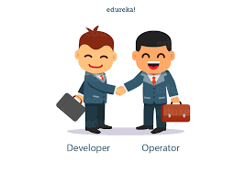

**So DevOps = Automate all the steps of the SDLC (AGILE ) with tools .**

**HOW WE CAN MAKE THOSE STEPS AUTOMATED  ?**

**BUILD : develop you code , you need to collect all the lines and make it in output to be understable by the webBrowser.**

**TEST : write codes to test the main code , it’s exactly the Xunit in ASP.NET .**

**INTEGRATION : We don’t need to integrate parts of codes manually we can do this automatically .**

**Deployment : we deploy the front end and the backend automatically and not manually .**

**Operation : make the infrastructure automated , and also make it able to give reclams and notification if there is something new .**

**Relationshep between the CI CD AND DEVOPS ?**

**THE CI/CD is often interconnected and together , they form a fundamental part of modern software developement practices and the essential part in the devops .**

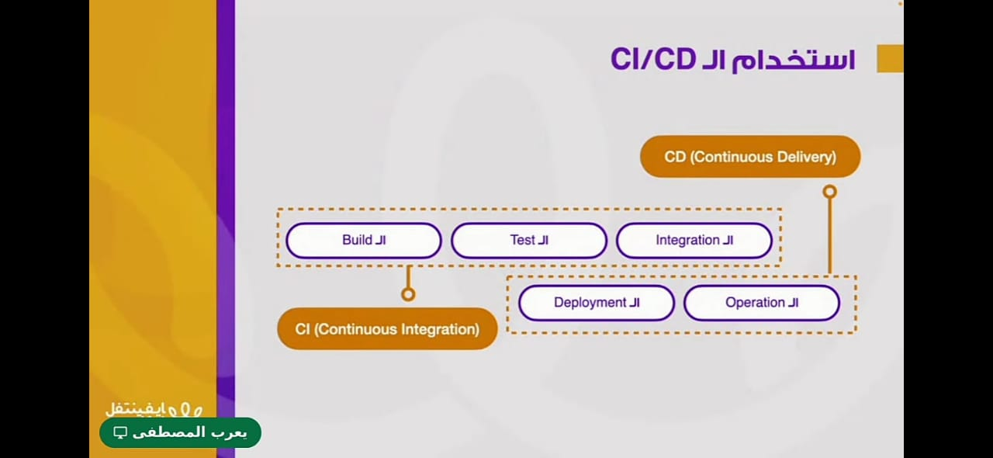

**CI : an automated build and a series of tests to detect integration erros and ensure the codebase’s integriry . the code changes are automatically built, testes, and validated.**

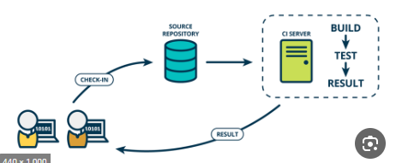

**CD (Continous delivery) : CD pipelines : extends CI by automatically deploying code changes to production or production-like environments after they pass the CI pipeline .**

**THE deploy to prodution is manual here .**

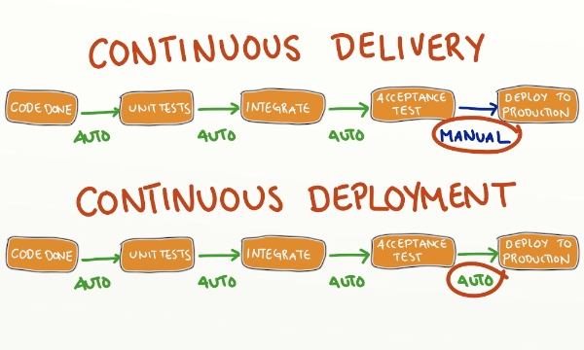

**Note : CD ( Continous deployment ) : is the process that extends the continous delivery , deploy the project to production automatically .**

**RESUME :**

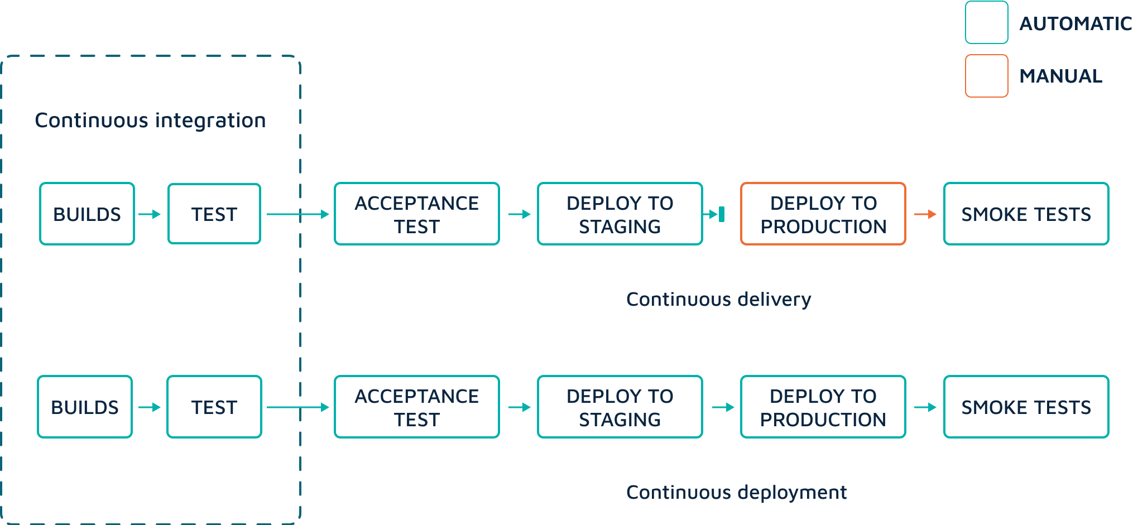

**CI and CD : are integral components of the DevOps philosophy, working together to automate and improve the software development and delivery process.**

**DevOps : focused on the cultural changes and collaboration and process improvement .**

**And then the foundation of the DevOps Enginer or SRE : Site reliability Engineer .**

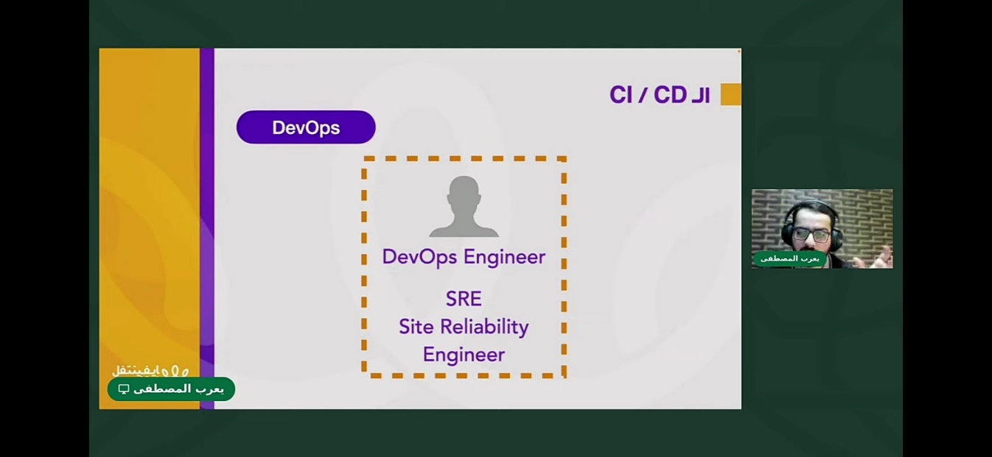

**HOW TO USE CI / CD ? (TOOLS) :**

**This tools enhances collaboration between development and operations teams by automating repetitive tasks and enabling rapid feedback . = > automating the CI/CD pipeline.**

**Helping organizations deliver high-quality software more efficiently.**

**GitHUB : facilites version control and collaboration among developers . provide code repositoreies , pull requests, issue tracking .**

**Travis CI :**

**Serve that automaticallay builds and tests code**

**changes pushed to GitHub repositores .**

**support the automation of CI/CD pipelines .**

**Jenkins :**

**Served for building , testing , and deploying code changes. And supports the creation of complex CI/CD pipelines with a wide range of plugins .**

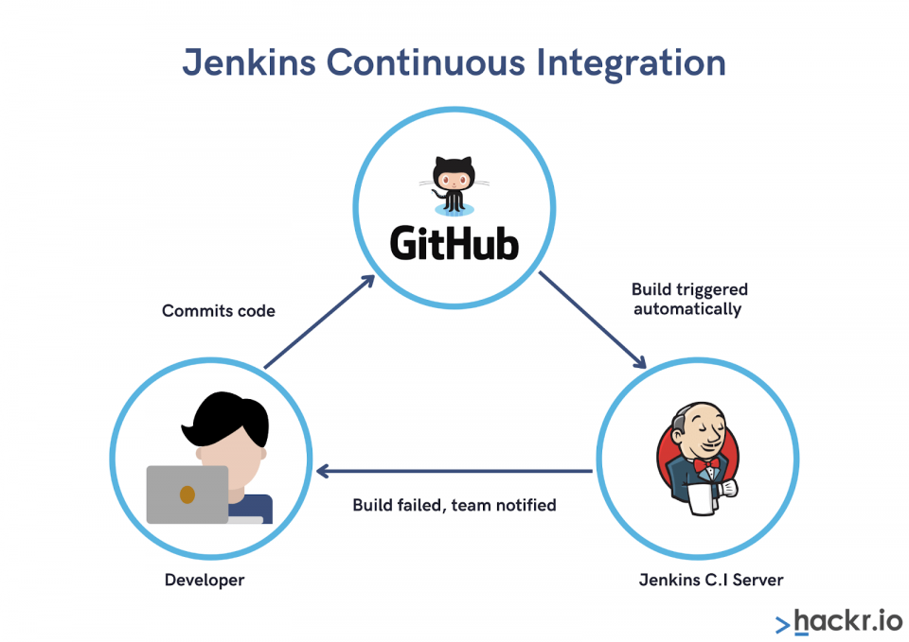

**GitHub Actions :**

**GitHub think of a tools to build , test , and deploy applications, called GitHub Actions .**

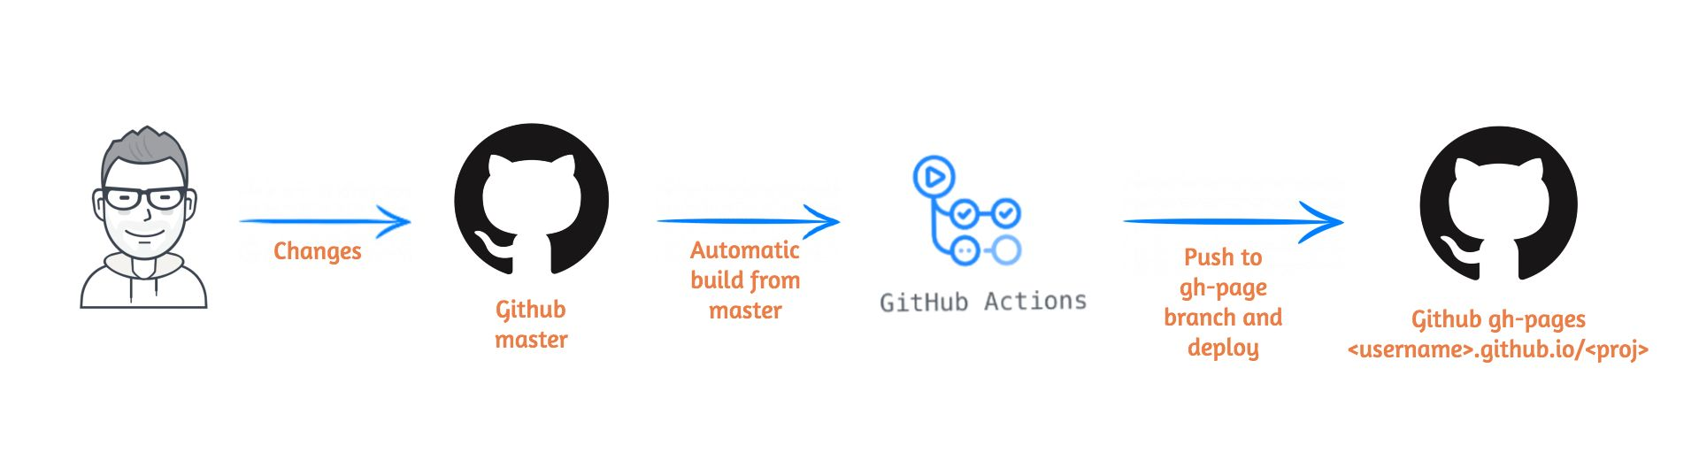

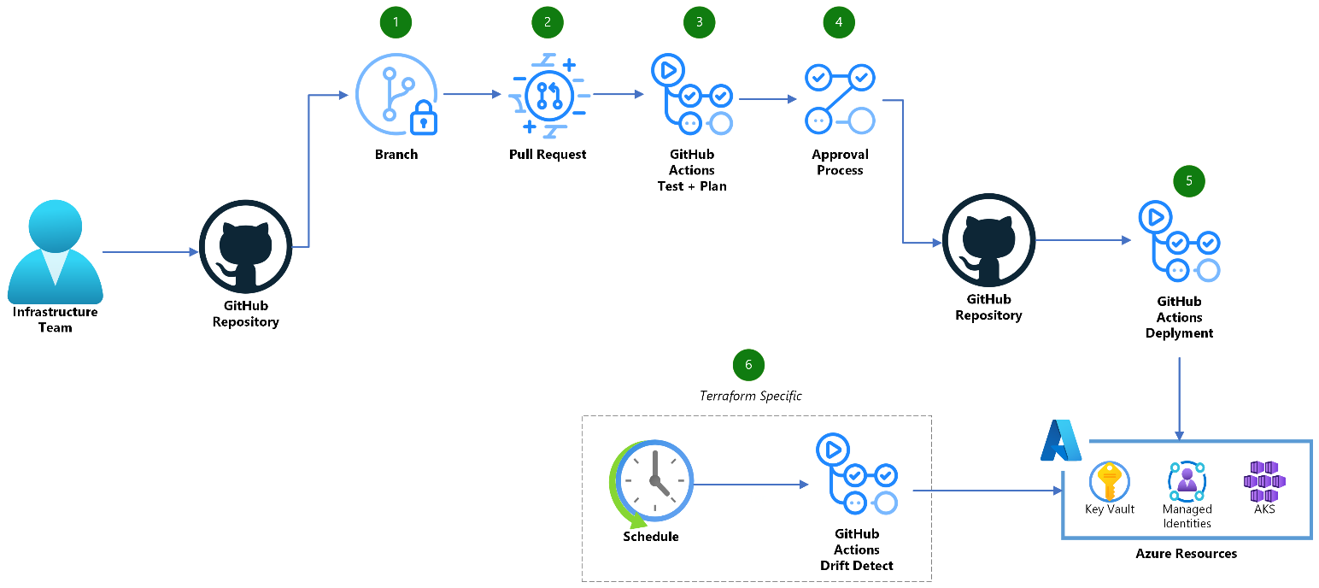

**Bitrise :**

**Automates build , test , and deployment processes for various platforms including iOS and Android.**

**Docker : is a containerization platform that allows applications and their dependencies to be packaged as containers . containers are used to ensure consistent environments across diffrerent stages of the CI/CD pipeline.**

**Promotes the ‘Build once, run anywhere’ concept. Enhace portability and scalability in DevOps practices .**

**LOGO IN DOCKER EXPLAIN THIS : the containers are the boxes on the fish .**

**Kubernetes : is a container orcherstration platform used for deploying,**

**Scaling and managing containerized applications . it plays a vital role in the CD phase by**

**Facilitating deployment and scaling of applications.**

**PRACTICE EXEMPLE :**

**You don’t need to use all thos tools but the importants are :**

**Github , GitHub actions , Bitrise**

**1 . GitHub :**

**You have 2 branches in each project : master and staging**

**You can’t delete them .**

**Staging :**

**before the production before you release the final project .**

**When You add a new feature => developer add a branch in the staging , he add a commit .**

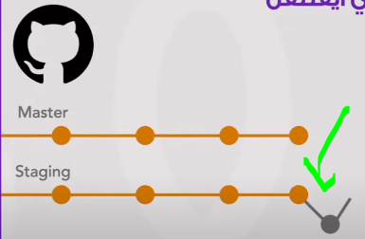

**=> he make request for the merge (pull request : he ask for it : merge request)**

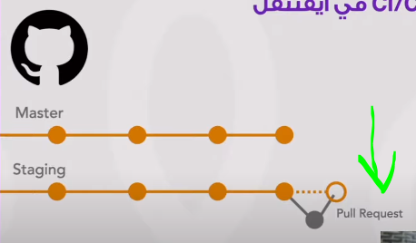

* **Here the role of the bitrise : it descover that somoene add pull request , so the Pipeline CI Begin . and bitrise gonna make automatically build , test, copy pre alpha (new app copy seen by the team only) , send the dawnload link to SLACK .**

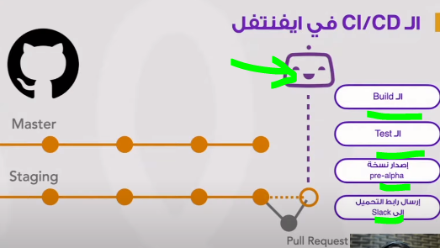

* **If all those steps are correct and there are no errors , the pull request gonna be a part of the staging branch .**

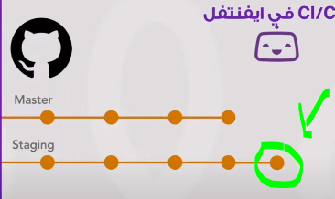

* **And also bitirise work for the second time , because it gonna notice that a new branch added to the staging branch .**

**Create copy alpha : to test it before send it to the master .**

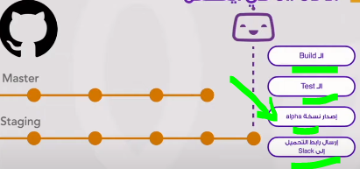

* **And the same steps if a develloper make a changes in codes and push it to github.**
* **And this is because of the CI .**

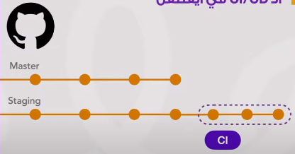

**But the master it must be a copy of the staging ,**

**The master branch = release the app in the app store .**

**We ask for a merger to the master branch .**

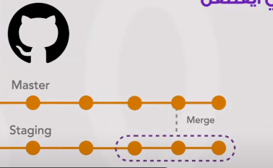

**Bitrise notice that there is a change in master branch .**

**And relase the beta copy inlcude the reel informations but the copy is in the team not yet realesed , and send it to the app store .**

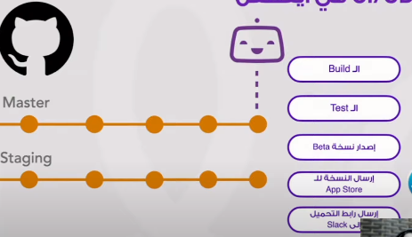

**Bitrise can make the realese automatically, not manually by you , so this is called continuous Deployment not delivery .**

**How to work with bitrise and github desktop :**

[**https://youtu.be/XdaW-gVzsXo?si=EMUUUz0y6RX6YHs5**](https://youtu.be/XdaW-gVzsXo?si=EMUUUz0y6RX6YHs5)